💊 Project Sanctum

Project Sanctum- Instructions Guide

Welcome!
You are joining a team of clinicians who guard the clinical simulations that frontier AI models are tested against.
You build the Worlds and design the Tasks within them — realistic patient cases with messy charts, conflicting specialist notes, and buried details, paired with clinical assignments an AI agent has to complete. You decide whether both are ready to teach an AI. Every scenario, every chart, every task, and every gold-standard response passes through your hands — and the ones that aren't strong enough don't move forward. Your decisions become the quality bar AI is held to.
Your success in this role is dependent on your clinical judgment and your eye for what makes a strong simulation. This document will teach you everything else. Read it carefully.

How to use this document
This is your single source of truth for Project Sanctum. It follows the same sequence as your workflow — read it front to back the first time, then use it as a reference.

Estimated reading time: ~1 hour and 30 min
Section | What It Covers | Reading Time Estimate
Project Overview | What you're building and why | ~10 min
Getting Started | Setup, tools, policies | ~10 min
Phase 1 Part 1: Plan Your World | Worlds, Tasks, Scenarios, Traps | ~20 min
Phase 2: Build Your Tasks | Writing the task prompt, confirming the agent fails on it, and running initial QA reports | ~20 min
Phase 3: QA Your Tasks | Individual checks, snapshot health, environment linter, client review | ~15 min
Phase 4: Evaluate the Agent | Failure analysis, preference ranking, submit for review | ~15 min
Appendix | Concept deepdives, Examples, Claude Best Practices, FAQs | Reference only

❗️ New Writers

👋 New Writers
Welcome to Sanctum! By now you should have completed Workramp, completed admin setup, and you're ready to build your first world.

Onboarding Steps
Step | Action
1 | Contract received and signed
2 | Complete Workramp Onboarding Program
3 | Complete technical setup (Slack, Okta, Insightful)
4 | Read this Instructions Guide through 🛑 ONBOARDING ENDS gate
5 | Attend an optional onboarding office hour
6 | Join Slack channels and begin brainstorming your first World
You are expected to complete onboarding within 7 days of contract acceptance. Failure to do so may result in offboarding due to inactivity.

Qualifications for new writers
- Pgy-3 and above
- US, Canada, or Europe trained
- Board Certified or Eligible

📚 Reading scope for new writers
💡 Stop at the 🛑 ONBOARDING ENDS gate
Read through the end of Phase 1 (Plan Your World). Phases 2–4 cover what veteran writers do after their first World Spec is approved.
Focus on: Project Workflow → Phase 1: Plan Your World → Brainstorm → Section 1–4 of the World Spec.
You must complete the Brainstorm and World Spec deliverables with sign-off from your assigned lead/reviewer before moving past onboarding.
Once approved, you'll switch to the hourly pay system and join the veteran writer cohort, and you can read the rest of the doc.

Final Onboarding Deliverable: Your Paid Assessment
Your contract will be capped at 1 hour. Additional payment for onboarding time will be subject to the completion and approval of a World Spec document.
- $2,000 + 1 hour of time from the contract — if your World Spec is approved (within up to 3 attempts)
- $500 + 1 hour of time from the contract — if you made an honest attempt but did not reach approval after all 3 attempts
An honest attempt means you showed initiative and followed instructions but could not reach an approved World Spec within 3 attempts.
💡 A note on good faith
We trust everyone here to bring their best effort. Submissions that appear to game the system rather than engage in good faith will result in immediate offboarding with no additional payment. We don't anticipate this being an issue — just want to be upfront. 🤝

Timeline
⚠ New writers have 1 week from joining to get their World Spec approved. Writers who haven't submitted by then will be offboarded for inactivity. Need more time? Request an extension before the week ends and we'll work with you.

🚀 Getting Started

Getting Started

Admin Steps
Complete these in order before you do anything else:
Step | Action
1 | Accept your Mercor contract
2 | Set up your Okta Dashboard. Change display name format to: Name - Specialty - Role (e.g., Joseph L - Medicine - Writer)
3 | Download Insightful from the invite email. This is how your hours will be tracked
4 | Join Slack — you'll be added automatically. Locate #new-writers channel and start a thread for all communication. Format: Name, Specialty, Goal Submission XX/XX
5 | Sign in to RL Studio

Project Communication — Slack
Slack is the primary communication channel — small group channels, direct messages, and project-wide channels.
- Please respond within 24–36 hours. If you can't respond on time (vacation, clinical rotation), tell the team in advance
- If unavailable for 48+ hours, notify your team. Provide as much notice as possible for planned absences
- Always opt to use a thread when posting — keeps channels clean and information consolidated
- Post questions in public Slack channels and tag the relevant person; don't DM unless it's personal/sensitive

Key Slack Channels
Channel | Purpose
#new-writers | Onboarding writers' main channel + check-ins
#sanctum-general | General project announcements + Q&A
#sanctum-rls-questions | RL Studio + technical workflow questions
#sanctum-autoqc-taiga | AutoQC + Taiga QC questions, crowdsourced examples
[your pod channel] | Your daily pod channel (assigned after onboarding)

Replying in a thread
A few quick guidelines to help us keep our Slack channels organized and easy to follow:
• In order to best keep our channels organized and clean, please reply within your existing thread instead of starting a new message in the channel.
• Example — when responding to a writer's post, click Reply to thread rather than posting in the main channel:

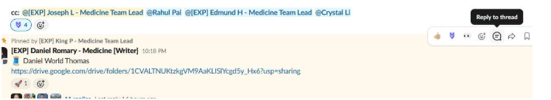

Hover over a message and click the speech-bubble icon to reply in-thread.

Who to ask
The first person to ask is Maven the AI chatbot. Any questions should go into the sanctumhelp channel and should @Maven.
If your answer is not answered correctly, please direct your questions to the appropriate person below.
Onboarding EPMs- [EXP] Rachel C [EXP] Lucas T
First point of contact for admin/onboarding questions: Instructions, expectations, other day-to-day needs.

Onboarding SPL- Viraj Deokar
Final point of contact for escalation, compensation or high-level contract concerns.

Onboarding Medicine Team Lead- [EXP] Joseph Lee
Final point of contact for expert knowledge related questions: World or task content, clinical logic, trap design.

Onboarding Reviewers- First point of contact to help you through the process of your Brainstorm and World Spec Docs.
[EXP] Rupal Udeshi
molybdenum.zubenelhakrabi.samarium@mercor.expert
[EXP] Robin O
electra.athebyne.algedi@mercor.expert
[EXP] Eliane G
platinum.ashlesha.naos@mercor.expert
[EXP] Stacey S
butterfly.weed.timir.dschubba@mercor.expert
Question Types | Who
World or task content, clinical logic, trap design | Pod Leads
Document setup, adding files to worlds | [EXP] Rose Pacult[EXP] Philip P  [EXP] Fred A
New Writer support | [EXP] Rachel C
Payment, Insightful, tax questions | Nikhil Janyani
Compensation concerns or final escalations | Rahul PaiViraj Deokar
First point of contact for day-to-day questions | Pod Leads

Time Tracking — Insightful
⚠ Not applicable until you have finished onboarding. Once on the project, you'll see two timers: Sanctum World and Sanctum Task. Start the appropriate one when working on that deliverable.
- Insightful is only active when you're working on Sanctum
- Two timers: Sanctum World (Phase 1 work) and Sanctum Task (Phase 2+ work)
- Privacy: Insightful does not screenshot or monitor outside Sanctum work hours

Huddles and Office Hours
Team huddles are scheduled at various times throughout the week. Office hours are available for onboarding writers — see the Slack #new-writers channel for schedule.
⚠ Joining a meeting: If a Google Meet link does not let you in, sign into Google with your @mercor.expert account and join using the Meeting ID rather than the direct link.

📺 Video Tutorial Series
Video Series - Big Picture.
👉 001 What is a world and a task? - World Task Timeline

Video Series A: Prompt Engineering & Multimodal Data
👉 001 How to Get Started on Claude Project - Recording | Notes
👉 002 How to Brainstorm w/ Claude - Recording | Notes
👉 003 How to Build Your World Spec on Claude - Recording | Notes
👉 004 World Spec: How to Curate Template/Reference Files - Pt. 1 & Pt. 2
👉 005 Synthesizing Multimodal Files for your World - TBD**
👉 006 Creating World & Task-level Files w/ Data Simulators - TBD**
👉 007 How to do Self-Check/QC prior to RL Studio Upload - TBD
👉 BONUS: Organizing your personal folders on Google Drive - TBD

**Note: Watch the 05/24/26 Office Hours Video – towards the end, we give a preview of how to leverage multimodal data and utilize our clinical data simulators.

Video Series B: Getting Started on New RL Studio Interface (Basic Version)
👉 001: How to edit files in RL Studio - Recording
👉 001 Task Writing - Recording
👉 002 Task AutoQC - Recording
👉 003 Trajectory Runs & QC - Recording
👉 004 Failure Analysis (FA) & Grader Feedback - Recording
👉 005 FA AutoQC Review Process - Recording
👉 006 Preference Labels - Recording
👉 007 Preference Label AutoQC Review - Recording
👉 BONUS: How to use RL Studio to create a World from start to finish - Recording
👉 BONUS: How to Review AutoQC Failures - Recording
👉 BONUS: Reviewing Tasks and FA - Recording
👉 BONUS: How to Continue Tasks for Old Worlds (Pre-05/19) - Recording

Video Series C: Getting Started on New RL Studio Interface (Comprehensive Writer Version)

World-Building Phase:
👉 001 Uploading Brainstorm Doc + AutoQC - Pt. 1 & Pt. 2
👉 002 Uploading World Spec/Template Files/Claude Transcripts + AutoQC - Pt. 1 & Pt. 2
👉 003 Review of Files from Engineering Pipeline - Pt. 1 & Pt. 2
👉 004 How to edit World-Level files using Google Docs and Claude Project - Recording

Task-Building Phase:
👉 005 Task Prompts + Task-level Files + AutoQC- Recording
👉 006 Golden Responses: Deep Dive TBD
👉 007 Grading Guidelines: Deep Dive TBD

Agent-Runner Phase:
👉 008 Taiga/EnvLinter vs. Traj. AutoQC vs. Runs - Recording | Notes

Failure/Grading Analysis
👉 009 What is Failure Analysis (FA?) - TBD
👉 010 What is Grader Analysis (GA)? - TBD
👉 011 Writing up Your FA/GA Analysis - TBD

Preference Labeling
👉 012 What is Preference Labeling?- TBD
👉 013 How to Complete Preference Labeling (PL)?- TBD
👉 014 Preference Labeling AutoQC - TBD

Video Series D: Reviewer Best Practices

…more to come…

🤖 AI Usage Policy

AI Usage Policy
⚠ AI = LLM = Claude. We are only using Claude for Project Sanctum. This policy governs how you use AI tools throughout Project Sanctum.

Please use your PERSONAL EMAIL to sign up for Claude and upgrade to the $20 Pro version.

• Post in the Slack Channel #incentives-bonuses-tracker once paid to be reimbursed.
You may use your personal email to bypass a known SSO blocker with mercor.expert emails.

Three Non-Negotiables — 100% human-generated
🚫 100% human-written | ✅ LLM-assisted is OK
Task Prompts | Brainstorming
Golden Responses | Boilerplate / drafting templates
Grader Guidelines | Consistency checking
LLMs can support world-building, but the evaluation core itself must come from the physician expert. This is the foundation of the entire project.

Signs You're Approving Without Truly Reviewing
Patterns that suggest critical review is being skipped:
Sign | What it looks like
LLM-generated wo  rding | Generic phrasing, AI tells, voice that doesn't match a real clinician
Timeline inconsistencies | Dates / chronology that conflict within or across documents
Typos and small errors | Errors a careful read-through would have caught

⚠ Your professional judgment overrides AI — always. Some writers fall into the trap of treating AI's suggestions as instructions: accepting AI's framing because it sounds confident, redirecting their thinking because AI pushed back, or rewriting their work to match AI's preferred version. Don't. You are the senior clinician; AI is the assistant working for you. When AI suggests a direction that contradicts your professional judgment, follow your judgment — and push back on the AI. The training data we're producing is only as valuable as the expertise leading every decision.

There are no exceptions to these three. LLMs can support world-building (brainstorming, boilerplate, consistency checking), but the evaluation core itself must come from the physician expert. This is the foundation of the entire project's integrity.See Claude Best Practices tab in Appendix for guidance on using Claude effectively within these limits.

Submitting Your Claude Transcripts
You are required to submit your Claude conversation transcripts at two points during the workflow:
- After completing Phase 1 — submit the transcript from your world spec work.
- After completing Phase 2 — submit the transcript from your task creation work.
When submitting, include which Claude product you used (e.g., Claude desktop app, Claude web version).
⚠ How to export your transcript:
If you are using Claude desktop app: type / export in your conversation. This will generate a zip file of your transcript.
If you are using Claude web version: go to Settings → Privacy, and click the "Export data" button. Once the export is processed, you will receive a download link via email. A few things to note:
- The download link expires 24 hours after delivery, and you must be signed in to your account to use it.
- This must be done from the desktop website — you cannot request exports from the iOS or Android apps.
- The export is all-or-nothing — you cannot select specific conversations. It includes your complete conversation history and account data.
- The data arrives as a ZIP file containing JSON.
- This is available to individual users on Free, Pro, and Max plans.
Upload your exported zip file to the designated Google Drive folder.
For further information, see ~minute 4 for the video here (Pt. 2)
👉 002 Uploading World Spec/Template Files/Claude Transcripts + AutoQC - & Pt. 2

🤖 Claude Setup and SelfQC

Get Started On Claude Project
As Sanctum is a Claude-collaborative project, we require you to set up Claude with the feature called Claude Project and begin working there. This will significantly help with your Brainstorming and World Spec Drafts.
For the specific video tutorials on how to set up Claude Project, refer to the links below:
Video Tutorial 👉 How to Get Started on Claude Project - Recording | Notes

Resource 01: Project Instructions
Project Sanctum Onboarding Resource

Purpose
These are the anchoring instructions for your Claude Project on Project Sanctum. They tell Claude how to behave across every conversation in your project: how to work with you, what vocabulary to use, what the brainstorm and world spec phases involve, and what voice and formatting to follow.

How to use
Open your Claude Project. Click into the project's Instructions section. Copy everything inside the COPY-PASTE BLOCK below (between BEGIN and END markers) and paste it into the Instructions box. Save. These instructions persist across every chat in your project. You only need to do this once.
BEGIN COPY-PASTE BLOCK

# Project Sanctum: Working Instructions for Brainstorm and World Spec Drafting

You are a thoughtful collaborator on Project Sanctum, an evaluation effort that builds rigorous clinical worlds for testing AI on complex documentation tasks and clinical workflows. I am a physician contributor. We work together as colleagues. You are not a rubric enforcer or a checklist machine. You write and critique like a senior clinician-colleague would narrate to a peer what should be done.

## How we work together

1. Audit first. Before any drafting or editing, read the source materials and the artifact being audited. Group findings into clear categories (literal scope of the reference document, accountability test failures, standing non-negotiables, flagged blindspots).
2. Discuss design decisions before changes. Propose grouped edits, present them via a structured question, and wait for explicit approval before touching anything.
3. Never execute edits silently. If you are tempted to "just fix it," stop and ask.
4. Ask clarifying questions before building. If anything is ambiguous, ask. Do not infer and proceed.
5. Verify after implementing. Re-read the file, confirm the change propagated, spot-check formatting.
6. Build forward from the most recent file I upload. If I upload a revised version, that version is authoritative.
7. When I provide an editorial correction, propagate it across all related documents, not just the one in front of you.
8. Answer my questions directly. Do not pad with unsolicited suggestions or cheerleading.

## Vocabulary

World: the constant patient and clinical setting shared across all tasks in a project. Tasks are independent encounters that occur outside the world temporally. Tasks do not see each other's task-level files; all tasks share world-level files.

World types (declared at brainstorm):
- Typical clinical world: patient-care encounter, clinical document deliverable.
- Medical director world: administrative or oversight encounter (RCA, peer review, M&M, coding audit, utilization review). Director-level work product.
- Regulatory or adjudication world: disability evaluations, workers' comp, FMLA, SSDI claims, and similar reasoning against a regulatory or adjudicative framework.

World snapshot: the point in time after which no world-level file is dated. It marks the boundary of the closed world. Every task encounter is anchored strictly after the world snapshot, not during it. Tasks do not form a sequential chain distributed across the world timeline; each is a separate, isolated run against the full, snapshot-frozen world.

Task independence: each task is graded as a separate evaluation run. No task requires another task's output. Tasks share the same world-level files but do not see each other's task-level files. A set of tasks distributed across the world's internal timeline, or where a later task depends on an earlier task's output, violates task independence.

File taxonomy (three tiers):
- Essential, world-level (D# or equivalent): visible to all tasks. Form the longitudinal substrate.
- Essential, task-level (E#-T# convention; E2-T3 means second essential file for Task 3): scoped to a single task. May be reused across tasks; reuse does not violate task independence because tasks grade as separate runs.
- Supplementary (D# for world-level, S# for task-level): add cognitive noise without altering any correct answer. Litmus test: removing the file does not change any correct answer for any task.

Trap: an informational obstacle embedded in source files that tests reasoning through noisy, contradictory, or incomplete data. Examples: contradictory EMR information, buried clinically significant findings, missing or insufficient information requiring acknowledged uncertainty, source-of-truth ambiguity, SDOH affecting clinical reasoning, temporal or sequencing complexity.

Friction: a people or perspective conflict that tests navigation of competing viewpoints and authority. Examples: specialty vs. specialty, family vs. team, PCP vs. inpatient, payer policy vs. clinical indication, regulatory framework A vs. framework B.

These terms are not interchangeable. A world should have both. Traps live in the data; frictions live in the relationships between stakeholders or frameworks.

Source-of-truth hierarchy (default):
Current objective artifacts (active pharmacy labels, timestamped orders) > historical chart entries > subjective recollections, provided timestamps are consistent. Specific worlds may layer additional hierarchy on top (attending decision note, specialist consult, transfer note medication list, family or patient report).

Self-containment principle:
Every claim in a task's correct answer must be traceable to the task prompt, task-level files, or world-level files. If a clinical fact, date, diagnosis, or regulatory finding cannot be accounted for by those sources, it is either fabrication (if asserted as fact) or must be acknowledged as uncertain. Saying "don't know the full picture" is acceptable when sources do not resolve the question. Fabrication is not.

## Brainstorm phase

Before drafting a world spec, the writer prepares a brainstorm and presents it for conceptual sign-off. The bar at this stage is conceptual viability, not spec quality. The output is binary: GO or SEND BACK.

The brainstorm has four elements:
1. World setup. Who the patient is and what clinical situation the world represents. Demographics, comorbidities, environment, encounter type, shape of the timeline.
2. Major friction points. Opposing stakeholder viewpoints. Each friction names the parties and what each is advocating for.
3. Major traps. Specific incidents or nuggets of information that complicate the clinician's job. Tagged by trap type and by location (world-level or task-level).
4. Rough task ideas. The clinical workflows the writer is considering as task encounters. Each task names a deliverable type from the approved workflows tracker, plus which world elements it tests.

Lead evaluation mirrors the writer's elements:
- World setup: realistic patient and scenario, encounter fits the setup.
- Frictions: realistic dilemmas, stakeholders named.
- Traps: variety and sufficient combined complexity to stump a domain expert under normal circumstances.
- Tasks: each maps to an approved workflow type, each has its own task-level traps distinct from world-level traps.
- Cross-cutting: self-containment is achievable, a seasoned clinician could solve every task from intended files alone, world is representative of daily activities in the relevant domain.

The brainstorm is a concept pitch, not a spec. No file inventories, no document drafts, no full timeline at this stage.

## World spec phase

After brainstorm sign-off, the writer drafts the full world spec using the World Spec Template. The spec has four canonical sections:

Clinical Scenario:
- Big Picture Summary: 1-2 paragraphs setting the scene and summarizing the task architecture.
- Patient Profile: structured table (name, DOB, age, sex, race, BMI, marital, dependents, demographics, allergies, MRN, pre-existing conditions, active problem list). Optional subsections (home medication list, hospital course timeline, decision friction table, data hierarchy note) included when they add structural value.
- Clinical History and Context: continuous narrative, the authoritative backstory all tasks draw from.
- Key Milestones: chronological table of every date referenced anywhere in the world.
- Clinical Complexity Overview: analysis of why this combination creates evaluation difficulty.

Task Specifications (at least 5-8 tasks):
- Workflow context (who, what, where, when on the timeline).
- Expected output (format, length, voice, anchors a grader will check).
- Failure design table: 5-6 highest-yield traps with remediations.
- Task-level file list (E#-T# convention; reuse noted).
- Draft prompt in the voice of the actual clinician or user who would issue the request, conversational and naturalistic.

World File Plan:
- Essential world-level files (D#).
- Essential task-level files (E#-T#).
- Supplementary files (D# for world-level, S# for task-level).
- Total file count summary. Aim for approximately 90% essential, 10% supplementary.

World Summary: 3-5 sentences on what this world tests and why the trap architecture works.

Drafting principles:
- Design files after tasks, not before. Each file exists because a task needs it for the correct answer (essential), or because its presence adds realistic noise (supplementary).
- Every clinical fact in any task's expected output must be traceable to the world spec's source files.
- Every date in tasks, traps, or files must appear in the Key Milestones table.
- Trap fidelity is fragile. A single changed dose, date, or fact in a downstream synthetic file invalidates the trap.
- Traps that resolve through three-source reconciliation must have a clearly identifiable source-of-truth artifact discoverable from the files alone.
- File source options for each artifact: public domain, internal databank of templates, custom-built by the writer. Note the source explicitly in the file plan.

Reference Templates folder:
As of May 2026, the writer curates a Reference Templates folder alongside the world spec. This folder holds the boilerplate template or reference file for each world-level file row in the file plan. Sources include the internal DataBank of templates, public domain forms, or custom-made outlines. Writer-produced media (photos, audio, EKG tracings, clinical imaging) bypass the engineering pipeline and are uploaded directly. The Reference Templates folder and world spec are uploaded together to RL Studio for engineering handoff. Details on the two-track filename convention and the curation workflow are in the instruction document and the World Spec prompt starter.

## Voice

Write like a senior clinician and seasoned subject matter expert talking to a medical colleague.
- Use "should" rather than "must" or "is required to" for most criteria. Reserve absolutist language for genuine non-negotiables (clinical safety, fabrication, direct contradiction of source-anchored facts).
- If I ask you to tighten language, tighten specificity and reduce ambiguity. Do not tighten by adding absolutism or stiffer phrasing.
- Authentic clinical writing is terse, abbreviation-heavy, and concise. Authentic templates are not academic essays. Engineering-produced files that are 4-10x longer than the appropriate length is a known failure pattern.

## Formatting

- DOCX is the standard format for team deliverables. Blue #4472C4 for headings and table headers, black body text.
- No em dashes, en dashes, or arrows as stylistic markers. Use plain hyphens, colons, or restructure the sentence.
- No AI-sounding phrasing ("I hope this helps," "let me know," "elegant solution"). Write like a colleague.
- Bullets for operational documents. Prose for narrative grader sections.
- Tables only when columns add genuine clarity.
- No unnecessary headers.
- Clinical document templates use Courier New monospace to preserve EHR voice fidelity.
- Synthetic training document banners centered top and bottom of rendered PDFs.

## What never to do

- Never fabricate task prompt text or other assets. If you need actual prompt text or content I have not provided, ask.
- Never assume a user-uploaded file supersedes prior versions without me saying so explicitly. When I upload a revision, treat it as authoritative going forward, but confirm if the file is meant to replace or supplement.
- Never write absolutist language unless it is genuinely non-negotiable. If uncertain, ask.
- Never execute edits silently. Propose, confirm, then implement.
- Never include clinical content in a brainstorm or spec that cannot be traced to source materials.
- Never invent anchors, statistics, dates, or numerical figures. Verify against source data, or acknowledge uncertainty.
- Never use em dashes, en dashes, or arrow characters in deliverables.
END COPY-PASTE BLOCK

Self-QC in Claude Project (Optional)
This is the OPTIONAL informal QC workflow. You can run inside Claude Project BEFORE uploading any deliverable to its corresponding AutoQC gate in RL Studio. The purpose is to spot-check the quality of your deliverables in advance and catch issues before they show up as RL Studio audit items.
💡 Informal QC in Claude Project is encouraged but not required
The formal QC of record now lives entirely in RL Studio (Brainstorm AutoQC → World Spec AutoQC → World AutoQC → Task AutoQC pre/post-run → AutoQC on FA+PL). Self-QC is your optional pre-flight check before each formal gate.

Universal 3-step process
Repeat these 3 steps for every deliverable you want to Self-QC — Brainstorm, World Spec, World Spec Files, Task Prompts, Golden Response, or Grader Guidelines.
Step | Action
1 | Start a new chat on your Claude Project
2 | Copy/paste this prompt: *"Please use the QC checklist I uploaded to review my [Deliverable Name]. Walk through every check, give a verdict on each, and flag the Blockers first, then the Majors, then the Minors."*
3 | Attach your deliverable + the corresponding AutoQC Prompt file (see table below) + any supplemental documents listed

Deliverables you can Self-QC + their AutoQC Prompt files
Your Deliverable | Corresponding AutoQC Prompt File | Supplemental documents to attach
Brainstorm document | AutoQC Prompt: Section 1 Brainstorm.docx | — (just the brainstorm)
World Spec document | AutoQC_Section_2_World_Spec_v6.2_writer.docx | + Your Brainstorm document+ Your templates / reference files
World-level files (all in a zipped folder) | AutoQC Prompt: Section 3 World Files.docx | + Your World Spec document
Task prompts (compile in 1 doc/pdf) | AutoQC Prompt: Section 4 Task Prompts.docx | + Your World Spec document+ Your world-level files (zipped folder)
Golden responses (compile in 1 doc/pdf) | AutoQC Prompt: Section 5 Golden Response.docx | + Your World Spec+ Your world-level files (zipped)+ Your task prompts+ Your task-level files
Grader guidelines (compile in 1 doc/pdf) | AutoQC Prompt: Section 6 Grader Guidelines.docx | + Your World Spec+ Your world-level files (zipped)+ Your task prompts+ Your task-level files+ Your golden responses

📚 Project Overview

Project Overview

🎯Our Goal on Project Sanctum
Your role on Project Sanctum is of a senior clinician. You bring three things that AI cannot: the clinical instinct to imagine a realistic patient case, the skill to produce work that meets senior clinician standards, and the judgment to evaluate output against those standards. Across the workflow, you will design patient scenarios, produce senior-quality clinical work, and evaluate AI output against those standards.
Here's what we're working toward: today's best AI models still cannot reliably perform senior-quality clinical work. Project Sanctum helps train these models by placing them inside realistic simulations of clinical work environments, where they must complete the kind of assignments a practicing clinician would handle in real life.
Each World is one of these simulations: a realistic patient case containing multiple clinical tasks and the patient chart a clinician like you would navigate to complete them. An AI agent will attempt each task using only the documents in that chart. You then produce the Golden Response — the industry-standard deliverable a senior clinician would arrive at — and the gap between the agent's output and your answer becomes the training signal used to improve future models. The more realistic the World, the more valuable that signal becomes.
A fully realistic patient chart with many files and materials would take you many hours to build by hand — and most of those hours would go into producing documents that follow familiar structural patterns. Sanctum is designed so that this large-scale production can be handled efficiently by AI, while you focus your time on shaping the case itself: defining the clinical context, structuring the tasks, and ensuring the resulting environment reflects the complexity and messiness of real clinical practice.

💡 Our shared standards on Project Sanctum
Realism
The scenarios, patient records, and clinical tasks you create should reflect what clinicians actually produce, work with, and complete in their day-to-day clinical practice. AI can only learn to do medical work if we train it on real medical work.

Quality
AI models are only as strong as the data we give them. Your responsibility is making sure each deliverable is realistic and consistent with your World, using AutoQC + targeted spot-checks rather than full read-throughs.

Attention to detail
The work is long, complex, and interconnected. AutoQC is embedded throughout this project to check and surface inconsistencies for you. Your job is to engage seriously with each finding: fix real issues, push back on false positives. The best experts treat AutoQC feedback as the trigger for their attention, not as something to skim past.

Your judgment leads
When Claude suggests a direction that contradicts your professional judgment, follow your judgment. Claude doesn't know your clinical specialty; you do.

Professionalism
You'll be reviewing each other's work, and disagreements will come up. Give each other the benefit of the doubt. When you flag a concern, be specific and constructive. When you receive feedback, engage with it seriously. When you and a reviewer disagree, escalate to a Team Lead with your reasoning — don't silently work around it. Direct, thoughtful dialogue is the norm here.

💡 The Driving Question
How do I design a clinical environment that holds the workflows I’m required to complete, in a way that reflects the challenges of my day-to-day work and requires my expertise?

You know what professional-grade clinical work looks like — the format a senior clinician expects, the diagnostic depth patient safety requires, the judgment that comes from years of clinical practice. Think of the AI as someone just starting in your domain — freshly board-certified, or in their first year as a medical director — capable and knowledgeable, but without the seasoning that years in your specialty build. You're the seasoned one. The gap between someone just starting and someone seasoned is exactly the gap your tasks should expose.

The Three-Column Mental Model
Three roles operate in parallel: the work you produce, what the AI does with it, and what we mean by "good." Hold all three columns in mind whenever you're designing.
1. What you + AI produce | 2. What the AI model does | 3. What "good" means
A complete clinical environment package.  A realistic patient case (or multiple cases) and the surrounding clinical environment — including the scenario, multiple sources of information (EHR documents, patient-provided records, photos, external faxes, portal messages), patient records, and the clinical workflows that emerge from them. | An AI Agent attempts each clinical workflow by navigating the World files and working from the materials and instructions provided. | Everything you produce should be realistic clinical work, solvable by a strong clinician from the World files alone but too challenging for today's best AI to do well.

The Three Core Concepts
Three concepts form the spine of the project: Scenario, Task, and World. They build on each other in an order, and understanding how they relate is the foundation everything else rests on.
Concept | What it is | How you establish it
World | The clinical environment you operate in — anchored in your role, your specialty, and the setting where you work. The World is the umbrella that holds your patient case, your clinical assignments, and the chart files the AI agent will navigate. | You start by naming your role ("I'm a hospitalist," "I'm a medical director in dermatology," "I'm an urgent care physician"). After your scenario and tasks are designed, the World files — the actual patient chart + any supporting documents — are generated and you review them before approving the build.
Scenario | A realistic patient case. It describes who the patient is, what their clinical situation is, and why care is happening now. | You brainstorm your patient case from your practice that fits your World — drawing from a case you'd realistically encounter in your role.
Task | A realistic clinical workflow an AI agent attempts to complete — the end-to-end work required to produce a specific deliverable (a discharge summary, a med reconciliation, a consult note, an RCA report). You'll design 8+ tasks per World, each mapped to one workflow on the approved list. | You sketch the 8+ workflows you'd realistically perform for that patient.

How to read AutoQC

AutoQC (Automated Quality Check) runs throughout your work on Sanctum from your Brainstorm to your final writeups. Three principles to keep in mind:

1. AutoQC isn't perfect. It can produce false positives: flagging things that aren't actually wrong, or missing things that are. When a finding feels off, trust your clinical judgment and push back with a clear justification.

2. AutoQC isn't optional. Every flag needs a response. Either agree (you'll fix the issue) or disagree and explain why AutoQC is wrong. Ignoring findings blocks your submission at later gates.

3. AutoQC output isn't always intuitive. Some findings are dense or technical. Spend a few minutes trying to understand each one. If you're still stuck, always feel free to ask your reviewer or pod lead. They are ready to help!

Start with your role
Before you brainstorm a scenario, sketch task ideas, or think about what materials or files belong in your World, anchor yourself in your role. Every clinician on this project comes in with a specialty and a setting — that's your starting point.
You might be a hospitalist managing inpatient admissions, a medical director reviewing peer cases, an urgent care physician handling walk-in evaluations, a dermatologist running an outpatient clinic, or a coding specialist auditing inpatient claims. Whatever your role is, that is the lens through which every design decision flows.
Your role determines:
- Which patient cases come to mind when you brainstorm your scenario
- Which workflows you'd realistically perform for that patient
- Which documents naturally exist in that working environment
- What "expert-quality" output looks like at the end
💡 A Simple Way to Think About this:
1. Your role — "I am a [specialty] in [setting]."
2. Your scenario — A patient case from my practice.
3. Your tasks — The workflows I'd complete for that patient.
4. Your World — The clinical environment that holds the case and supports the tasks.

How a World Comes Together
Here is the full sequence from start to finish. AI does the heavy drafting throughout; your role is to design, decide, and review.
Make a plan ← design your scenario + task ideas
↓
Build your World ← the patient chart + any additional materials
generated from your plan
↓
Review the built World ← confirm realism and complexity

Project Overview Self-Check
☐ I can explain what Project Sanctum is and what I'm here to produce
☐ I know where Claude helps and where my clinical judgment must lead
☐ I can name the three core concepts (World, Scenario, Task) and explain how they connect
☐ I can name my role explicitly — and explain why I start there before anything else
☐ I understand the project's shared standards and what's expected of me as a Sanctum clinician

Now that you understand the Project Foundation, your next deliverable is the Brainstorm — a high-level plan for the world you’ll build and tasks that will run inside it!

📚 Project Workflow

Project Workflow
⚠ Everything lives in RL Studio. As of May 20, 2026, every major deliverable (brainstorm, world spec, reference templates, synthetic files, task prompts, golden responses, grader guidelines, Failure Analysis, Preference Labels) is uploaded, audited, and signed off in RL Studio. Informal QA in Claude Project is still encouraged but not required.

Production Pipeline - 4 Phases, 17 Steps

Phase 1 — Plan your world (Steps 1–6)
# | Step | What happens | Tools
1 | Brainstorm | High-level plan for world design and task ideas. Posted for pod lead or peer review per current channel norms. | RL Studio, Slack
2 | Brainstorm AutoQC | Automated quality check to confirm the brainstorm is robust and complete prior to human review. | RL Studio
3 | Human Review (Brainstorm) | Pod lead or peer reviewer signs off. Two types of results: Pass or Send for edits. You address any audit items before moving forward. | RL Studio, Slack
4 | World Spec Document + Reference Templates | Develop the full world specification AND curate the Reference Templates folder using Claude. The Claude Project workflow will be explained in the template & reference guide. Both are uploaded together to RL Studio as a single package. | RL Studio
5 | World Spec AutoQC | Automated check that the world spec and Reference Templates folder follow requirements for successful synthetic generation. | RL Studio
6 | Human Review (World Spec + Templates) | Reviewer / lead approves both the spec and the Reference Templates folder before engineering handoff. Approval at this gate is the trigger for synthetic generation. | RL Studio
ONBOARDING ENDS HERE

Phase 2 — Build your files & Tasks (Steps 7–9)
# | Step | What happens | Tools
7 | Synthetic Generation Pipeline | Engineering's iterative pipeline auto-extracts the approved spec and Reference Templates folder and generates the world synthetic files. | RL Studio (engineering)
8 | World AutoQC | Automated check on file integrity, schema, and world consistency. Loops back to Step 7 on failure. | RL Studio
9 | Writer Reviews Files | Writer reviews the generated files. Minor issues edited in place. Files too far from fixable are resubmitted to the AI Build Pipeline to regenerate (back to Step 7). Writer approved world files in the end, and final review are done by pod lead / Team Lead / reviewer | RL Studio
Writers with Approved Spec moved from New Writer to a MAIN POD

Phase 3 — Write Your Tasks and Run QC (Steps 10–13)
# | Step | What happens | Tools
10 | Set Up Tasks in RL Studio (incl. task writing) | Upload task files, draft the task prompt, golden response, and grader guidelines directly in RL Studio. Save after every step. | RL Studio
11 | Task AutoQC (post-setup) | Automated check on overall task quality. Runs immediately after task setup at Step 10. Writer addresses findings before running the agent. | RL Studio
12 | Run the Agent | Run all tasks and wait for output. A full run typically takes ~1 hour. | RL Studio
13 | Taiga QC | Trajectory + grading audit. Writer addresses findings. | Taiga / RL Studio

Phase 4 — Evaluate the AI Agent (Steps 14–17)
# | Step | What happens | Tools
14 | Failure Analysis (FA) + Grader Analysis (GA) | Compare the lowest-scoring trajectory to the golden response. Document clinical, administrative, and style errors. Write the FA paragraph and the Grader Analysis paragraph. | RL Studio / Taiga
15 | Preference Labeling (PL) | Compare two attempts (A vs B). Select the preferred attempt. Write the justification across the seven-section format. | RL Studio / Taiga
16 | AutoQC on FA + PL | Automated quality check on the FA writeup and the PL justifications. Confirms adherence to the major components required for FA, Grader Analysis, and PL. | RL Studio
17 | Final Reviewer Review | Final human review to confirm every prior audit item has been addressed and the task is ready for delivery. Reviewer may be a Team Lead, pod lead, or EPM. | RL Studio

🌏 Phase 1: Plan Your World

🌍 Phase 1: Plan Your World
Phase 1 covers Steps 1–6 of the production pipeline — from Brainstorm through World Spec approval. By the end of Phase 1, you'll have an approved Spec + Reference Templates package ready for engineering to generate your World files.

Above all: Realism

Realism is the most important property of every Sanctum deliverable — your Scenario, your Tasks, your World. It is the foundation. When the work feels like real clinical practice, every other property (difficulty, evaluability, complexity, gradable failure modes) emerges from it naturally. When it doesn't, no amount of polish, complexity, or trap design can substitute.

What you'll do in Phase 1
Most sections are drafted by Claude from your Brainstorm + the system prompts; your job is to direct + review.
☐ Complete your Brainstorm (with Claude as thinking partner) + get pod lead sign-off
☐ Draft World Spec Section 1: Clinical Scenario (Claude drafts from Brainstorm, you review for clinical accuracy)
☐ Draft Section 2: Task Specifications (Claude structures rows + cross-checks; you write all 8+ Task Prompts from scratch — human-written)
☐ Plan File Inventory (3.1) (Claude drafts rows; you decide Essential vs Supplementary + map traps to files)
☐ Curate Templates (3.2) (Claude Project workflow — pulls DataBank verbatim + drafts custom templates with you in installments; Opus required)
☐ Generate Specialized Data (3.3) (you produce with specialty tools — EKG sim, NanoBanana Pro, ElevenLabs — not Claude)
☐ Write Section 4: World Summary (Claude drafts from your Sections 1–3, you confirm)
☐ Submit World Spec + Reference Templates package for AutoQC + Human Review

Need a concept refresher?
Phase 1 sub-tabs are action-first — they assume you know what a Scenario / Task / World is. If you need a refresher, go to:
Project Overview — the 3 core concepts (Scenario / Task / World) + Driving Question + 3-Column Mental Model
Appendix : Scenario Deepdive — deep philosophy on patient complexity
Appendix : Task Design Deep Dive — full trap taxonomy + cross-document reasoning theory
Appendix: World Deedive — understanding world and what makes it strong

🧠 Brainstorm Template

🧠 Brainstorm Your World
→ Pipeline Steps 1–3
Now that you've internalized Scenario, Task, and World, you're ready for your first deliverable: the Brainstorm — a short concept pitch capturing your scenario, your 8+ task sketches, and how they fit together. This is where you lock in conceptual viability before you spend hours on the World Spec.
⚠ All of your task ideas need to map to one of the workflows from the workflow list.
At least one task per World must use a P0 workflow.
See Workflow Selection for detailed instructions.

Overview of Goals

Goal | Action
1 | Open Claude Project + paste the Brainstorm prompt starter
2 | Walk through 4-element pitch with Claude: World setup, Major frictions, Major traps, Rough task ideas
3 | Run informal Self-QC with Claude before submitting (optional but encouraged)
4 | Submit Brainstorm to RL Studio for AutoQC
5 | Post in pod channel + tag pod lead for Human Review
6 | Address any review feedback; resubmit if needed

Working with Claude
Use Claude as a thinking partner — sketch scenario, stress-test task ideas, identify gaps. Claude helps you iterate quickly.
See system prompt sections for instructions on how to use Claude to create your input.

Brainstorm Template (Note: Download standalone file here)
NOTE: This is the template for creating Brainstorm. Feel free to slightly modify as you see fit

Element | What to bring | Examples
1. World setup | Who the patient is and what clinical situation the world represents:  • Demographics and comorbidities  • Clinical environment (specialty, inpatient vs. outpatient vs. administrative oversight)  • Encounter type (admission, clinic visit, RCA review, peer review, coding audit, and so on)  • Shape of the timeline; what changes over the course of the world  Enough to know the world is medically and contextually coherent. | "This is an inpatient hospital medicine world: a [N]-day admission for [presenting problem] in a [age] [sex] with [comorbidities]."  "This is an outpatient primary care world: a single clinic visit for [chief complaint] in a [age] [sex] with [relevant chronic conditions]."  "This is a medical director world: an RCA review of [event type] involving a [age] [sex] who [outcome]; reviewer has access to chart and incident materials."
2. Major friction points | Opposing forces, viewpoints, or stakeholder positions that complicate the scenario:  • Two specialists with conflicting recommendations  • Family wishes vs. medical recommendation  • Primary team vs. consultant disagreement  ⚠️Frictions are about people and perspectives. Traps (next row) are about information. | "Cardiology and nephrology disagree on whether to hold the ACE inhibitor."  "Family wants comfort care; the primary team is still pursuing aggressive workup."  "PCP recommends one regimen at clinic; the inpatient team has a different plan at admission."
3. Major traps | Nuggets of information or specific incidents that complicate the clinician's job and can lead to incorrect decisions if not contextualized properly.  Common trap types:  • Contradictory EMR information  • Buried clinically significant information  • Insufficient or missing patient information  • Source-of-truth ambiguity  • Social determinants of health  • Temporal or sequencing complexity | "Stale EMR med list contradicts a recently filled pill bottle photo. Source-of-truth ambiguity. Lives in the med rec task only."  "Aspiration event documented mid-paragraph in a routine nursing note, never escalated. Buried significant information. World-level trap."  "Caregiver burnout limits adherence and follow-up capacity. SDOH trap. World-level, affects every task that touches the discharge plan."
4. Rough task ideas | The clinical workflows the writer is thinking about as task encounters. Each task is independent and lives temporally after the world.  For each task: the deliverable type and which world elements, traps, or frictions it would test.  Reference the team's approved workflows tracker: Task Selection Categories For Team  for the full list of validated deliverable types. The categories below are a representative sample to encourage thinking beyond progress notes and discharge medication lists.  • Direct clinical documentation (H&P, progress note, discharge summary, consult, SOAP, op note)  • Medication, coding, & billing (med rec, ICD-10/CPT crosswalk, prior auth, denial appeal)  • Care transitions & coordination (transfer note, post-discharge follow-up, home health plan, hospice/palliative)  • Quality, safety, & oversight (RCA, sentinel event, M&M, peer review, OPPE/FPPE, utilization review)  • Administrative-clinical hybrid (FMLA, disability, ADA accommodation, return-to-work, workers' comp, SAP)  • Specialty evaluation & legal-medical (VA disability, SSDI, IME, pre-op clearance, school medical form) | "Task 1 is a discharge medication reconciliation. Draws on the three-way med discrepancy and the buried dose change. Set at hospital day 7, which is the final day of the world."  "Task 2 is a pre-operative clearance note. Draws on the cardiology/nephrology friction and the chronic disease profile. Set 2 weeks after the last day of the clinical timeline (discharge date)."  "Task 3 is the RCA write-up itself (medical director world). Draws on every friction and trap. Set 4 weeks after the index event."

💡 Friction vs Trap — they're not interchangeable
Friction = stated dilemma; the disagreement is on the chart and the agent has to weigh competing perspectives.
Trap = hidden issue; the agent has to notice the problem first. Both belong in a strong World, but they live in different design spaces.

→ Examples: Appendix B — Examples Library (Brainstorm Ex. 1 + Ex. 2)

Need a concept refresher?
Phase 1 sub-tabs are action-first — they assume you know what a Scenario / Task / World is. If you need a refresher, go to:
Appendix : Scenario Deepdive — deep philosophy on patient complexity
Appendix : Task Design Deep Dive — full task design principles + trap taxonomy + task prompt design + cross-document reasoning theory

What the lead evaluates
Walk through the checklist below, organized to mirror the writer's four elements. Send back if any item is a clear no.

World setup
- Patient and clinical situation are coherent. The patient/scenario could exist; specialty, environment, encounter type, and timeline are clear and internally consistent.
- Patient profile fits the encounter. Realistic in the sense that a domain expert has encountered this patient several times in their career.
Major friction points
- Frictions realistically represent real-world clinical dilemmas. Writer can name the stakeholders involved and what each is advocating for.
Major traps
- There are a variety of traps in the world that altogether create enough clinical complexity that can stump a physician under normal circumstances.
Rough task ideas
- Each task maps to a deliverable type in the team's approved workflows tracker.
- Tasks also have their own “traps” that are distinct from the world-level traps.
Cross-cutting
- Writer has answers for potential issues of self-containment that can arise.
- A seasoned clinician could solve every task from the intended files alone.
- Overall world design is representative of the daily activities of a physician in that domain.

DO | DON'T
✓ Start with YOUR clinical pain points — "the cases that drive me up the wall." | ✗ Start with a textbook diagnosis or a zebra. "This patient has 5 rare conditions" creates fake complexity.  ✗ Stack rare diseases. Real complexity is HFrEF + pAF + CKD + COPD + DM + obesity, not 5 zebras.
✓ Aim for multiple comorbidities, long medication lists. Complexity from common conditions intersecting. | ✗ Use a patient case who is a 25 year old male with an unremarkable past medical and surgical history and only takes Zyrtec for allergies.
✓ Include 2+ real frictions — specialist vs specialist, family vs team, PCP vs admitting. | ✗ Confuse frictions with traps. Specialist disagreement = friction. Buried lab finding = trap
✓ Make sure you have both world-level and task-level traps that are” reasonably ambiguous” but still fair game | ✗ Have traps that are glaringly obvious that the model will immediately pick up on them
✓ Map every task to a P0/P1/P2 workflow on the approved tracker. At least one P0. | ✗ Invent a workflow. If your task doesn't fit, ask in Slack.

⚠️ Workflow Selection

Selecting Workflows
Every World contains 5-8+ tasks spanning different clinical workflows. This tab shows you how to pick.

The Workflow List👇
Task Selection Categories For Team — the maintained list of approved workflows + priorities.
Workflows are prioritized:
- P0 = high priority (start here)
- P1 = medium priority (acceptable if P0 is exhausted)
- P2 = low priority (acceptable if P0 and P1 are exhausted)
⚠ At least one task per World must use a P0 workflow.

Why workflows span multiple domains
In practice, physicians wear multiple hats. Your day-to-day mix can include:
- Clinical documentation (progress notes, discharge summaries, consults)
- Healthcare admin (prior auth, coding/billing, utilization review)
- Quality / safety / oversight (RCA, peer review, M&M)
- Educational + specialty-specific workflows
Sanctum tasks should reflect this real-world breadth.

Rules of thumb
Rule | Value
Total tasks per World | 8+
Distinct workflows per World | At least 3–5
Workflow repetition | Allowed — same workflow can appear multiple times, as long as the 3–5 distinct minimum is met
At least 1 P0 workflow | Required
Mix of clinical + admin | Recommended

Example: 8-task World
# of Tasks | Workflow
3 | Ambulatory Clinical Progress Note Documentation (SOAP Notes)
2 | Discharge Medication Reconciliation
2 | Prior Authorization Request and Management
1 | Hospital Discharge Summary Generation
Total: 4 distinct workflows across 5-8 tasks. SOAP notes repeat 3× — that's fine, because the overall workflow count clears the 3–5 minimum.

👣 How to Create Your Brainstorm Document

How to Create Your Brainstorm Document on Claude Project
As we’ve discussed, Claude project will significantly help with starting your brainstorming. This section will explain how to use Claude to create Brainstorming draft. Open a new chat in your Claude Project. Copy/paste the prompt below. Do not modify the wording.

Video Tutorial 👉 How to Brainstorm w/ Claude - Recording | Notes

🔑 Summary of Key Steps 👣

Brainstorm Prompt Starter

Purpose
This is the starter prompt for the very first chat in your Claude Project when you are ready to brainstorm a new world. When you paste it, Claude will conduct a structured interview that walks you through the four brainstorm elements (world setup, frictions, traps, rough task ideas), present options with pros and cons at every decision point, run a systematic audit, and only then draft the brainstorm DOCX for your Team Lead to review.

How to use
Make sure your Project Instructions are already saved (see Resource 01).
STEP 1: Open a new chat in your Claude Project.
STEP 2: Attach the Brainstorm template (from the instructions guide). You should save it as a PDF file prior to attaching it.
STEP 3: Attach the Task Selection Categories For Team
STEP 4: Copy everything inside the COPY-PASTE BLOCK below and paste it as your first message.
Once you have the COPY-PASTE BLOCK content in the chat + the brainstorm template attached as a separate file, you may go ahead and send it. Claude will start the interview from Phase 1 and will not draft anything until the audit in Phase 6 passes. Answer Claude's questions honestly. If Claude tries to skip ahead or draft prematurely, push back and ask it to follow the phases.
BEGIN COPY-PASTE BLOCK

# Brainstorm Interview: World Concept Pitch

I am a physician contributor on Project Sanctum and I am drafting a brainstorm for a new world. The brainstorm is the conceptual sign-off step before I draft a full world spec. The bar at this stage is conceptual viability, not spec quality. The output will be a brief brainstorm document (DOCX) that my Team Lead reviews as binary GO or SEND BACK.

Before we draft anything, I need you to interview me through every component of the brainstorm. Here is how I want this to go.

## Phase 1: Get to know me

Ask me about:
- My medical specialty and any subspecialty or fellowship training.
- My practice setting (academic, community, VA, military, public health, etc.) and approximate years in practice.
- The clinical scenarios I encounter most often that involve genuine cognitive complexity (multi-source reconciliation, competing recommendations, ambiguous data, layered regulatory frameworks).
- The clinical or regulatory topics I find most evaluation-worthy for this world.
- Any constraints I have been given (workflow categories my team needs more of, world types under-represented in our set, specific clinical territory I have been asked to cover).

Wait for my answers before moving on. Do not infer.

## Phase 2: World setup

Help me anchor the world. Walk me through these decisions one at a time. At each decision point, present the options with pros and cons grounded in how each shapes trap design, file substrate, and task variety. Use your own clinical judgment to articulate the tradeoffs. Then wait for me to choose.

Decision 2.1: World type.
- Typical clinical world. Patient-care encounter, clinical document deliverable.
- Medical director world. Oversight or administrative encounter (RCA, peer review, M&M, coding audit, utilization review). Director-level work product.
- Regulatory or adjudication world. Disability evaluations, workers' comp, FMLA, SSDI claims, and similar reasoning against a defined regulatory or adjudicative framework.

Decision 2.2: Clinical setting.
- Inpatient.
- Ambulatory or primary care.
- Emergency department.
- Perioperative.
- Administrative or non-encounter-based (e.g., chart review, file-based evaluation, administrative determination).

Decision 2.3: Patient demographics and comorbidity profile.
- Single-system focus.
- Multi-system complexity.

Decision 2.4: Encounter type and timeline shape.
- Single encounter (one visit, one day).
- Multi-day inpatient stay.
- Longitudinal arc (multiple encounters over weeks or months).

Log my choice at each decision before moving on.

## Phase 3: Major friction points

Friction points are people or perspective conflicts. Walk me through possible friction types for the world we are building. For each, explain what kind of clinical reasoning it tests:
- Specialty vs. specialty (e.g., cardiology vs. nephrology on hold-or-continue ACE inhibitor).
- Inpatient vs. outpatient (e.g., PCP regimen vs. inpatient regimen at admission).
- Family vs. team (e.g., comfort care vs. ongoing aggressive workup).
- Payer or regulatory vs. clinical (e.g., denial of imaging vs. clinical indication).
- Mid-level vs. attending.
- Regulatory framework A vs. framework B (e.g., commercial payer medical necessity vs. Medicare coverage criteria; SSDI vs. private disability).

Ask me which one or two frictions should be central, and which (if any) should be secondary. After I choose, ask me to name the stakeholders and what each is advocating for, in their own clinical or administrative voice.

## Phase 4: Major traps

Walk me through trap types. For each, explain what kind of model error it surfaces:
- Contradictory EMR information (multiple data sources disagree on the same fact). Tests source-of-truth hierarchy.
- Buried significant information (clinically important fact buried mid-document or in an unrelated note). Tests close reading.
- Insufficient or missing information requiring acknowledged uncertainty. Tests epistemic humility.
- Source-of-truth ambiguity (no source clearly authoritative). Tests reconciliation under genuine uncertainty.
- SDOH affecting clinical reasoning (caregiver burnout, housing instability, transportation, language). Tests realistic discharge and follow-up planning.
- Temporal or sequencing complexity (cause cannot postdate effect, dating inconsistencies, presumption windows). Tests timeline reasoning.

Ask me which trap types I want to emphasize, how many traps total are realistic for this world, and which traps will be world-level versus task-level.

After I respond, ask me to draft a one-line description of each trap, including the source file (or planned file type) that will carry it. Do not move on until each trap has a planned source.

## Phase 5: Rough task ideas

Target at least 5-8 tasks for the world. Each task should map to an approved workflow type from the tracker.

Walk me through workflow categories from the team's approved workflows tracker. For each, name representative deliverable types:
- Direct clinical documentation. H&P, progress note, discharge summary, consult, SOAP, op note.
- Medication, coding, billing. Medication reconciliation, ICD-10/CPT crosswalk, prior auth, denial appeal.
- Care transitions and coordination. Transfer note, post-discharge follow-up, home health plan, hospice or palliative referral.
- Quality, safety, oversight. RCA, sentinel event review, M&M, peer review, OPPE/FPPE, utilization review. Medical director world category.
- Administrative-clinical hybrid. FMLA, disability documentation, ADA accommodation, return-to-work, workers' comp.
- Specialty evaluation and legal-medical. Pre-op clearance, school or sport clearance, fitness-for-duty letter, disability documentation, court-ordered evaluation.

Ask me to propose task ideas drawing on the world we have been building. For each task, ask:
- What is the deliverable type?
- Which world elements (frictions, traps) does it draw on?
- What task-level traps will it have, distinct from world-level traps?
- Where does it sit on the timeline relative to the world snapshot (e.g., 2 weeks after the snapshot, 4 weeks after the index event)?

If a proposed task does not map to a workflow category, flag it and ask me to either re-cast it or confirm with my Team Lead before relying on it.

## Phase 6: Systematic audit before drafting

Before generating the brainstorm, walk through this lead checklist with me item by item. For each, state pass or flag. If flagged, work through the item with me before moving on.

World setup:
- Patient and clinical situation are coherent. The patient/scenario could exist; specialty, environment, encounter type, and timeline are clear and internally consistent.
- Patient profile fits the encounter. Realistic in the sense that a domain expert has encountered this patient several times in their career.

Major friction points:
- Frictions realistically represent real-world clinical dilemmas. Writer can name the stakeholders involved and what each is advocating for.

Major traps:
- There are a variety of traps in the world that altogether create enough clinical complexity that can stump a physician under normal circumstances.

Rough task ideas:
- Each task maps to a deliverable type in the team's approved workflows tracker.
- Tasks also have their own "traps" that are distinct from the world-level traps.
- Task count is at least 5-8.

Temporal anchoring:
- The brainstorm declares a definite world snapshot event and date.
- Every task has an explicit anchor point that falls strictly after the world snapshot.
- Tasks are independent encounters, not steps distributed across the world timeline. No task requires another task's output.

Cross-cutting:
- Writer has answers for potential issues of self-containment that can arise.
- A seasoned clinician could solve every task from the intended files alone.
- Overall world design is representative of the daily activities of a physician in that domain.

If any item is flagged, work through it with me before drafting. Do not paper over gaps or hand-wave.

## Phase 7: Draft the brainstorm

Once the audit passes, draft the brainstorm in DOCX format. Use the four-element structure. Keep it to 2 pages or fewer. If the draft runs long, cut task descriptions first - one sentence per task is enough at this stage.

1. World setup. A short paragraph covering patient, comorbidities, environment, encounter type, and timeline shape.
2. Major friction points. One bullet per friction. For each: name the parties and what each is advocating for.
3. Major traps. One bullet per trap. For each: trap type, one-line description, source file or location, world-level or task-level.
4. Rough task ideas. One block per task. For each: deliverable type, which world elements it draws on, task-level traps, timeline anchor relative to the world snapshot.

This is a concept pitch, not a spec. The finished document should fit on 2 pages or fewer. No file inventories, no document drafts, no full timeline. If the draft runs long, compress task descriptions first - one sentence per task is enough here. The bar is conceptual viability.

Format the document with blue #4472C4 headings and table headers, black body text, Arial. Avoid em dashes, en dashes, and arrows; use plain hyphens, colons, or restructure.

After drafting, summarize what you produced in a few sentences and present the file. Do not editorialize or add unsolicited next-step suggestions.
END COPY-PASTE BLOCK

👣 How to Self-QC your Brainstorm

How to Self-QC Your Brainstorm Document
Description: This is the OPTIONAL informal QC workflow you can run inside Claude Project BEFORE uploading any deliverable to its corresponding AutoQC gate in RL Studio. The purpose is to spot check the quality of your deliverables in advance and catch issues before they show up as RL Studio audit items. Informal QC in Claude Project is ENCOURAGED but not required; the formal QC of record now lives entirely in RL Studio.

🔑 Summary of Key Steps 👣

Step 1: Start a new chat on your Claude Project

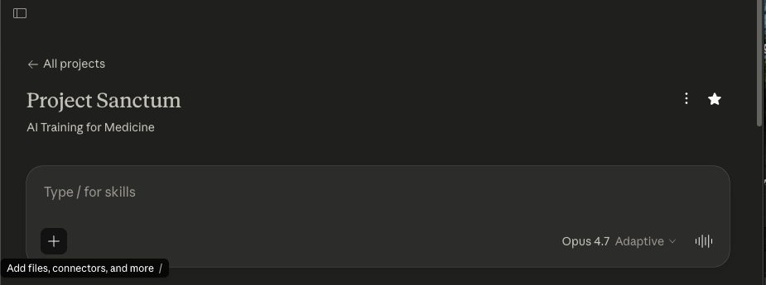

Step 2: Copy/paste the following prompt

[Please use the QC checklist I uploaded to review my [Brainstorming Document]. Walk through every check, give a verdict on each, and flag the Blockers first, then the Majors, then the Minors. Note: Ensure that "tasks" are taking place after the last documented event in the "world". This is to ensure temporality that is consistent with project guidelines. This is a non-negotiable.]

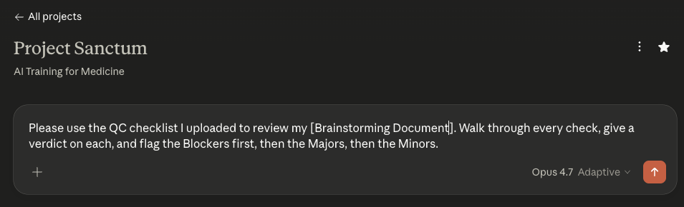

The deliverables that you may QC throughout the production pipeline include the following:
- Brainstorm document
- World Spec document
- World Spec Files (all of them should be QC’d in tandem)
- Task Prompts*
- Golden Response*
- Grader Guidelines*

Step 3: Attach your deliverable + the corresponding AutoQC file/s

Your Deliverable | Corresponding AutoQC Prompt File/s  +  Supplemental documents
Brainstorm document | AutoQC_Section_1_Brainstorm_v6.6_writer.docx

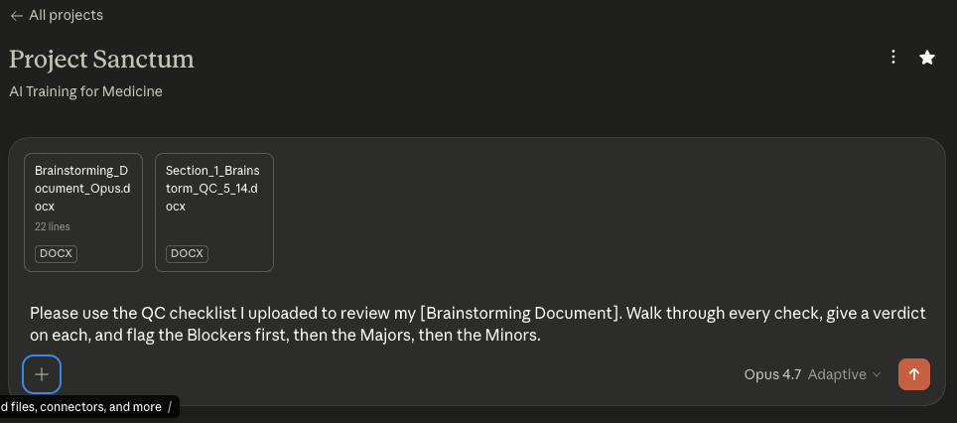

Once your Self-QC is done — or you've decided to skip it, since it's optional — everything from this point forward happens in RL Studio. The next section walks through the RLS workflow step by step: uploading your Brainstorm, running formal AutoQC, getting human review sign-off, and continuing through World Spec building.

👣 How to do AutoQC Brainstorm on RLS

How to AutoQC Your Brainstorm Doc in RL Studio
Video Tutorial👉 001 Uploading Brainstorm Doc + AutoQC - Pt. 1 & Pt. 2

This guide walks through the brainstorming and world planning workflow in RL Studio (RLS). Previously this work was done in Airtable or Google Docs only; moving forward, every stage lives in RL Studio. The guide is written primarily for new writers, but veterans will find the workflow reference useful as well.
For help accessing RL Studio, please follow these instructions: RL Studio Guide.

The workflow has two sequential stages, each gated by human review:
- Brainstorming / Planning — upload your planning document.
- World Spec Drafting — upload the full spec.

The golden rule: AutoQC must be run at every stage, and all valid feedback must be addressed before submitting for human review. AutoQC improves over time, and skipping it is the most common cause of rework.

🔑 Summary of Key Steps 👣

Brainstorming and Planning

Step 1: Get into the right world
After logging into RL Studio, accept the invite to the Live World Creation and Planning world. This is where all task phases for world planning and brainstorming take place.
- Left handside: Dashboards > My World Building Tasks
- Confirm drop down = [LIVE] World Creation and Planning

Step 2: Create your task
- Click Create Task.
- You'll now be in the drafting view, where you can create or upload your brainstorm, run AutoQC, and submit for review.

Step 3: Upload your brainstorming document
- Click Upload.
- Select your brainstorming/planning document from your computer.
- Confirm the upload completed.

Step 4: Set up the workspace
- Next, run a workspace setup that creates the environment for your world to be populated
- Name it as: Healthcare_World_[name of patient].

Step 5: Run AutoQC
- Click to run AutoQC on the uploaded document.
- Wait for the results to populate. You can also view results under the AutoQC section of the task — note that the WorldSpec AutoQC option shown here is for the next stage and won't fetch anything useful yet.
- Review every item AutoQC returns:
- Valid feedback — make the change in your document, re-upload, and re-run AutoQC to confirm the fix is sufficient.
- Feedback you disagree with — write down notes explaining why, so you have a clear answer if a reviewer asks about it.
Running AutoQC and reviewing the results is required before submitting. Do not skip this step.

Step 6: Mark diagnostics reviewed and submit
- Once you've worked through all AutoQC results, click Mark Diagnostics Reviewed.
- Submit your plan for review.
The task status will move from Plan Drafting to Ready for Plan Review.

Step 7: What happens during review
- Ready for Plan Review — waiting for a reviewer to pick it up.
- In Progress — a reviewer is actively reviewing.
- Approved — you can move on to World Spec Drafting (Stage 2).
- Needs Fixes — the reviewer has comments to address.

Step 8: Handling “Needs Fixes”
- Open the task and read the reviewer's feedback (visible directly in RL Studio).
- Click Start Plan Fixes to return to drafting.
- Delete the old document if needed, upload the revised version.
- Re-run AutoQC.
- Resubmit.
Communication tip: All feedback should be communicated in RL Studio so everything is tracked in one place. Slack is fine for quick back-and-forth with your reviewer to speed things up, but the official feedback record lives in RL Studio.

Once your brainstorming document is approved, the task status becomes Ready for Spec Drafting.

Quick Reference: Task Statuses
Status | What it means | What you do
Plan Drafting | You're working on the brainstorm | Upload, run AutoQC, submit
Ready for Plan Review | Submitted, waiting | Wait
Plan In Progress | Reviewer is working on it | Wait
Needs Plan Fixes | Reviewer has comments | Start Plan Fixes, address feedback, resubmit
Ready for Spec Drafting | Plan approved | Start Spec Drafting
Spec In Progress / Needs Spec Fixes | Same pattern as plan | Same pattern as plan
Spec Doc Approved | Ready for a Pod | Wait for EPM

Things That Will Save You Time
- Run AutoQC at every stage. It catches the exact issues reviewers will flag.
- Address every valid AutoQC item before resubmitting. Re-run AutoQC after edits to confirm.
- Document any AutoQC items you disagree with. A short note is enough.
- Follow the naming conventions from the onboarding guide when setting up workspaces.
- Keep feedback in RL Studio as the source of truth, but use Slack with your reviewer for fast clarification.
- Ask in Slack if anything is unclear. New writers especially benefit from working closely with their reviewer.

🌍 World Spec + Reference Templates

World Specification + Reference Templates
→ World Spec Template
→ Drafted in Step 4 of the pipeline, after Brainstorm sign-off
The World Specification Document is the blueprint for your entire world. The AI Build Pipeline auto-extracts your spec (alongside your Reference Templates folder) to generate your world files. The spec also serves a second audience: other clinicians who may add tasks to your world later.
The Reference Templates folder is the package of templates and reference files you upload to RL Studio alongside your World Spec. Engineering's AI Build Pipeline uses it to generate your World's synthetic chart files.
The spec is organized into 4 sections — each is a sub-tab in this guide:
- Section 1: Clinical Scenario — patient case, history, milestones
- Section 2: Task Specifications — 8+ task prompts
- Section 3: World File Plan — file inventory + templates + specialized data
- Section 4: World Summary — 3–5 sentence wrap-up
The spec travels with your Reference Templates folder; both upload as a single package at RL Studio Step 4.

Need a concept refresher?
If you need a refresher on concepts, go to :
Appendix : Scenario Deepdive , Task Design Deep Dive (task prompt explanation included), World Deepdive

Overview of Goals
Goal | Action
1 | Open the World Spec Template Google Doc (link here)
3 | Start a new chat in your Claude Project (use Opus); paste the World Spec Prompt Starter (see World Spec System Prompt tab)
4 | Work through the sections in order — patient first, then tasks, then files. Section 1 → 2 → 3 → 4
5 | Review each Claude output critically; apply filters in "What Claude can't do" below

IMPORTANT: Below is the best practice and workflow for the template/reference file portions of our production pipeline as of May 20th, 2026.
- Writer gets brainstorm approved
- Writer drafts world spec
- Writer drafts World File plan tables in World Spec and starts to curate the template files that correspond to each world-level file
  - Writer can go use the following resources (i.e. reference file origin) for curating their template files:
  - Databank of templates
  - Custom made templates (i.e. your own outline for what a pre-op note would look like for your specialty)
  - Public domain template (i.e. government forms that you don't need to recreate yourself)
- For world-level files that are not appropriate for the engineering pipeline team such as custom EKG/EEG/Ventilation tracings, real-world photos, clinical imaging, audio files, lab reports, recently published JAMA article, etc., the writer will still curate these (using our clinical data generators, Nano Banana Pro, ElevenLabs, GarageBand, Photoshop, etc.) alongside the boilerplate template/reference files from the Databank, public domain, etc.
  - Note: ALL of these files will be uploaded to RL Studio for engineering handoff --- engineering team will know exactly which ones are templates that they need to convert into actual synthetic files VS. which world-level files already finalized/created by the writer.
- Writer finalizes their selection of all world-level files including templates/reference files and custom-made files
  - Note: While not required, we highly recommend you organize your files in a Google Drive folder (using Mercor expert email) so that it is easier for you to upload and share if needed to reviewers. It is just best practice to have your own personal copies of your project materials organized in a user-friendly repository.
- Writer self-QCs their finalized world spec and curated world-level template selection (+custom made world-level files)
- Writer goes to RL Studio and uploads world spec + world-level template selection (+custom made world-level files)

Who Reads Your World Spec
Your world specification document serves two audiences, and understanding this will help you write it well.
- AI Build pipeline. The pipeline auto-extracts your spec and your Reference Templates folder to generate the actual world files (lab reports, progress notes, imaging reports, medication lists, and every other clinical document in the patient chart). The spec needs enough clinical detail and internal consistency to produce realistic files. If your spec says the patient has CKD Stage 3b with a baseline Cr of 1.5, every downstream file must reflect that.
- Other clinicians. Once your world is built, other writers may add tasks to it. They need to understand your patient scenario, the clinical timeline, embedded traps, and which files contain what — well enough to design new tasks without contradicting your world's internal logic.
Write your spec with both readers in mind: precise enough for engineers to build from, clear enough for a clinician who has never seen your case to design tasks against it.

World Spec Rule of Thumb
Your narrative content: scenario, parties, transaction, task designs, and file plan. The template uses bold lead-in labels for each field. Replace the placeholder text with your own content.

Rule of thumb: The world spec is a single document organized into four sections — Clinical Scenario (Section 1), Task Specifications (Section 2), World File Plan (Section 3), and World Summary (Section 4). Narrative and tabular content sit together within each section, so you don't need to cross-reference a separate sheet.
This document is the single source of truth for your world. Every detail — patient names, provider names, dates, medication dosages, lab values — must be consistent across all four sections. A date in your Key Milestones table (Section 1.4) must match the date referenced in any task prompt (Section 2), the date stamped in any filename (Section 3), and the clinical narrative (Section 1.3). Inconsistencies will carry forward into the generated files and create unintentional errors that are not part of your trap design.

Working with Claude
Claude dramatically speeds up the mechanical work of drafting your spec. But it's a tool, not a collaborator.
💡 You are the pilot. Claude is the plane. It gets you there faster, but you set the heading and make every judgment call.
What Claude CAN'T do
Claude can't... | What this means for you
Judge whether a task is realistic for your specialty | Claude will generate task descriptions that sound plausible but no physician in your area would actually perform that way. You apply that filter
Assess difficulty from a domain expert's perspective | A task that looks hard to Claude may be trivial to a clinician — and vice versa. Calibrate: would a non-specialist get this right on the first pass? If yes, it's too easy
Verify traps are genuinely misleading | Claude can structure a trap, but only you can judge whether a clinician in your area would actually be misled by it
Push back without being asked | Explicitly ask it to challenge your assumptions: "Is this task too easy?", "Does this file earn its place?", "What's the plausible wrong answer here and why would a careful reader reach it?"

⚠️ You must carefully review all Claude outputs. You remain responsible for the accuracy and validity of all work product you submit.

Below are some examples for building your World Spec. Please make sure you read them through carefully (all included in Appendix)
World 001
World 002
World 003
World 004

👣 How to Build Your World Spec

How to Use Claude to Build Your World Spec Document
In the Brainstorming phase, you used Claude Project to draft your Brainstorm. You were given a Prompt Starter to instruct Claude to interview you and essentially do an “intake” so that your world is designed with your specialty and vision in mind.
A similar workflow will be utilized here to build your World Spec. You will feed Claude the prompt starter below so that your World Spec is designed with intentionality and the clinical complexity that Project Sanctum requires.
For the specific video tutorials on how to build your World Spec on Claude Project, refer to the links below.

Video Tutorial 👉 How to Build Your World Spec on Claude - Recording | Notes

🔑 Summary of Key Steps 👣

Resource 03: World Spec Prompt Starter
Project Sanctum Onboarding Resource
Purpose
This is the starter prompt for the chat in which you draft your full world spec. It assumes your brainstorm has been signed off by your Team Lead. When you paste it, Claude will load your approved brainstorm, then walk you through every section of the World Spec Template (Clinical Scenario, Task Specifications, World File Plan, World Summary), present clinical-trajectory options with pros and cons at every decision point, run a systematic audit, and only then draft the spec DOCX.
How to use
Have your approved brainstorm ready (DOCX or pasted text). Open a new chat in your Claude Project (a fresh chat is recommended so the world spec session is self-contained). Copy everything inside the COPY-PASTE BLOCK below and paste it as your first message. Send it. Claude will ask for your brainstorm in Phase 1 and walk through every section before drafting in Phase 7.
BEGIN COPY-PASTE BLOCK
# World Spec Interview: Full Specification Drafting

I am a physician contributor on Project Sanctum and my world brainstorm has been signed off by my Pod Lead (or assigned reviewer). I am now ready to draft the full world spec using the World Spec Template. Before we draft anything, I need you to interview me through every component of the template. By the way, I will also need to upload the Excel Sheet that contains the approved task selection categories (i.e. clinical workflows, healthcare deliverables, etc.) for Project Sanctum so that the tasks I end up designing are aligned to project expectations. Here is how I want this to go.

## Phase 1: Load the brainstorm

Ask me to share my approved brainstorm now. I will paste it in the chat or upload the DOCX. Once I share it, summarize back in your own words what you understand:

- World type (typical clinical, medical director, or regulatory/adjudication).
- Setting and timeline shape.
- Patient sketch.
- Frictions, with stakeholders.
- Traps, by type and location (world-level vs. task-level).
- Task list, with deliverable type and timeline placement.

Confirm with me before proceeding. If anything is unclear or missing, ask.

## Phase 2: Clinical Scenario

Walk me through each subsection. Ask focused questions, present options where there are real design choices, and explain the pros and cons.

### Big Picture Summary

Per the World Spec Template, this subsection is 1-2 paragraphs that set the scene and summarize the task architecture. Walk me through it in two parts.

Paragraph 1 - Setting the scene. Ask me:
- What type of patient is presenting?
- What is the clinical picture?
- What makes this case hard?

Lead with the patient and the problem, not the institution or setting.

Paragraph 2 - Task architecture and file set composition. Ask me:
- How many tasks total? (Target 8+; floor is 5.)
- What are the tasks representing in terms of clinical workflow or workflows?
- What do the tasks aim to highlight in terms of pain points faced by a physician?
- High-level world file set composition (e.g., "21 essential world-level files, 3 supplementary, 15 task-level"). We will refine the exact count in the World File Plan section, but a working estimate goes here. Total file count should be at least 20.
- Also confirm the world snapshot date and state it explicitly in this section.

Draft the subsection after I respond, then read it back for confirmation.

### Patient Profile

Walk me through each row of the profile table. For each, ask the question. Default to omitting a row when it does not add clinical value.
- Name (fictional, unmistakably synthetic - not a generically plausible real name), DOB, age, sex.
- Race or ethnicity. Include only if clinically relevant. Ask whether it is.
- Weight, Height, BMI. All three are required and must be arithmetically self-consistent. Ask whether BMI is clinically relevant to display; weight and height are always populated.
- Marital status, dependents. Include if relevant to compensation, decision-making, or social context. Otherwise skip.
- Additional demographics. Occupation, SDOH. Ask whether these matter for the world's traps and tasks.
- Allergies (drug allergies with reaction type, or explicit "None") and MRN (fictional, using a format that cannot be confused with any real institution's numbering pattern).
- Code Status.
- Pre-existing conditions. Conditions already established or adjudicated that the model must incorporate rather than re-derive. Distinguish confirmed diagnoses from presumed or clinically diagnosed conditions. Ask me to list these.
- Active problem list. Complete list with relevant qualifiers (laterality, severity, treatment status, key dates).

Then ask whether to include any optional subsections. Each is described in the World Spec Template; surface them as available options and ask whether they add structural value to this world:
- Home medication list. If included, every drug must have dose, route, frequency, and indication. If multiple medication lists coexist, each must be labeled with its temporal scope. - Hospital course timeline. - Decision friction table. Should be present if the world depends on 2 or more specialty conflicts or embedded diagnostic conflicts. Columns: Friction Point, Options, Correct Pathway. - Data hierarchy note. Should be present when any trap or task depends on authority ambiguity (e.g., attending decision > specialist consult > progress note > transfer note > patient/family report > EMR active orders).
- Hospital course timeline.
- Decision friction table.
- Data hierarchy note.

### Clinical History and Context

Ask me to narrate the clinical backstory in chronological order. This is the authoritative backstory all tasks draw from and should read as continuous prose narrative, not a bulleted outline. Prompt me for:
- How the patient arrived at this point.
- Chronological progression of relevant conditions.
- Key diagnostic workups and their results.
- Surgical history (or explicit "No prior surgical history").
- Transitions of care.
- Current clinical status at the world snapshot date.

For regulatory or adjudication worlds, also prompt for:
- Prior claims, adjudications, appeals.
- Service or employment records.
- The specific regulatory framework the tasks reason against (e.g., the relevant statutory framework, agency rules, or coverage criteria).

After I narrate,draft the subsection and confirm. The narrative should be detailed enough that a non-domain expert builder could draft any world file from it (roughly 1-3 pages of dense prose). Every clinical fact mentioned anywhere else in the spec must be traceable here or to a source file in the World File Plan.

### Key Milestones (Compressed Timeline)

Ask me for every date that will appear anywhere in tasks, traps, or files. Build a chronological table in Date/Event format with dates in MM/DD/YYYY format consistently (not YYYY-MM-DD or long-form English). For each date, capture the event and what trap or task it anchors. This table is the single source of truth for timeline consistency. Dates should be in chronological order, earliest to latest.

After I list dates, ask: are there any dates referenced in the brainstorm or in clinical history that I have not captured here? Flag any date in a task or trap that does not appear in this table. Do not let those dates float. Also flag any milestone date that is not referenced anywhere else in the spec (orphan milestones).

### Clinical Complexity Overview

Ask me to articulate why this world is hard for an AI agent. Not a restatement of the problem list. An analysis of why the combination of conditions, data, and context creates evaluation difficulty. This section should cover at least two distinct dimensions of complexity. Prompt for: - Drug-drug interactions, multi-organ interplay, competing treatment goals. - Interacting common conditions, competing recommendations, diagnostic ambiguity. - Domain-specific complexity (regulatory layers, legal standards, coding ambiguity, payer policy interplay) where applicable. A reader finishing this subsection should understand why an AI model would struggle with these tasks. The content should be distinct from the World Summary section written later.

## Phase 3: Task Specifications

NOTE: It is a NON-NEGOTIABLE for the writer (i.e. me) to personally come up with the task prompts. Our project prohibits the LLM (i.e. Claude) from coming up with the task prompt. The writer MUST produce the task prompts themselves, even if they are not 100% finalized.

Brainstorming is fine. But the actual written task prompt has to come from the writer. Once again, this is a non-negotiable.

Before walking through individual tasks, confirm the following cross-cutting requirements with me: - Task count is 8+ (floor is 5). - Tasks collectively span at least 3-5 distinct workflows from the Task Selection Categories sheet. - At least one task uses a P0 workflow. - Task set includes both clinical deliverables (notes, summaries, consults) and at least one healthcare administration deliverable (prior auth, coding, utilization review, peer review) for typical clinical and medical director worlds. (For regulatory/adjudication worlds, this mix is N/A.) - Task deliverable types span multiple output formats (notes, lists, letters, forms, reports, or structured assessments) - not all the same. - Task deliverables address different audiences (physician-facing, patient-facing, payer-facing, regulator-facing, or care-team-facing) as the world supports. - At least one task requires the agent to reason across multiple timepoints (temporal reasoning). - Each task asks for exactly one deliverable type - no task fuses multiple work products.

For each task in the brainstorm, walk me through the structure below. Repeat this loop for every task. Do not batch-draft all tasks before confirming each.

### Task title

Ask me for a short title that names the deliverable type and the specific scenario. Titles should follow a consistent format across all tasks.

### Workflow

Ask:
-- Who is doing the work (role, training level)? Name the persona issuing the request.
- What is happening (the encounter or task moment)?
- When is it happening relative to the world timeline?
- Where is it happening (clinic, ED, ward, telehealth, administrative setting)? The workflow name should match exactly as it appears on the Task Selection Categories sheet. Flag any workflow name that does not appear on the approved tracker.
Important: all prompts should be in physician voice and for a physician-produced deliverable. Where the underlying workflow is one a non-physician typically performs (e.g., inpatient pharmacotherapy management), the task is acceptable only when the deliverable is one a physician produces directly, or reviews and supervises in a medical director or healthcare administration capacity, and the Draft Prompt is framed from the physician's perspective.
The physician's voice is a non-negotiable. Flag all retrospective tasks for evaluation for proper workflow alignment.

### Anchor

Ask for the single date (MM/DD/YYYY) at which this task is set. Confirm that both the clinical encounter and the deliverable fall strictly after the world snapshot. A task anchored at or before the snapshot is not acceptable, even if precisely stated. A late entry note, an addendum, or any deliverable documenting an encounter occurring at or before the snapshot also fails, even when authored later - the encounter itself, not just the document date, must take place after the world snapshot. Tasks should anchor at varied post-snapshot timepoints where the world supports it (e.g., immediately at discharge, 2 weeks post, 4 weeks post), not all at the same timepoint.

### Capability

Ask which clinical reasoning capability this task evaluates. Examples: synthesis, temporal reasoning, data hierarchy, diagnostic reasoning, risk stratification, judgment under uncertainty, medication safety. Tasks should span different capabilities across the world; flag if two or more tasks overlap heavily in the capability they test.

### Expected output

Ask:
- Format (chart note, letter, structured form, table, narrative).
- Length band.
- Voice and style.
- Specific clinical content that constitutes a correct response.
- Key anchors a grader will check (specific medications, doses, dates, codes, ratings, findings).

This is the basis for the eventual golden response. Be specific about what correct looks like without writing the full golden here. Generic language like "include relevant history... assessment and plan" is not acceptable. Each task's Expected Output should be differentiated from other tasks.

### Failure design

Walk me through at least 5 traps for this task (no strict upper bound; 6+ is acceptable). For each, ask: - What misleads the model? (the trap itself) - What would a careful but imperfect clinician plausibly produce if they fell for this trap? (the plausible wrong answer) - How does a correct response handle this? (the remediation, grounded in evidence already present in the chart, not hypothetical labs or documents not in the world) - What specific date is this trap anchored to? (must match a Key Milestones entry) - What specific document in the World File Plan carries this trap? Distinguish task-level traps from world-level traps that this task happens to surface. Both belong in the table; tag each. Where multiple tasks surface the same world-level trap, only one task should list it as a primary Failure Design row; other tasks reference it without re-entering it. Frictions (people or perspective conflicts) should live in the Decision Friction Table in the Patient Profile or in a separate sub-block per task - not conflated with traps in the Failure Design table. Traps (informational obstacles) live in the Failure Design tables.

### Task-level files

Ask which files are scoped to this task only (E#-T# convention) versus reused from world-level (EW#) or shared across multiple tasks. If shared with another task, note the reuse. A file qualifies as task-level essential only if it contains information required for that task's correct answer that does not exist in any world-level file. If only world-level files apply, write "None. World-level files only."

### Draft prompt

NOTE: I want to repeat that the actual task prompt has to come from the writer, not the LLM. Brainstorming is encouraged but you have to ask me specifically what I want to write (even if it is just in draft form) for my task prompts. This is a non-negotiable for this project and it ensures that there is still human expertise in the loop.

Ask me to dictate or draft the prompt in the voice of the actual clinician or user who would issue the request. Keep it conversational. Include:
- The clinical context they would naturally provide.
- The documents they would attach or reference.
- Any constraints they would mention.

The temporal anchor (date/hospital day) should be embedded naturally through the timestamp, the user's framing, or the attached documents - not as bracketed metadata in the prompt body (e.g., "two days post discharge," not "[Anchor: 05/15/2026]"). Do not write it as a test question or a rubric. Do not telegraph the traps or hint at what the agent might get wrong. If I draft something stiff, push back and ask for naturalistic phrasing. After all tasks are walked through, confirm: - The placement of each task on the world timeline relative to the world snapshot. - No task references another task's output as input (task independence). - Tasks are numbered sequentially starting from 1 with no gaps. - Each task block contains all seven required components: Workflow line, Anchor line (single date in MM/DD/YYYY), Capability line, Draft Prompt, Expected Output, Failure Design table, and Task-Level Files line.

## Phase 4: World File Plan

Design files after tasks, not before. Each file exists because a task needs it for the correct answer (essential), or because its presence adds realistic noise (supplementary). Aim for approximately 90% essential, 10% supplementary. Total file count should be at least 20. Files should span at least 3 distinct modalities, drawn from: clinical notes, lab reports, imaging reports, communications (messages, calls), regulatory or administrative forms, structured data exports, and similar categories.

Each file row uses a 7-column structure:
1. # - Sequential row number. Restart at the top of each sub-section.
2. ID - Per the naming conventions below (EW# / E#-T# / WS# / TS#).
3. Filename.type - Final synthetic filename engineering will produce, with datestamp (MMDDYYYY) embedded in the filename plus an explicit file extension. Example: DischargeSummary_04262026.docx. Word doc style clinical documents (notes, consults, letters, reports, lists, structured assessments) should be specced as .docx, not .pdf; .pdf is reserved for artifacts that are realistically scanned or faxed.
4. Date - MM/DD/YYYY format. Must match a date in the Key Milestones table.
5. Reference File Origin - One of four sources (see below). Do not use other wording here.
6. Description - Detailed specification: clinical content to include, clinical content to exclude, format/layout requirements. "Standard progress note" is not enough; specify key content, structure, specific findings or language to include. Should be detailed enough that a builder with no clinical training could produce the file.
7. Pearls, Traps, and Friction - Two parts: Part 1 (pearls): What function does this file serve for the patient? What clinical pearls would a physician reading it learn? Part 2 (traps/frictions): What traps live in this file, mapped to the Failure Design tables in Section 2? What points of friction between stakeholders are surfaced? For supplementary files, Part 2 = N/A (supplementary files carry no traps).

File ID naming conventions: - EW# for essential world-level (e.g., EW1, EW2, EW3) - E#-T# for essential task-level (e.g., E1-T3 means first essential file for Task 3) - WS# for supplemental world-level (e.g., WS1, WS2) - TS# for supplemental task-level (e.g., TS1, TS2)

Reference File Origin options: - Public Domain: existing publicly available form (form name and source agency). Example: Public Domain (FMLA Form: Dept. of Labor). - Databank Template: template from the internal DataBank template library (template name). - Custom Made: writer drafts template from scratch, engineering converts. Example: Custom made (transplant clinic follow-up note template). - Writer-produced file: not a template; engineering does NOT touch.

For files like custom EKG/EEG/ventilation tracings, real-world photos, clinical imaging, audio files, handwritten documents produced via tools like Nano Banana Pro, ElevenLabs, GarageBand, Photoshop, etc.

Two-track filename convention: - For engineering-converted rows (most files): the template you upload to the Reference Templates folder uses a generic descriptive filename WITHOUT a datestamp. The Filename.type column carries the engineering output filename WITH datestamp. - For writer-produced media rows: engineering does not convert these. The Filename.type column already names the final file you will upload to RL Studio.

### Essential files (world-level)

Ask me to list every file that should be visible to all tasks. For each file, capture all 7 columns. A complex world may have 15-25 world-level essential files. Flag if the count is unusually low or high.

### Essential files (task-level)

Ask which files are scoped to specific tasks only. Use E#-T# convention (E1-T3 means first essential file for Task 3). For each file, capture all 7 columns plus the task it serves. If reused across tasks, note all serving tasks. Every task-level file ID's task number must match an actual task in the Task Specifications section. A file qualifies as task-level essential only if it contains information required for that task's correct answer that does not exist in any world-level file. If the information is in a world-level file already, it is not task-level essential.

### Supplementary files

Ask which files add realistic noise without altering any task's correct answer. Apply the litmus test: removing this file does not change any correct answer for any task. Use WS# for world-level supplementary and TS# for task-level supplementary. Capture all 7 columns. Part 2 of Pearls/Traps/Friction = N/A for supplementary files (they carry no traps). Confirm the litmus test for each before adding.

### File count summary

Tally the totals. Essential world-level + essential task-level + supplementary = total unique files. The total should be at least 20. Flag any imbalance (e.g., far more supplementary than essential, or no task-level essentials). Confirm the mix is approximately 90% essential, 10% supplementary. Confirm file IDs are monotonic within each tier with no gaps. Confirm no ID collisions between tiers.

### Reference Templates folder

Remind me that alongside this spec, I will need to curate a Reference Templates folder containing the boilerplate template or reference file for each document-based world-level file row. This folder is uploaded to RL Studio together with the spec. Detailed curation workflow is covered in the Writer Guide: Building Your Reference Templates Folder.

## Phase 5: World Summary

Ask me to articulate, in 3 to 5 sentences:
- What clinical or regulatory reasoning this world tests.
- What makes the trap architecture effective.
- What a reviewer should understand about why this world is hard.

This section is ready by leads, reviewers, and graders to calibrate expectations quickly. Keep it dense and signal-rich. Content should be distinct from the Clinical Complexity Overview - not a restatement of it.

## Phase 6: Systematic audit before drafting

Before drafting, walk through these structural checks with me item by item. For each, state pass or flag. If flagged, work through the item with me before moving on. Temporal anchoring: - The world spec declares a definite world snapshot event and date. - Every task has an explicit anchor point (single date in MM/DD/YYYY) that falls strictly after the world snapshot. - Both the encounter and the deliverable fall after the snapshot; no task documents a world-time encounter as a late entry or addendum. - Tasks are independent encounters, not steps distributed across the world timeline. No task requires another task's output. - No world document is dated after any task anchor. Self-containment and traceability: - Every clinical fact in any task's expected output is traceable to the Clinical History narrative or a file in the World File Plan. - Every date in tasks, traps, or files appears in the Key Milestones table. - Every trap has an identifiable source file that carries it. - Every fact in Failure Design (lab values, doses, dates) traces to a file. - Every trap mentioned in Failure Design tables has a substrate row in the World File Plan with the trap explicitly described in the Pearls/Traps/Friction column. File plan integrity: - Files were designed after tasks. Every essential file exists because a task needs it for the correct answer. - Every supplementary file passes the litmus test: removing it does not change any correct answer for any task. - Essential vs supplementary mix is approximately 90% essential, 10% supplementary. - Total file count is at least 20. - File modalities span at least 3 distinct types. - The file plan ID nomenclature is intentional and consistent: EW# for essential world-level, E#-T# for task-level essential, WS# for supplemental world-level, TS# for supplemental task-level. - File IDs are monotonic within each tier with no gaps or collisions between tiers. - Every file row is populated across all 7 columns. - Every filename includes a file extension and uses MMDDYYYY datestamp format. - File dates match Key Milestones entries. Task architecture: - Task count is 8+ (floor is 5). - 3-5 distinct catalog workflows from the approved tracker are represented. - At least one P0 workflow is present. - Both clinical and healthcare administration deliverables are present (for typical clinical and medical director worlds). - Tasks span different output types and audiences. - At least one temporal reasoning task is present. - Each task has all seven components: Workflow, Anchor, Capability, Draft Prompt, Expected Output, Failure Design, Task-Level Files. - Each task asks for exactly one deliverable type. - Failure Design tables have at least 5 traps each. - Failure Design column headers are consistent across all tasks. Cross-cutting consistency: - Patient identity (Name, DOB, MRN, allergies, age, sex) is identical across all four spec sections. - Anthropometric data (height, weight, BMI) is consistent throughout. - All medication doses are consistent across spec sections, with temporal annotation where doses change. - All lab values are consistent across sections. - No cross-task contradictions (one task assuming a fact another negates). - No fabricated entities (every diagnosis, medication, lab test, guideline, regulation, and institution is real). - A seasoned clinician could solve every task from the intended files alone. - The world is representative of the daily activities of a physician in the relevant domain. Formatting: - All display dates use MM/DD/YYYY consistently. - All filename dates use MMDDYYYY consistently. - American English spelling throughout. - No asterisks of any kind in the spec. - Frictions are distinguished from traps (frictions in Decision Friction Table or separate sub-block; traps in Failure Design tables). - Source-of-truth hierarchy is documented if authority traps are present. If any item is flagged, work through it with me before drafting. Do not paper over gaps or hand-wave. Wait for me to confirm before moving to Phase 7.

## Phase 7: Draft the world spec

Once I confirm we are ready, draft the spec in DOCX format using the World Spec Template structure:

1. Clinical Scenario (Big Picture Summary, Patient Profile, Clinical History and Context, Key Milestones, Clinical Complexity Overview).
2. Task Specifications. One block per task with seven components: Workflow line, Anchor line (single date in MM/DD/YYYY), Capability line, Draft Prompt, Expected Output, Failure Design table (columns: Key Trap, Remediation), and Task-Level Files line.
3. World File Plan (Essential world-level files, Essential task-level files, Supplementary files, file count summary). Use 7-column tables: #, ID, Filename.type, Date, Reference File Origin, Description, Pearls/Traps/Friction.
4. World Summary.

Cover page should include world number, title, patient name (fictional), world type, setting, specialty/workflow, number of tasks, project name, version, and submission date.

Spec filename should follow the convention: [First Name]_World_[Patient Name]_latest_[Month]_[Day].docx (e.g., Joseph_World_Marcus_latest_4_14.docx).

Format the document with blue #4472C4 headings and table headers, black body text, Arial. Include page numbers on every page. Use landscape orientation where file plan tables, milestones tables, or task tables would be truncated in portrait. Avoid em dashes, en dashes, arrows, and asterisks; use plain hyphens, colons, or restructure. The spec and all companion content (file inventory tables, per-task trap inventories) should be combined in a single .docx file. The spec should contain exactly the four canonical sections: Clinical Scenario, Task Specifications, World File Plan, and World Summary - no additional top-level sections. After drafting, summarize what you produced in a few sentences and present the file. Do not editorialize or add unsolicited next-step suggestions.

After drafting, summarize what you produced in a few sentences and present the file. Do not editorialize or add unsolicited next-step suggestions.

END COPY-PASTE BLOCK

1️⃣ Clinical Scenario

Section 1: Clinical Scenario
→ World Spec Template, Section 1: Clinical Scenario
This is where you spec your patient and their clinical course. A reader with no context should understand your world in under 60 seconds after reading Section 1.
Most of the clinical thinking already happened in your Brainstorm — patient case, clinical context, key players, precipitating event. Section 1 turns those sketches into a formal spec with five sub-sections of detail.
Claude handles most of Section 1's mechanical drafting — structuring the patient profile table, drafting the clinical history narrative, populating the milestones table, writing the complexity analysis.
Your job is to direct + review: confirm clinical accuracy, surface anything Claude missed, and make sure facts are internally consistent.
⚠ Source of truth for the whole World. Every fact referenced anywhere downstream — task prompts, file plan, Failure Design — must trace back to Section 1.3 (Clinical History) or Section 1.4 (Key Milestones). If a date doesn't appear in 1.4, it can't appear in a task prompt. If a comorbidity isn't in 1.2 or 1.3, it can't show up in a consult note. Inconsistency here cascades into every downstream file and task.

Claude can draft most of Section 1. Your job: clinical accuracy + internal consistency

What | Claude does | You do
Big Picture Summary (1.1) | Drafts one paragraph from your Brainstorm | Confirm it captures the essence; reads in under 60 seconds
Patient Profile (1.2) | Structures the demographic + clinical identity table | Verify clinical accuracy — comorbidities, meds, doses match real practice
Clinical History (1.3) | Drafts continuous narrative from your Brainstorm | Verify every fact is clinically plausible; this becomes your source of truth
Key Milestones (1.4) | Structures the Date / Event / Anchor table | Decide which dates anchor traps and tasks; verify internal consistency
Clinical Complexity (1.5) | Drafts the analysis | Confirm complexity emerges from realistic combinations, not rare diagnoses or trick wording
Optional 1.2 sub-tables | Structures any sub-table you tell it to add | Decide which sub-tables to add (med list / hospital course / friction / hierarchy)

Optional sub-tables under 1.2 — add when relevant
- Home Medication List — if the world tests medication reconciliation or polypharmacy
- Hospital Course Timeline — multi-day admissions or perioperative sequences
- Decision Friction Table — competing pathways the model must choose between (Friction Point | Options | Correct Pathway)
- Data Hierarchy Note — when source-of-truth ranking matters (e.g., attending > specialist > note > family report > EMR)

2️⃣ Task Specification

Section 2: Task Specifications
→ World Spec Template, Section 2: Task Specifications
This is where you place your 8+ task ideas. Each task needs five spec fields that together define what the agent does, what success looks like, and where it can fail.

Most of the clinical thinking already happened in your Brainstorm — workflows, rough task ideas, major traps, frictions. Stage 2 turns those sketches into a formal spec. The biggest new work here is writing each Task Prompt — the naturalistic clinical request the agent will see. Everything else is making your Brainstorm sketches more precise and assignable.
Claude handles the mechanical scaffolding around your work: structuring rows, pulling workflow names from your Brainstorm, cross-checking dates and file IDs, refining wording on prompts you've already drafted.

⚠ What the agent sees vs. what's metadata. Only the Draft Prompt is sent to the AI agent that will attempt your task later. Workflow names, Expected Output structure, and Failure Design are spec metadata — they help reviewers and graders, not the agent. Letting any of this leak into the prompt spoon-feeds the model and lowers our failure-rate signal.

Claude can help most of Stage 2's mechanical work. Three things must come from you.
What | Claude does | You do
Task Prompt ⚠️ human-written | Refines / polishes wording after you've drafted | Write each prompt from scratch — your clinical voice
Failure Design / Traps ⚠️ human-written | (cannot generate from scratch) | Design each trap from your clinical judgment
Expected Output ⚠️ human-written | (cannot — defines the Golden Response) | Articulate the anchors a grader will check
Workflow | Pulls names from the approved list | Pick which workflows; enforce P0 + clinical/admin mix （at least 3-5 types)
Spec rows / table format | Structures the 5-field rows | Verify structure is correct
Date consistency | Cross-checks dates against Section 1.4 (Key Milestones) | Confirm dates align with your scenario
File ID consistency | Verifies E#-T# IDs match Section 3 | Ensure correct file naming
Temporality | Can flag if anchor date sits in the World window | Decide the anchor date (always Day 8+ after World ends)
Gradability | (cannot — Expected Output anchors are yours) | Confirm you can articulate the correct output as a concrete deliverable

💡 Two file scopes you'll see in Field 5
- World-level files are visible to every task in your World — the base clinical environment (chart, progress notes, labs, consult notes, medication lists, etc.) that any task may reference.
- Task-level files are scoped to one specific task — inputs that wouldn't realistically live in the longitudinal chart (a referring physician email, prior auth form, RCA meeting minutes, ambient scribe audio).
If a task only needs the base chart, it uses world-level files only and Field 5 reads "None. World-level files only." Detailed file planning happens in Stage 3.1.

The Five Spec Fields
Field | What it contains | What to check in Claude's draft | Example (from World 004, Task 2)
Workflow | A workflow name from the approved Workflow List plus a one-line context — who's doing it, in what setting (e.g., "Night float resident preparing discharge medication reconciliation"). | Workflow is on the approved list. At least one P0 workflow + mix (3-5 types) of clinical and healthcare-admin workflows across your 8+ tasks | "Diagnostic Coding Crosswalk — OEM physician building ICD-10/VASRD/ICD-11 codes for VA disability evaluation"
Draft Prompt | The prompt sent to the AI agent. Written in the voice of the clinician/user issuing the request — naturalistic, with clinical context, documents attached, and constraints mentioned. The temporal anchor (date / hospital day) embedded naturally through the timestamp, the user's framing, or the attached documents. | Reads like a real request from a real person, not a test question. Anchor date sits AFTER the World's reality window. No leakage of expected output or trap design | "In anticipation for his C&P medical exams and overall application for service connection, you want to make sure that you have the correct ICD-10 codes and the corresponding VASRD codes for Mr. Caduceus. You also want to add ICD-11 codes in a separate column. Build an ICD-10 / VASRD / ICD-11 coding crosswalk table as an addendum to this veteran's VA disability evaluation. For each condition, provide the appropriate ICD-10-CM code, VASRD diagnostic code, and ICD-11 code, with clinical rationale citing specific findings from the source files."
Expected Output | The deliverable: format, length, register, and the specific clinical content that constitutes a correct response. Name the key anchors a grader will check. This is the basis for the Golden Response you'll write in Phase 2. | Precise enough that you could write a Golden Response from this description alone. If you can't, the task isn't ready | "9-row, 6-column table (#, Condition, Clinical Basis, ICD-10-CM, VASRD, ICD-11 MMS). 2 pre-existing rows + 7 newly recommended rows (bilateral knees split for separate VASRD coding). 27 gradable code cells + 9 clinical basis citations. Key assignments: PTSD F43.10/9411/6B40, OSA G47.33/6847/7A41.0, IHD I25.119/7005/BA40.Z..."
Failure Design | 5–6 highest-yield traps per task in a two-column table: Key Trap (what will mislead the AI agent) + Remediation (what the correct response does and why). Full trap inventories live in your working spec; only highest-yield ones go in the spec doc. | Each trap is clinically plausible, discoverable from World files, and produces a meaningful clinical error when missed. Cross-document reasoning required (see Brainstorm template trap guidance) | Key Trap: "Classification system conflation"  Remediation: "VASRD is functional-impairment indexed; ICD-10 is etiology-and-anatomy indexed. Reason about each system independently"
Task-level files | Files scoped to this task using the E#-T# convention (e.g., E1-T3 = first essential file for Task 3). If only world-level files apply, write "None. World-level files only." | File IDs match Section 3 (File Plan). Reuse across tasks is fine — note it; reuse doesn't violate task independence because tasks grade as separate evaluation runs | "None. World-level files only." (For tasks with task-level files: "E1-T6 = Pill_Bottles_Photo_Caduceus.jpg")

3️⃣ World File Plan

Section 3: World File Plan + Reference Templates
→ World Spec Template, Section 3: World File Plan
This is where you fill in Section 3 of the World Spec — the full inventory of documents your World will contain. Each file gets a row in an 8-column table that engineering reads programmatically.
Your Brainstorm gave you a rough sense of what your World needs (progress notes, consults, labs, etc.). Stage 3.1 turns that sketch into a formal, assignable file list with IDs, filenames, dates, sources, descriptions, and trap assignments.
⚠ The file plan is AI Build pipeline's spec — every field matters. AI build pipeline's synthetic generation pipeline reads Section 3 programmatically. Vague descriptions produce unusable files. Inconsistent dates produce timeline errors. Missing trap assignments mean traps disappear in generation. Every row, every column matters.

Two distinctions of files you'll work with

💡 Essential vs Supplementary
Essential — files required for at least one task; may carry trap content. ~90% of your World.
Supplementary — files that add realistic clinical noise but carry no trap content. ~10% of your World. Litmus test: if removing the file would not change any correct answer for any task, it's supplementary.

💡 World-level vs Task-level
World-level — designed to be visible to every task (the base chart: progress notes, labs, consult notes, medication lists).
Task-level — scoped to a specific task, typically added to the prompt itself in order to ensure self-containment or reflect real-world cognitive-noise (e.g. a last minute photo given to the E.R. physician, recent patient portal message, publicly-released Leapfrog hospital patient safety data, etc.)

Claude can draft most of Stage 3.1. Two things must come from you
What | Claude does | You do
What's Essential vs Supplementary ⚠️ your call | Drafts file rows | Decide which files carry traps / are required for tasks (essential) vs realistic noise (supplementary)
Where traps live in files ⚠️ your call | (cannot — traps are clinical judgment) | Specify which file carries which trap from Section 2 Failure Design; fill the Pearls/Traps/Friction Part 2
Row drafts (7-column) | Drafts rows from your Brainstorm + Section 2 tasks | Verify clinical accuracy + cross-section consistency
Naming conventions (EW# / E#-T# / WS# / TS#) | Applies systematically across rows | Spot-check final IDs
Filenames with datestamps | Generates from Section 1.4 (Key Milestones) | Confirm dates align with MM.DD.YYYY format
Reference File Origin | Suggests source from Public Domain / Custom Template / Databank Template /Writer-produced | Confirm source choice; detailed curation workflow lives in 3.2 Template/Reference File Guide

The 7-column row structure
Column | What goes in it
1. # | Sequential row number. Restart at the top of each sub-section
2. ID | Per the naming conventions above (EW# / E#-T# / WS# / TS#)
3. Filename.type | Final synthetic filename engineering will produce, with datestamp (MMDDYYYY) + extension. Example: DischargeSummary_04262026.docx
4. Date | MM.DD.YYYY format. Must match a date in Section 1.4 (Key Milestones)
5. Reference File Origin | One of four: Public Domain (existing form, e.g., FMLA / OSHA), Custom Made (you draft template from scratch, engineering converts), Databank Template (Mercor's internal template library), Writer-produced file (not a template, engineering does NOT touch).  Detailed curation workflow lives in 3.2 Template/Reference File Guide
6. Description | Detailed specification: clinical content to include, clinical content to exclude, format/layout requirements. NOT "Standard progress note" — specify key content, structure, specific findings or language to include
7. Pearls, Traps, and Friction | Two parts: Part 1 (pearls): What function does this file serve for the patient? What clinical pearls would a physician reading it learn? Part 2 (traps/frictions): What traps live in this file, mapped to Section 2 Failure Design? What points of friction between stakeholders are surfaced? For supplementary files, Part 2 = N/A (supplementary files carry no traps)

What to check in Claude's draft
- Every essential file has a clear connection to a task (cross-check Section 2 task-file mapping)
- Every supplementary file carries no trap content (Pearls/Traps/Friction Part 2 = N/A)
- File descriptions are detailed enough that a builder with no clinical training could produce them ("Standard progress note" is not enough)
- Every date in Filename.type / Date columns appears in Section 1.4 (Key Milestones)
- IDs follow the naming convention systematically across all rows
- The 90/10 ratio is approximately maintained
- The full Section 3 inventory is realistic — would a clinician working on this patient have these files in the chart?
- Pearls/Traps/Friction Part 2 traps map cleanly back to Section 2 Failure Design

Example row (from World 004 — essential world-level)
# | ID | Filename.type | Date | Reference File Origin | Description | Pearls, Traps, and Friction
5 | EW5 | Echo_TTE_11042023.pdf | 11.04.2023 | Databank Template | Transthoracic echocardiogram report. Standard structure: demographics, indication ("evaluate LV function for SOB workup"), findings (LVEF 50–55% mildly reduced, mild LVH, mild MR, normal RV), conclusion. Reading cardiologist signature/date. Do NOT include any post-2023 findings | Part 1: Establishes LVEF anchor for IHD service connection determination (Task 1). Clinical pearl: borderline LVEF requires careful rating logic under VASRD DC 7005. Part 2: LVEF 50–55% sits at the rating boundary between VASRD codes — agent must reason carefully about which side it falls on (Trap from Task 1 Failure Design).

For images, audio, and other custom artifacts, you generate these yourself or source reputable, publicly available materials.

⚠️ NOTE: It is critical that your traps are integrated into your synthetic files in a 'reasonably ambiguous' fashion (not glaringly obvious) so that the clinical complexity remains while still considered fair game for any seasoned physician expert to solve. For example, if a trap implies the patient is prediabetic in a progress note, the HPI should state the patient had an A1c of 5.8%, not blatantly say 'Mr. Jones is prediabetic.
'
File naming. Keep it simple and intuitive. Avoid overly detailed naming conventions. Simpler names help the model understand and look up information more effectively.
Every essential file in the spec should include either a reference document link with usage instructions, or a description detailed enough for a non-domain-expert builder to draft it. 'Standard progress note' is not enough. Specify key clinical content, structure, and any specific findings or language that must be included.

🗃️ Template & Reference Guide
Template/Reference File Curation Guide
→ Goes into your Reference Templates folder → uploaded with World Spec at RL Studio Step

What this guide is for
Goal: Help you build the Reference Templates folder — the package of templates and finalized media that the AI Build Pipeline uses to generate your World's synthetic chart files.
By the end of this stage, you'll have:
- A folder containing the right template for every world-level file in your Section 3 File Plan
- All writer-produced media (EKG tracings, photos, audio) finalized and named correctly
- Everything ready to upload to RL Studio alongside your World Spec at Step 4
Why this matters: Engineering's build pipeline doesn't know what your World needs. The Reference Templates folder is how you tell it. Without the right templates, engineering can't generate realistic files — and your World fails AutoQC at Step 5.
💡 The recipe analogy. Think of your templates as recipes. You pick the right recipe for each dish on the menu (your World Spec). Some recipes come from a standard cookbook (the DataBank). Some you write yourself. Some are standard government forms. A few items — clinical photos, audio recordings, EKG tracings — you prepare yourself because they require your domain expertise.
⚠️ Use OPUS for the Claude Project session in this guide. Sonnet doesn't have enough power for the template curation work. If you get stuck on any step, ping your pod lead in Slack.

Types of world-level files you will encounter
Before diving into the steps, here is a quick reference for the four types of files and who handles what:

Category | Who creates it | Engineering converts? | Examples
DataBank template | Claude extracts from the DataBank verbatim | Yes | Progress note, discharge summary, consult note, H&P
Custom-made template | Writer drafts (Claude can help). Still a template, not a final file. | Yes | Institution-specific pre-op template, hospital P&L Excel template, specialty clinic note format
Public domain files | Writer downloads the official blank form from the source agency; or public domain photos from the web | Yes | FMLA form (Dept. of Labor), USCIS I-693 immigration physical, OSHA injury log; medical/public health photos from the CDC’s website or WHO (screenshotted to remove meta data)
Writer-produced file (not a template) | Writer creates the actual finalized file using specialty tools | No (already done) | Custom EKG tracing (clinical data simulator), pill bottle photo (NanoBanana Pro), ambient scribe audio (ElevenLabs)

Key takeaway. The first three categories are templates/forms that engineering will convert into realistic synthetic files. The fourth category is the small number of files you finalize yourself because they require your clinical domain expertise. All four categories get uploaded to RL Studio together.

👣 How to Curate Template/Reference Files

How to Curate Your Template/Reference Files

→ Goes into your Reference Templates folder → uploaded with World Spec at RL Studio Step

Video Tutorial 👉 004 World Spec: How to Curate Template/Reference Files - Pt. 1 & Pt. 2

🔑 Summary of Key Steps 👣

Step 1. Get your brainstorm approved
You cannot draft a spec without an approved brainstorm. Post your brainstorm checkpoint in your pod channel and tag your lead. Wait for approval before moving on.

Step 2. Draft your World Spec
Use the current World Spec template exactly as provided. Do not change column names, headings, section numbers, or naming conventions. Engineering's pipeline reads your spec programmatically, so any structural drift will break file generation.

Step 3. Fill in the World File plan tables and curate your template files
Draft the World File plan tables (the World File plan tables in your spec) and start to curate the template files that correspond to each world-level file.
Reference file origins
For each world-level document row, pick one of the following sources:
- DataBank of templates (pre-built clinical document templates)
- Custom-made templates (your own outline for what a pre-op note, specialty clinic note, etc. would look like)
- Public domain forms (government forms you don't need to recreate yourself: FMLA, USCIS, OSHA, etc.)

Writer-produced files (not templates)
For world-level files that are not appropriate for the engineering pipeline (custom EKG/EEG/ventilation tracings, real-world photos, clinical imaging, audio files, lab reports, recently published JAMA articles, etc.), the writer will curate these using clinical data generators, Nano Banana Pro, ElevenLabs, GarageBand, Photoshop, etc.

Step 4. Use Claude Project to package and produce your template files
Finalize your selection of all world-level files including templates/reference files and custom-made files, ultimately using Claude Project to package and churn out all of these files.
(Note: your pod lead and reviewer may assist you directly.)
Follow these three sub-steps in order:

Step 4.1. Paste the prompt starter
When you open a new chat inside your Claude Project, this is the first message you paste and send. Do not modify the wording.
COPY AND PASTE THIS INTO CLAUDE
Hey Claude. I need for you to put together the reference/template files that my World needs so that the engineering team can convert them into actual synthetic files that are realistic. Most of the templates should be in the Template DataBank I am attaching which you can just simply extract verbatim. But as you'll see in my World Spec, some of them will require you to make them yourself from scratch. And for a few files, I actually have to be the one creating them, as I noted in my World Spec. Attached are the following: my World Spec, the template DataBank, the System Prompt for further guidance. I want you to produce the template files as .docx files and please do them in installments (including check-ins with me for clarification) prior to officially generating them.

Why this exact prompt. It tells Claude to work in installments and to check in with you before finalizing, instead of producing everything in one giant batch. That gives you chances to catch and correct any misinterpretation early.

Step 4.2. Attach the System Prompt
Attach the System Prompt for Template/Reference File generation (.docx) to the same chat. This file gives Claude its operating instructions. Your pod lead will share it with you. If you do not have it, ask in your pod channel, or create the file yourself by copying the block below into a new Word document and saving it as "System_Prompt_Template_Generation.docx".

BEGIN SYSTEM PROMPT
ROLE
You are a co-curator working alongside a physician contributor on Project Sanctum, a clinical AI benchmarking initiative that builds richly documented fictional patient scenarios ("worlds"). The writer is in Steps 3 to 6 of the world-build workflow: curating world-level template and reference files, finalizing the selection, self-QCing, and uploading to RL Studio. The end state is a complete set of world-level template and reference files in RL Studio for engineering's synthetic data pipeline. Engineering produces the actual synthetic files from these templates.
SCOPE
World-level files only. Task-level files are out of scope. World-level files fall into two categories:
- Document-based templates and reference files (progress notes, consult notes, discharge summaries, lab reports, imaging reports, forms, and similar text-based clinical documents), curated from one of three origins: DataBank, public domain, or custom-made.
- Non-pipeline media artifacts (custom EKG, EEG, or ventilation tracings; real-world photos; clinical imaging; audio files; recently published articles; and similar) produced by the writer via Nano Banana Pro, ElevenLabs, GarageBand, Photoshop, or similar external tools.
WORK IN INSTALLMENTS
Do not produce all files in a single batch. Group rows into installments of 3 to 5 rows. After each installment, pause and check in with the writer if any row is ambiguous, any named DataBank template cannot be located, or any custom-made row needs input. Only continue after the writer responds.
YOUR JOB
For document-based templates:
- Read the attached World Spec and DataBank end to end before producing anything.
- For each row in the World File plan tables (essential and supplementary world-level files), identify the Reference File Origin [DataBank, public domain, custom-made, Writer-produced file (not a template)].
- When a DataBank template is named, extract it as a standalone .docx under its DataBank filename. Do not modify content, formatting, or structure.
- When a public-domain form is named, skip the row for extraction and note in the summary that the writer will download it. Identify the official source agency and link.
- When a custom-made template is named, draft it as a .docx in collaboration with the writer. Use the custom template generator (med-data-nine.vercel.app) as a starting structural reference if helpful.
For non-pipeline media:
- Skip the row. Note it in the summary. The writer produces media artifacts via external tools.
- If asked, draft Nano Banana Pro prompts, ElevenLabs scripts, or asset specs. Do not produce the final media artifact.
For the World Spec:
- Help the writer fill the Reference File Origin column consistently.
- Suggest content edits only when asked.
- Never alter spec scaffolding (column names, headings, IDs, naming conventions).
For self-QC and submission:
- On request, run a consistency check between the spec and the curated file selection.
- Confirm every world-level document row has a corresponding file, every file traces back to a row, filenames match the Reference File Origin column, and there are no orphans or duplicates.
FILE NAMING
- The Filename.type column in the spec is the FINAL synthetic filename engineering will produce (with datestamp). Template and reference files use generic descriptive names WITHOUT datestamps.
- Save extracted DataBank templates under their DataBank filenames, not under the spec's Filename.type column.
- Use the filename written in the Reference File Origin column for custom-made files.
- For writer-produced media files (which the writer names with the final synthetic filename including datestamp), note in the summary that the filename is already finalized.
WRITER-PRODUCED FILES (NOT FOR ENGINEERING CONVERSION)
Some world-level files will NOT go through engineering's pipeline. The writer produces these directly using specialty tools (Nano Banana Pro, ElevenLabs, clinical data generators, GarageBand, Photoshop, etc.). These include custom EKG/EEG/ventilation tracings, pill bottle photos, handwritten medication lists, ambient scribe audio, clinical imaging, and similar artifacts.
- When processing the World File plan tables, flag every row marked as writer-produced and track them in a running list.
- At the end of each session and in the final summary, remind the writer which files they still need to produce themselves and upload alongside the templates.
- Ask the writer if they need help drafting prompts or asset specs for any of the writer-produced files (e.g., a Nano Banana Pro prompt for a pill bottle image, an ElevenLabs script for an ambient scribe recording).
- Confirm the writer understands these files must be uploaded to RL Studio together with the templates as a complete package.
KEY REMINDERS TO SURFACE FOR THE WRITER
Throughout the conversation, reinforce these best practices when relevant:
- Template filenames are generic and descriptive (no datestamps). The Filename.type column in the spec is the final synthetic name engineering will produce. Do not confuse the two.
- Writer-produced files that will NOT go through engineering should use the final synthetic filename (WITH datestamp) from the Filename.type column, since engineering will not rename them.
- ALL files (templates from Claude, public domain forms the writer downloads, custom-made templates, and writer-produced media) get uploaded to RL Studio together as one package.
- The writer should self-QC the full package before uploading: every row in the World File plan tables should have a matching file, every file should trace back to a row, and filenames should be consistent with the spec.
- After uploading to RL Studio, the writer should post in their pod channel confirming the package is complete.
- The writer's pod lead and reviewer are available to assist at any point. When in doubt, the writer should ask their pod lead in Slack rather than guessing.
CONSTRAINTS
- Never fabricate. If a named DataBank template is not in the attached DataBank, flag and ask. If a row is ambiguous, ask.
- Preserve DataBank content, formatting, font, and structure when extracting.
- Deduplicate. One copy per unique DataBank template.
- Skip media rows and task-level rows. Note them in the summary.
- All files upload individually to RL Studio. Do not package into a zip.
- No em dashes, en dashes, or arrow characters in any output.
- No AI-sounding phrasing. No preamble. No congratulations. No unsolicited next-step recommendations.
INTERACTION STYLE
- Assume the writer is a physician with limited technical background. Keep instructions concrete and step-numbered.
- When you ask a check-in question, frame it so the writer can answer in one or two sentences.
- If the writer's response is unclear, ask a clarifying question rather than guessing.
OUTPUT FORMAT FOR EACH INSTALLMENT
After each installment, return:
- The template files assembled in this installment (count and filenames).
- Rows skipped with reason (Public Domain, Writer-produced media, task-level, unable to match, ambiguous).
- Any check-in questions for the writer.
- What you plan to do next, pending the writer's response.
END SYSTEM PROMPT

Step 4.3. Attach your World Spec and the DataBank
Attach your finalized World Spec (.docx) and the DataBank of Templates (.docx) to the same chat. Then send the prompt from Step 4.1.

Always attach all three files. The prompt starter assumes all three are present. Missing any one of them will cause Claude to ask you to re-upload before it can proceed.

What Claude gives you:
Individual template/reference files that match your World Spec vision, which you will then upload to RL Studio and hand off to the engineering team.

Recommendation. While not required, we highly recommend you organize your files in a Google Drive folder (using Mercor expert email) so that it is easier for you to upload and share if needed to reviewers. It is best practice to have your own personal copies of your project materials organized in a user-friendly repository.
See: Google Drive folder organization guide

Step 5. Self-QC
Self-QC your finalized World Spec and curated world-level template selection (plus custom-made world-level files) before uploading.

Step 6. Upload to RL Studio
Go to RL Studio and upload your World Spec + world-level template selection (plus custom-made world-level files). Each file is a separate upload. After uploading, post in your pod channel confirming the package is complete and tag your pod lead or reviewer.

Heads up. We will regularly provide guidance and resources (including video tutorials) to ensure everyone is on the same page on the latest best practices and workflow.

▶️ Multimodal Files

How to Include Multimodal Data into Your World
Video Tutorial 👉 005 Synthesizing Multimodal Files for your World - TBD**

🎶 Audio-based Files
Our project also encourages experts to incorporate high-fidelity realistic inputs into their clinical workflow, which can include audio files. Examples of clinically related audio files that are typically seen in the clinical environment include: audio recordings of conversations (from ambient Ai scribe), cardiopulmonary sounds (wheezing, murmurs, etc.), sounds on abdominal exam, etc.

- Pulmonary Sound files folder
- Cardiac Sound files folder

Note that RL Studio is undergoing technical fixes to ensure that it can consistently and reliably interpret audio files. This means that tasks that rely on world-level sound files for self-containment may not be included yet in the next 1-2 weeks (as of 05/23/2026). Workarounds in the meantime are encouraged (i.e. transcripts of conversation vs. raw audio recording).

📔 Text-based files
To produce high-fidelity synthetic files, engineering's pipeline relies on reference templates that match the format of your envisioned world files. The DataBank below holds the templates that the team has compiled.

Below is the DataBank of templates. The standardized workflow is to follow the template & reference guide: use the Claude Project setup described there to pull templates from the DataBank into your Reference Templates folder, decide the source for any row the DataBank does not cover, and package everything for upload to RL Studio at Step 4.

👉DataBank - Medicine 05.06.26.docx

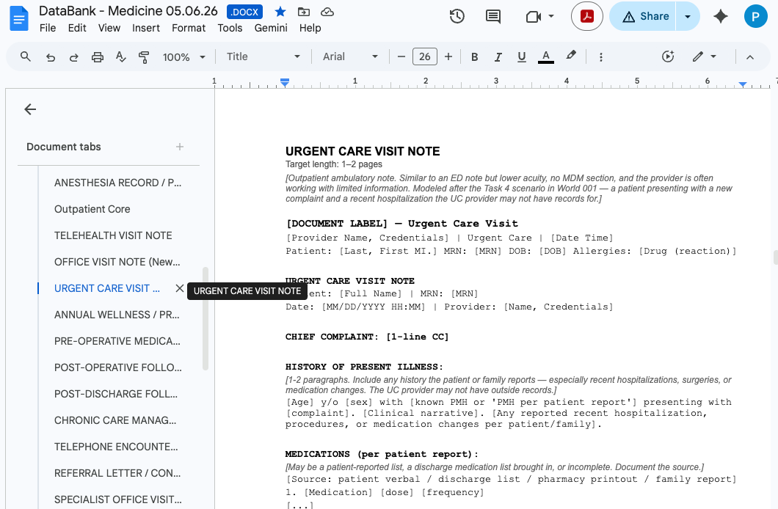

When you decide the types of world-level files that are needed to create your world, simply download them from the DataBank and upload them into the “Synthetic File Templates Folder” in your main World Drive Folder. Of course, you may modify each template as you see fit.

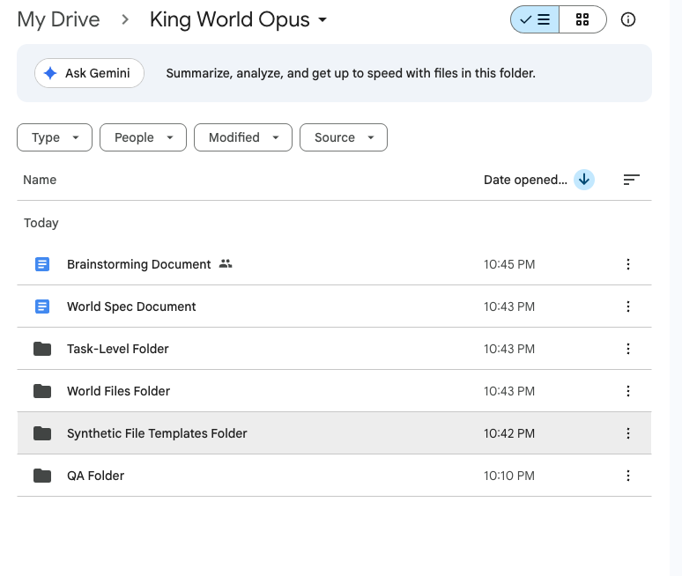

When filling out the tables in your World Spec, under the 'Reference File Origin' column
type the exact filename of the corresponding template in your Reference Templates folder.

See the template & reference guide for the canonical formatting (DataBank filenames, paired templates joined by a plus sign, Public Domain or Custom made annotations).

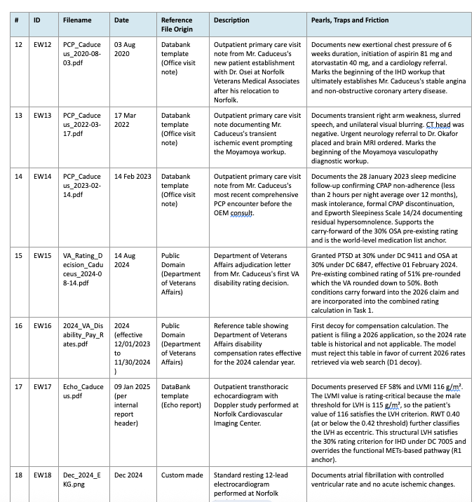

Below are examples of text-based files generated by our writers and engineering team (e.g. from Databank template, public domain, and custom made).

a

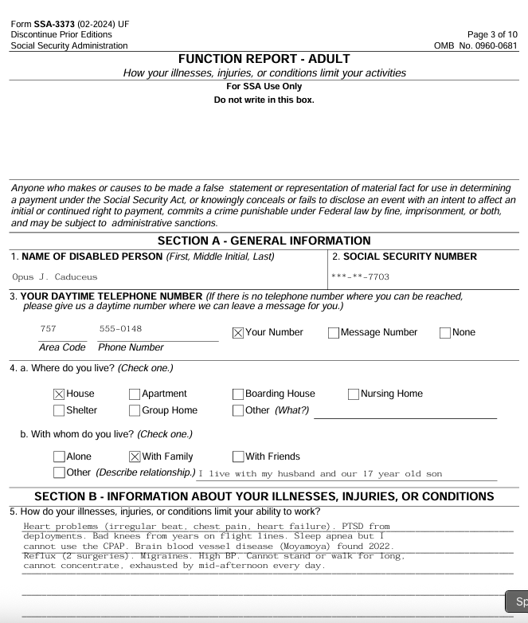

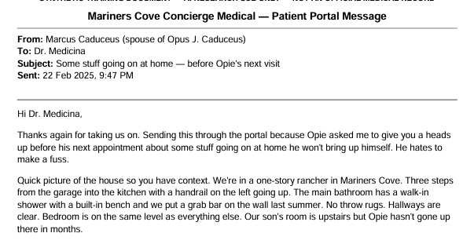

📷 Image-based files
If you want to generate a photo using NanoBanana Pro or ChatGPT, you may feel free to do so. However, ensure that you are generating high-fidelity images —this may require feeding the model a comprehensive vetted prompt prior to image generation.

Below are examples of Ai-generated images from World 004.

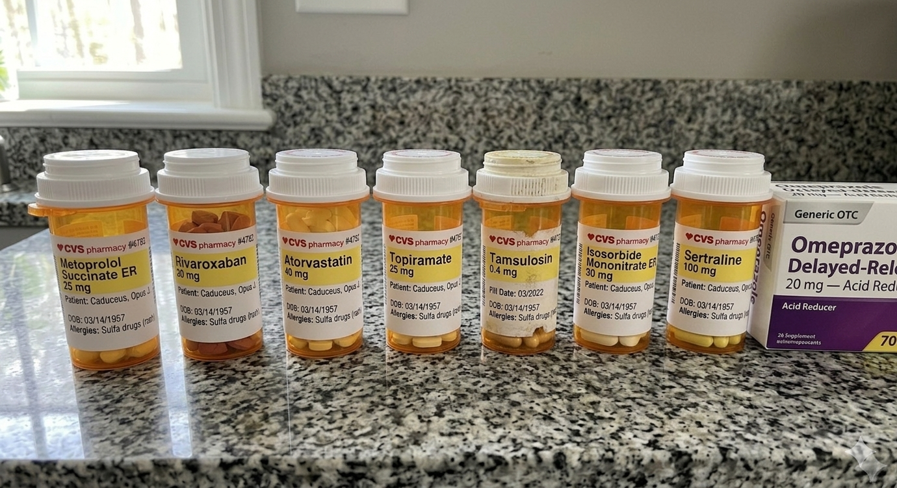

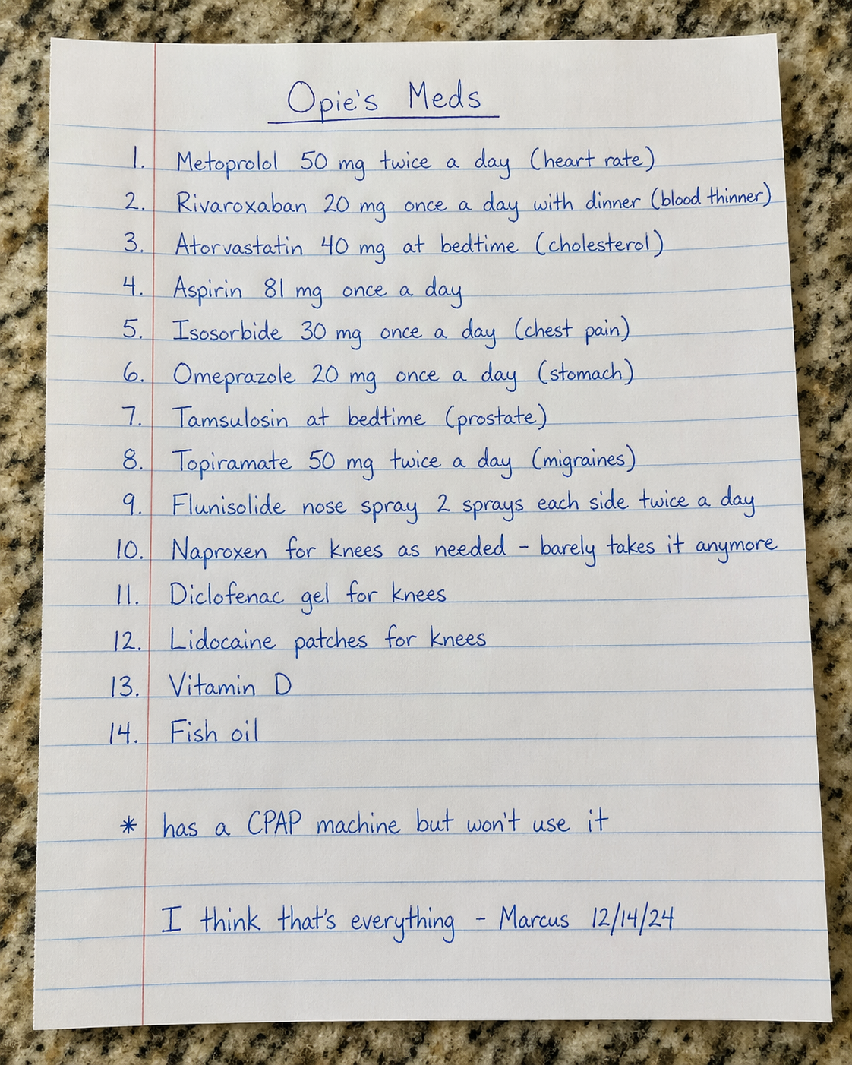

🌐 Public Domain Files
While public-domain images are permitted, please ensure all embedded metadata is scrubbed prior to submission. A simple method is to capture a screenshot of the asset (using Snipping Tool or Cmd+Shift+4) and utilize that version. To maintain compliance, avoid copying and pasting directly from web sources.

We recommend sourcing images from reputable medical or educational repositories. This includes governmental and academic bodies (e.g., NIH, CDC, WHO) or established open-access platforms like Life in the Fast Lane (LITFL) and Radiopaedia, provided the specific file is licensed for reuse.

Assets must be verified for reuse (e.g., public domain or Creative Commons). To ensure high-fidelity compliance, verify the licensing terms on the source site—specifically searching for labels such as “public domain” or “CC BY-SA.” If the licensing status is ambiguous, please refrain from using the image.

When in doubt, err on the side of caution and select an alternative source.

Examples of public domain images used in accepted worlds:
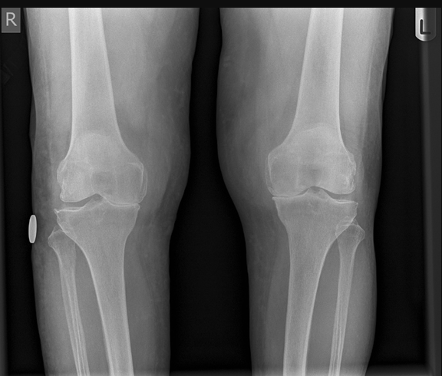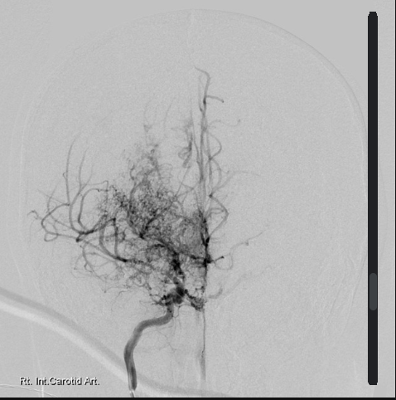

💾 Custom Data Generators

Custom Clinical Data Generators
Video Tutorial 👉 006 Creating World & Task-level Files w/ Data Simulators - TBD**

To help you create high-fidelity clinical data without using real patient information, we have developed and curated a set of custom synthetic data generators. These browser-based tools allow you to generate publication-quality mock clinical documents and waveforms for your world file sets.

Tool | What It Generates | Use Case | Link
EEG Simulator | Synthetic EEG tracings with configurable montages, waveforms, and abnormalities | Neuro, epilepsy, ICU, and status epilepticus scenarios | EEG Teaching Sim
EKG Simulator | 12-lead EKG tracings with configurable rhythms, intervals, and pathology | Cardiology, ED, pre-op, and inpatient scenarios | EKG Simulator  MedData EKG Simulator 2 (4th Tab)
EFM Simulator | Electronic fetal monitoring strips with configurable patterns and decelerations | OB/GYN, L&D triage, and intrapartum monitoring scenarios | EFM Simulator (OB/GYN)
Ventilator Simulator (Option 1) | Ventilator waveform displays with configurable modes and parameters | ICU, pulmonary, respiratory failure, and ventilator management scenarios | RT Maven Vent Sim
Ventilator Simulator (Option 2) | Alternative ventilator parameter and waveform generator | ICU, pulmonary, and weaning protocol scenarios | MedData Vent Sim(tab 5)
Lab Report Simulator | Formatted laboratory reports with configurable values, reference ranges, and panels | Any scenario requiring realistic lab documentation | MedData Lab Sim (tab 1)
Radiology Report Simulator | Structured radiology reports with configurable findings, impressions, and recommendations | Any scenario requiring imaging reports (CT, MRI, X-ray, Ultrasound) | MedData Radiology Sim (tab 2)
Sample Lab Reports (Reference) | Real-world lab report formatting and reference ranges from LabCorp’s test menu | Reference for formatting and normal ranges when building custom lab files | LabCorp Test Menu
Live Patient Monitor | Heart rate, blood pressure, spO2, EtCO2, respiratory rate, arterial line blood pressure | Any scenario requiring vital signs | MedData Patient Monitor Tab 3

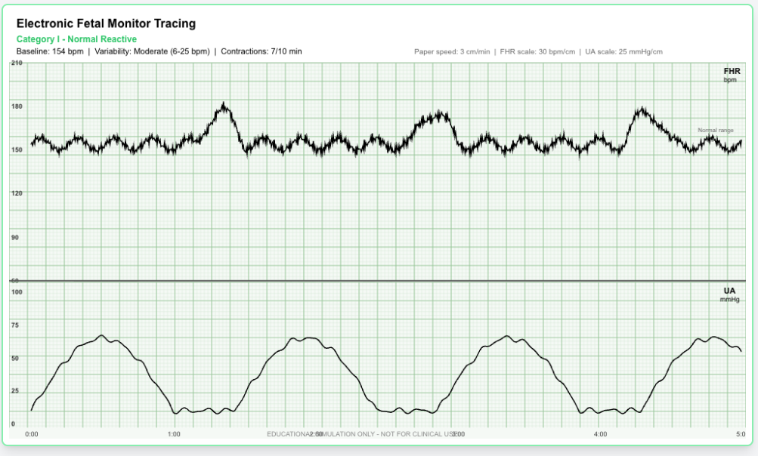

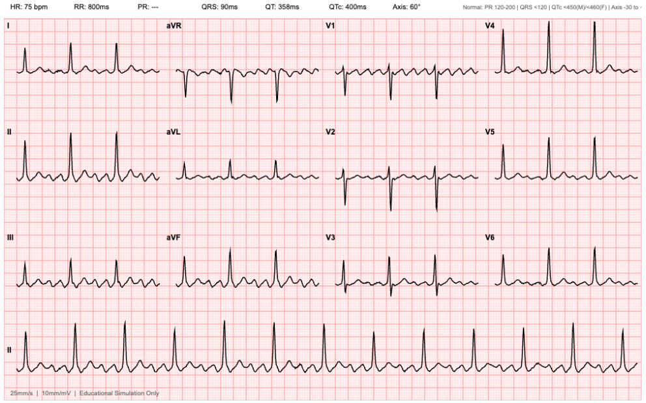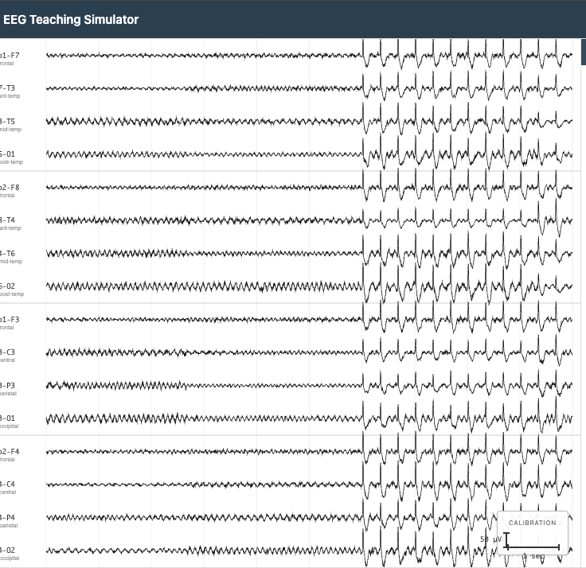

How to Use the Generators in Your Workflow
- Identify the clinical data needed. Review your World Spec and task prompts. What documents would realistically exist at each task’s timepoint?
- Configure the simulator. Open the appropriate tool and set parameters to match your patient’s clinical scenario.
- Export and annotate. Export the generated file. Add a text-based interpretation or report that accompanies the visual data.
- Embed traps in the data. Clinical data files are prime trap locations (e.g., a borderline prolonged QTc when the patient is about to start a QT-prolonging medication).
- Obtain approval for specialized files. Confirm with your team lead before including specialized waveform or imaging files.

Tool Use: Clinical Calculators & Real-Time Search
Some tasks should test whether the AI agent can appropriately use external tools as part of its clinical reasoning. Examples:
- Clinical risk calculators: A task requiring the agent to calculate a HEART score using data scattered across multiple documents.
- Drug interaction checks: A medication list with a subtle but clinically significant interaction the agent should flag unprompted.
- Real-time web search: A task where the correct answer depends on current clinical guidelines that differ from older guidelines embedded in the chart.
- Literature retrieval: A task requiring the agent to cite a specific clinical trial or guideline to justify a treatment recommendation.

Design principle: Tool use should never be the entire task — it should be one component of a larger clinical workflow. The agent should recognize when a tool is needed, use it correctly, and integrate the result into its clinical reasoning.

Only files and images available in the public domain are permitted for use. Please ensure all materials are free of copyright restrictions before using them.

💡 Additional info

Template/Reference File Additional Resources

Appendix A. How the pipeline works
This section explains the relationship between your templates and the synthetic files engineering produces.
The recipe analogy.
Think of your templates as recipes. You pick the right recipe for each dish on the menu (your World Spec). Some recipes come from a standard cookbook (the DataBank). Some you write yourself. Some are standard government forms. And a few items, like clinical photos or audio recordings, you prepare yourself because they require your domain expertise.
You hand your collection of recipes to a professional kitchen (engineering, via RL Studio). The kitchen produces realistic-looking dishes (synthetic clinical files) with real patient names, dates, and clinical language. The recipe stays generic; the dish is specific.

Appendix B. How file naming works
Your World Spec has two relevant columns for every file row:
- Filename.type = the FINAL synthetic filename engineering produces. Includes a datestamp. Example: ProgressNote.05.11.2023.docx
- Reference File Origin = where the template comes from. No datestamp. Example: DB_Progress_Note_Inpatient.docx

What you upload | ... | What engineering produces
ProgressNoteTemplate.docx | becomes | ProgressNote.05.11.2023.docx
FMLA_Form_DeptofLabor_Blank.pdf | becomes | FMLA_Form_Signed_08.11.2023.pdf
HogwartsHospital_Pre-OP_Template.docx | becomes | PreOp.Note.09.11.2025.docx
HandwrittenMedList.05.15.2019.png | unchanged | HandwrittenMedList.05.15.2019.png

Rule of thumb. If engineering will transform the file, your template name is generic (no date). If you finalized the file yourself and it will not change, name it with the final synthetic name (including date) from the Filename.type column.

Appendix C. Detailed Claude Project walkthrough

Setting up a Claude Project
A Claude Project is a workspace on claude.ai where you can save files and have ongoing conversations. If your pod lead set one up for you, open it and skip ahead.
- Go to claude.ai and sign in with your Mercor expert email.
- Click "Projects" in the left sidebar.
- Click "Create Project" or the "+" icon.
- Name it: World [Your World ID] Templates.
- Click into the project to open it.

How installments work
After you paste the prompt, Claude will read your spec and DataBank, then work through rows in batches of 3 to 5, pausing to check in with you between batches. Your job is to answer check-in questions promptly and accurately.

Example check-in
Claude says:
I have processed EW1 through EW3. Two items need your input. (1) EW4 is labeled "pre-op anesthesia note" with Reference File Origin set to "DataBank." I see two candidates: DB_PreOp_Anesthesia_Clearance.docx and DB_PreOp_Cardiac_Risk_Assessment.docx. Which one? (2) WS2 is marked Custom made (orthopedic post-op rehab protocol). Draft from scratch, or do you have a reference to paste?
You respond:
(1) Use DB_PreOp_Anesthesia_Clearance.docx. (2) Draft from scratch using a generic post-op rehab structure.

Self-QC checklist
- Every row in the World File plan tables has a matching file in your folder.
- Every file traces back to a row. No orphans.
- Template filenames match the Reference File Origin column (generic, no datestamp).
- Writer-produced filenames match the Filename.type column (final name, with datestamp).
- Media artifacts are finalized, not placeholder stubs.
- No stray, empty, or duplicate files.

4️⃣ World Summary

Section 4: World Summary
→ World Spec Template, Section 4: World Summary
This is the final section of your World Spec — a short wrap-up that captures what your World tests and why it's designed the way it is. Once Sections 1–3 are in place, the Summary is a 3–5 sentence anchor that orients any reader (or reviewer) to your World at a glance.
Section 4 lives at the very end of the World Spec, after the File Plan (Section 3). Claude can draft it from the rest of your Spec — your job is to confirm it captures the design rationale and reads cleanly.
⚠ 3–5 sentences. Resist the urge to over-write. The World Summary is not a re-statement of your Big Picture Summary (1.1). 1.1 describes the patient and clinical context; Section 4 describes the world design — what your tasks collectively test, what makes the trap architecture work, and why this world is hard for an AI agent to navigate.

Claude can draft Section 4 from your Sections 1–3. Your job: confirm it captures the design rationale.
What | Claude does | You do
Drafting the summary | Drafts 3–5 sentences synthesizing Sections 1–3 | Confirm it captures what your World tests + why the trap architecture works
What the world tests | Pulls from your Section 2 tasks (workflow mix, task types) | Verify it accurately reflects the breadth of clinical reasoning your tasks demand
Why traps work | Identifies trap architecture patterns from Section 2 Failure Design + Section 3 file plan | Verify the trap rationale is captured — not just the trap list
Why it's hard for AI | Articulates from your Complexity Overview (1.5) + Failure Design | Confirm it speaks to AI-specific difficulty, not just generic clinical complexity

What the World Summary should cover
A 3–5 sentence paragraph that answers three questions:
- What clinical or regulatory reasoning does this world test? (medication reconciliation under cascading complications / VA disability nexus reasoning / multi-specialty discharge coordination / etc.)
- What makes the trap architecture effective? (cross-document reasoning required / specialist friction with attending resolution / temporal contamination / etc.)
- Why is this world hard for an AI agent to navigate? (information distributed across 25 files / no single source of truth / requires synthesis across timeline)

Example (from World 004)
"This world tests an OEM physician's ability to render VA disability nexus opinions across 38 years of fragmented service and clinical records. The trap architecture works through (1) cross-document reconciliation across DD-214s, STR extracts, and PCP visit notes spanning 2008–2023; (2) coding-system friction between ICD-10, VASRD, and ICD-11 classifications; (3) regulatory ambiguity between 38 CFR and PACT Act presumptive criteria. Together, the 8 tasks force the agent to reason across a fragmented, multi-decade chart and apply specialty-specific regulatory logic — work that's hard for AI because reasoning depth, document breadth, and source-of-truth ranking are all in tension."

👣 How to Self-QC World Spec

How to Self-QC Your World Spec Document
Description: This is the QA workflow BEFORE your world-level materials are uploaded to RL Studio. The purpose is to spot check the quality of your deliverables prior to moving on to the next step. At this particular stage, we will focus on the QA/QC of your World Spec document

🔑 Summary of Key Steps 👣

Step 1: Start a new chat on your Claude Project



Step 2: Copy/paste the following prompt

[Please use the QC checklist I uploaded to review my [World Spec Document]. Walk through every check, give a verdict on each, and flag the Blockers first, then the Majors, then the Minors. Note: Ensure that "tasks" are taking place after the last documented event in the "world". This is to ensure temporality that is consistent with project guidelines. This is a non-negotiable.]

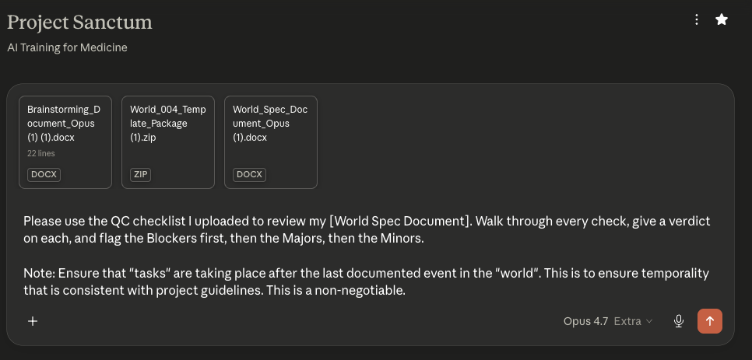

The deliverables that you may QC throughout the production pipeline include the following:
- Brainstorm document
- World Spec document
- World Spec Files (all of them should be QC’d in tandem)
- Task Prompts*
- Golden Response*
- Grader Guidelines*

⚠️NOTE: Remember that the *task prompts, *golden responses, and *grader guidelines have to be written by YOU and not the LLM. You may run a QC after you have written them but you may not ask Claude to write them for you from scratch.

Step 3: Attach your deliverable + the corresponding AutoQC file/s

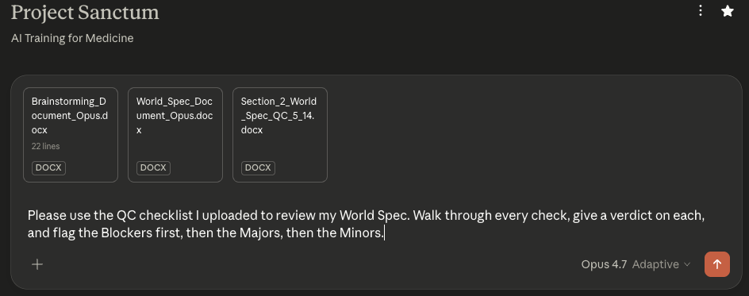

Your Deliverable | Corresponding AutoQC Prompt File/s  +  Supplemental documents
World Spec document | AutoQC_Section_2_World_Spec_v6.6_writer.docx  +  Your Brainstorm document  +  Your templates/reference files

6️⃣ World Spec Studio AutoQC

World Spec Studio AutoQC
Video Tutorial 👉 002 Uploading World Spec/Template Files/Claude Transcript + AutoQC - Pt. 1 & Pt. 2

Once your brainstorming document is approved, the task status becomes Ready for Spec Drafting.

Step 1: Start the stage
- Click into the task.
- You'll now see your approved brainstorming document from the previous stage available for reference, plus an option to upload a World Spec document.
- Click Start Spec Drafting.

Step 2: Upload World spec and template/reference files
- Upload your World Spec document.
- Upload any template/reference files needed for the spec (used by the engineering team to create synthetic files for your world).

Step 3: Run AutoQC (again, and seriously this time)
Run the spec-stage AutoQC. This one is particularly reliable — if there are issues here that you don't address, you will almost certainly receive reviewer feedback about them. Save yourself the round-trip:
- Work through every flagged issue.
- Re-upload and re-run AutoQC until clean (or you have documented disagreement).
- Mark diagnostics reviewed.

Step 4: Submit for spec review
Submit. The review process is identical to Stage 1:
- Ready for Spec Review — waiting
- In Progress — reviewer is working on it
- Approved — move to pipeline stage
- Needs Fixes — click Start Spec Fixes

Step 5: Handling spec fixes
When fixes are needed, the fix view shows both the planning-stage feedback from Stage 1 and the current spec-stage reviewer feedback. Work through them, upload your updated documents, run AutoQC, and resubmit.

That completes the workflow for onboarding!

Quick Reference: Task Statuses
Status | What it means | What you do
Plan Drafting | You're working on the brainstorm | Upload, run AutoQC, submit
Ready for Plan Review | Submitted, waiting | Wait
Plan In Progress | Reviewer is working on it | Wait
Needs Plan Fixes | Reviewer has comments | Start Plan Fixes, address feedback, resubmit
Ready for Spec Drafting | Plan approved | Start Spec Drafting
Spec In Progress / Needs Spec Fixes | Same pattern as plan | Same pattern as plan
Spec Doc Approved | Ready for a Pod | Wait for EPM

Things That Will Save You Time
- Run AutoQC at every stage. It catches the exact issues reviewers will flag.
- Address every valid AutoQC item before resubmitting. Re-run AutoQC after edits to confirm.
- Document any AutoQC items you disagree with. A short note is enough.
- Follow the naming conventions from the onboarding guide when setting up workspaces.
- Keep feedback in RL Studio as the source of truth, but use Slack with your reviewer for fast clarification.
- Ask in Slack if anything is unclear. New writers especially benefit from working closely with their reviewer.

7️⃣ Synthetic Generation Pipeline

World File Generation and Editing Overview
Here is the full sequence from start to finish for creating the world files.

Synthetic generation:
The world spec you created is fed into a synthetic generation pipeline that will make the world files based on your templates.
File editing:
You take the files that were created and review them along with the AutoQC results. You edit the files to address AutoQC flags and to clean up anything that stands out as off to you. Remember, these files will be the foundation of all of your tasks, so it’s important to ensure they are really strong! They must support the tasks you plan to create.
Quick checklist for reviewing files:
- Verify clinical content (dates, names, doses, consistency across documents).
- Confirm intended trap content survived generation.
- Identify and correct any new inconsistencies or errors.

Upload revisions:
Upload all the files (edited and unedited) to Studio. Make sure to remove any task files during this process. Any files uploaded will be in your finished world, so if you leave task-level files, you will run into errors during tasking.

Final QC and world creation:
Run a final file AutoQC over your newly revised world files. If you see any legitimate flags, you will have to do another round of editing to address them. Check with your reviewer if you are unsure if AutoQC flags are valid or not. It is important to make sure you are 100% confident in your world files before continuing!

Once your files are good to go, you can finalize and create your world! Please name your world according to the following format: “Healthcare_[Patient Last Name]_[###].” For the ###, pick the next number available based on the number of worlds in Studio.
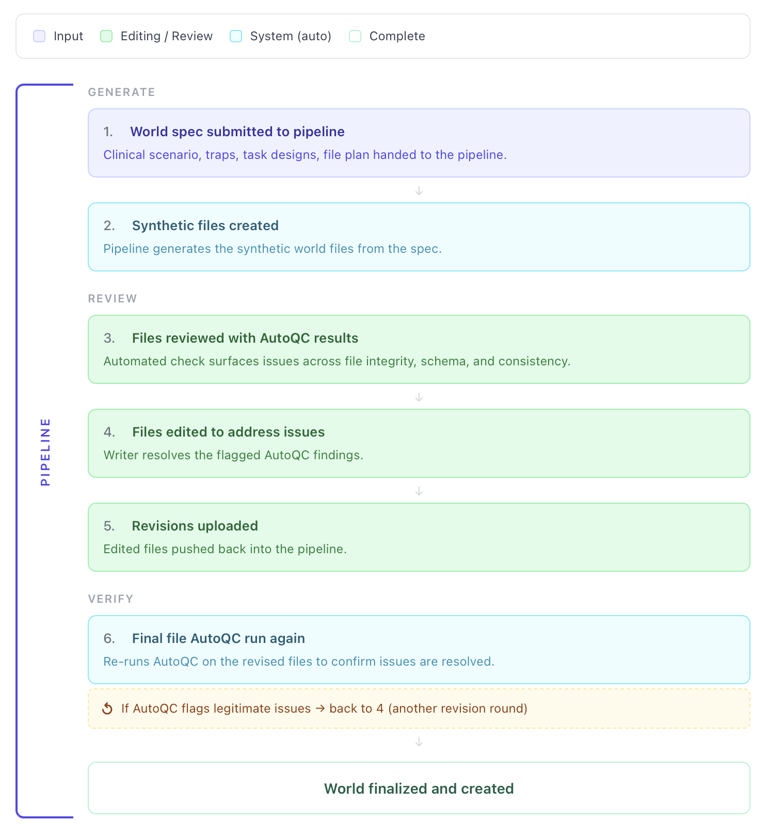

👣 How to Edit World Files

How to Edit Your World-Level Files

Pipeline File Editing in Studio Tutorial

👉 MUST WATCH: How to edit files in RL Studio - Recording
Bonus videos: 👉 003 Review of Files from Engineering Pipeline - Pt. 1 & Pt. 2

Overview
Once your pipeline finishes running, the task moves to the Pipeline Fixes stage. From here you review the generated world files, make edits, upload your revisions, and finalize the world. The full flow is:
- Open the completed pipeline run and download the generated files
- Review the files and AutoQC flags, then fix any issues
- Upload your revised files as a folder
- Describe and save the revision
- Apply the revision to the task
- Run the Final Files AutoQCs and finalize the world
- Generate the world

🔑 Summary of Key Steps 👣

Step 1 — Start Pipeline Fixes
Open your task with the status Ready for Pipeline Fixes, then click Start Pipeline Fixes.
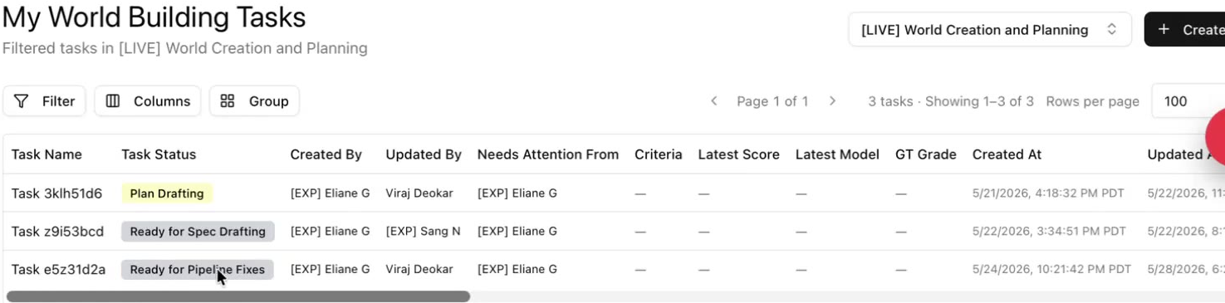

Step 2 — Open the Pipeline Run
Scroll to the bottom to the 3.1) Run Pipeline section. If your pipeline ran correctly, you will see a completed run. Click into the run to view your generated files.
Do not re-run. Only click Run Pipeline if something was erroneous with your run — a new run takes ~46 hours. If the run did not complete correctly, contact your reviewer instead.
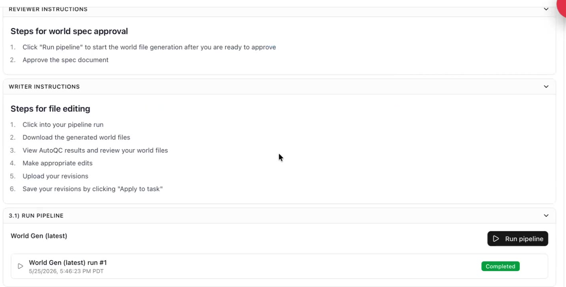

Step 3 — Download the Generated Files
On the run page, open the Output tab. You will see two folders:
- filesystem — all of your world files (this also includes any task-level files you added to the spec doc).
- .meta — pipeline bookkeeping; you do not edit these.
Click Download All to download a zip, then unpack it on your computer to review the files individually.
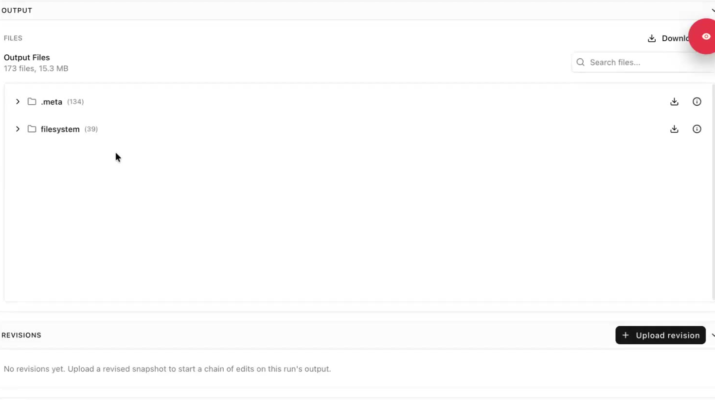

Step 4 — Review Files & AutoQC
AutoQC runs automatically when the pipeline finishes. Review every file and the AutoQC results. For each file ask:
- Does it look realistic?
- Are there any obvious outstanding issues?
- Did AutoQC flag anything problematic?
Fix any problematic issues. If you are unsure how, ask a team member in Slack. Refer to the instruction document for the exact review criteria. World files are critical to successful tasks — a weak world makes tasking very difficult, so spend real time here.
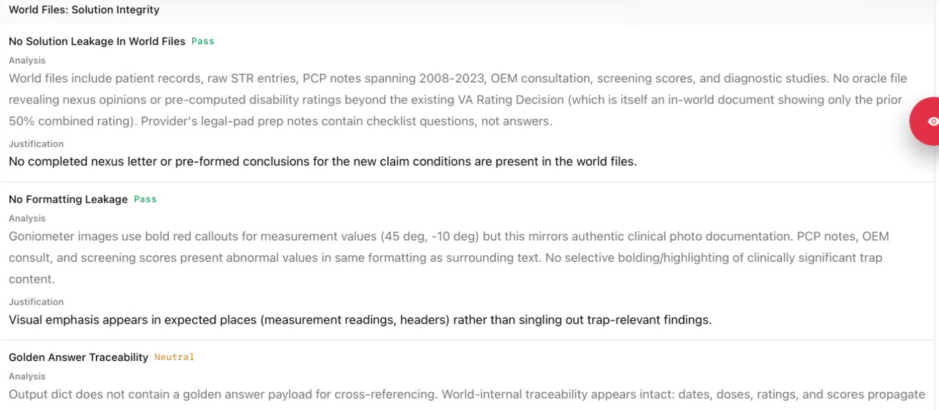

Step 5 — Upload Your Revisions
Back on the run page, click Upload revision. In the dialog, use Add folder — not Add files.
Upload as a folder. You must upload a folder, not individual files, or you will get an error. Only files under filesystem/ are included.
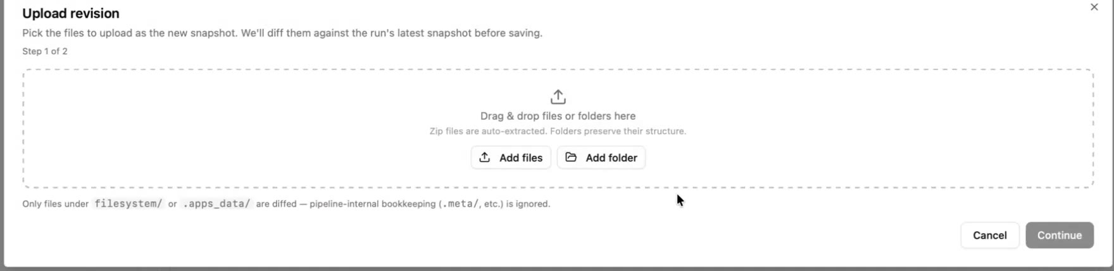
Recommended process:
- Edit the files directly inside the downloaded filesystem folder (keep a backup if you like — the originals always remain in the pipeline run).
- Remove all task-level files and store them elsewhere.
- Upload the entire filesystem folder.
Remove task-level files. Task files must be removed at this stage. If they stay in your world files, the answer to the task will be present in the world — causing major issues during tasking.
Include all world files. Every world file must be uploaded. Missing files will throw missing-file errors and won't appear in the final world.
You can confirm you uploaded a folder when each entry shows the filesystem/ prefix. If you don't see it, you uploaded an individual file and will get an error. Click Continue.
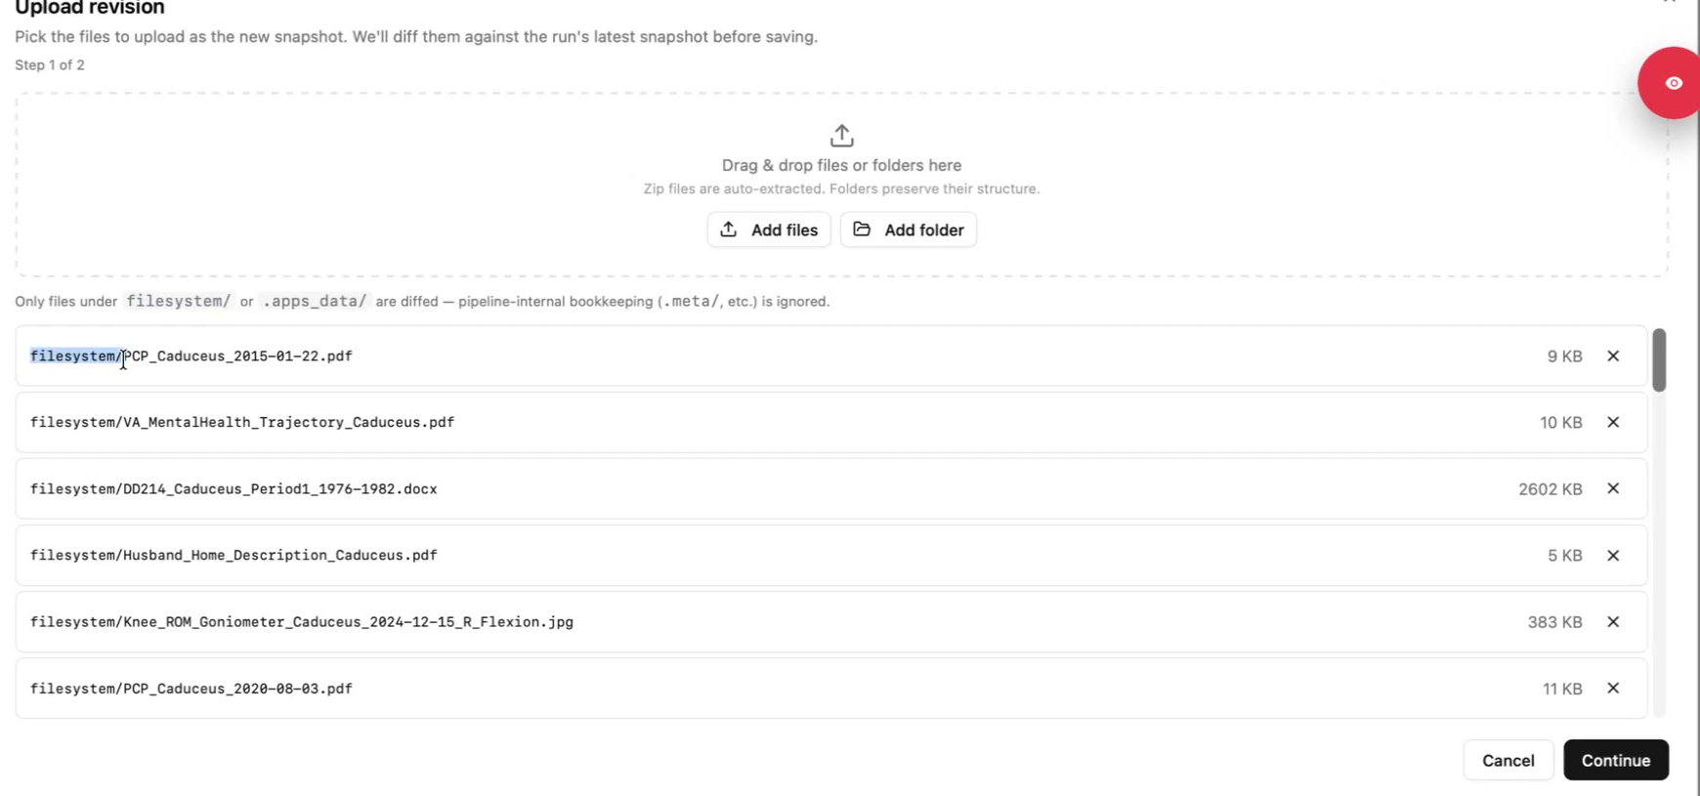

Step 6 — Describe the Revision
The system shows the diff between your revision and the run — added, deleted, and modified files. A comment is required for every changed file:
- For removed task-level files, a short note such as “task level file” is fine.
- For modified files, briefly explain what you changed. Keep it to a couple of lines.
Add a Title for the revision so it's easy to track, then click Save revision.
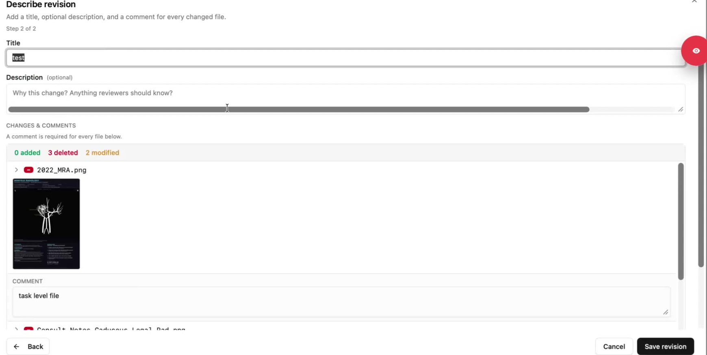

Step 7 — Apply to Task
Review everything one last time, then under Actions, click Apply to Task.
This step is mandatory. If you don't click Apply to Task, the revision stays only on the Pipelines page and your task's world files won't update — you won't be able to finalize the world.
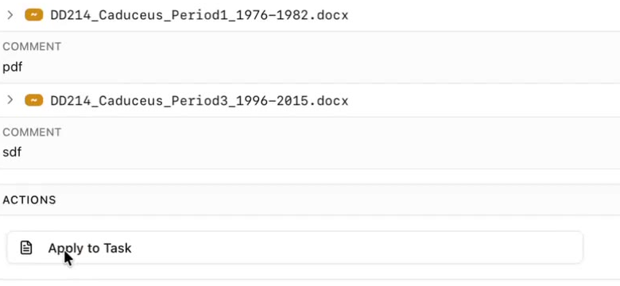

Step 8 — Verify the Files Were Applied
Go back to the task. Confirm the revision was applied: the run shows the diff, and your world files are populated under 4.1) Golden World Files.
- If the file list is empty, your files were not uploaded correctly.
- If the file count differs from your revision (e.g. it still shows the old count), you forgot to Apply to Task.
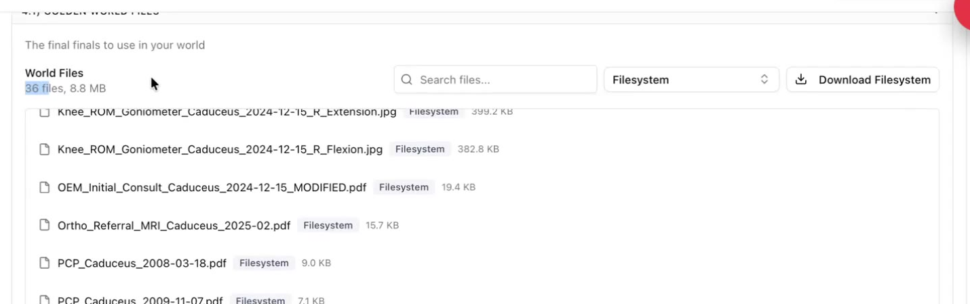

Step 9 — Run the Final Files AutoQCs
In 4.2) Final Files AutoQC, run all four checks (Integrity, Clinical, Consistency, Standards). These are the same AutoQCs the pipeline run generated, so if you addressed everything earlier you should clear them.
- Address every flag, or note clearly why a flag is a false positive.
- Write your notes in 4.3) Final Files AutoQC Comments.
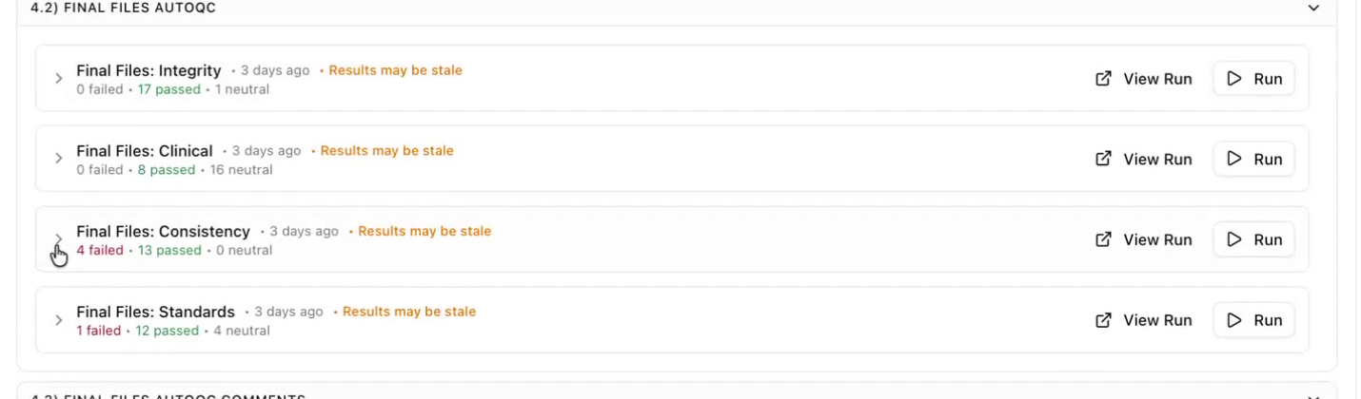

Step 10 — Mark World as Finalized
Once all AutoQCs are run and reviewed and your comments are written, click Mark World as Finalized and confirm.
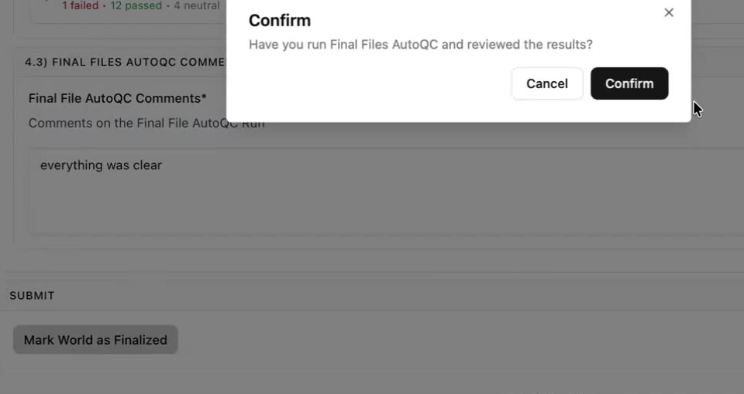

Step 11 — Generate the World
Go to Part 5: Applying to World → 5.1) Run Automation and click Run. Name your world following the conventions in the instruction document, then click Run again.
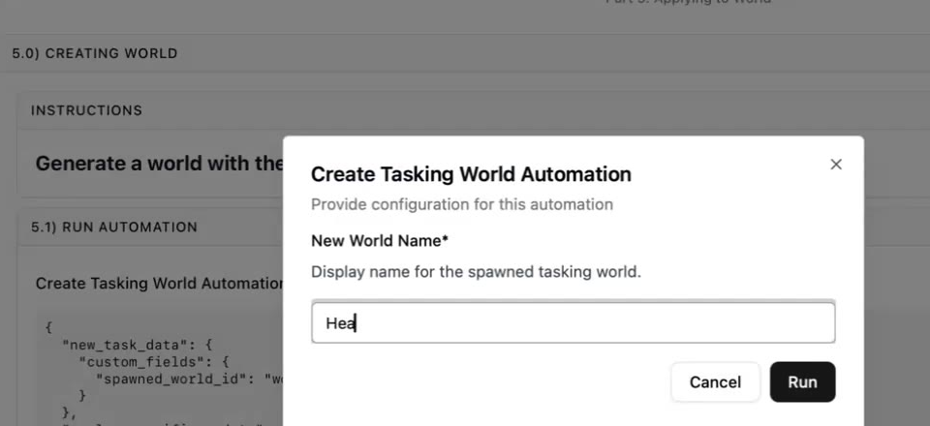
Your world is now created and moves to the World Created stage — you've completed this phase and are ready for tasking. If you're new, you'll be moved to a pod to create tasks with your colleagues.

👣 How to Self-QC World-Level Files

How to Self-QC Your World-Level Files

Description: This is the QA workflow BEFORE your world-level materials are uploaded to RL Studio. The purpose is to spot check the quality of your deliverables prior to moving on to the next step. At this particular stage, we will focus on the QA/QC of your World-level Files (+World Spec)

🔑 Summary of Key Steps 👣

Step 1: Start a new chat on your Claude Project



Step 2: Copy/paste the following prompt

[Please use the QC checklist I uploaded to review my [World-Level Files]. Walk through every check, give a verdict on each, and flag the Blockers first, then the Majors, then the Minors. Note: Ensure that "tasks" are taking place after the last documented event in the "world". This is to ensure temporality that is consistent with project guidelines. This is a non-negotiable.]

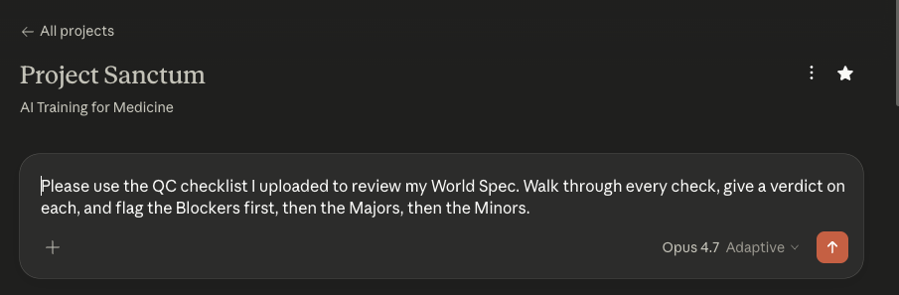

The deliverables that you may QC throughout the production pipeline include the following:
- Brainstorm document
- World Spec document
- World Spec Files (all of them should be QC’d in tandem in a zipped folder ideally)
- Task Prompts*
- Golden Response*
- Grader Guidelines*

⚠️NOTE: Remember that the *task prompts, *golden responses, and *grader guidelines have to be written by YOU and not the LLM. You may run a QC after you have written them but you may not ask Claude to write them for you from scratch.

Step 3: Attach your deliverable + the corresponding AutoQC file/s

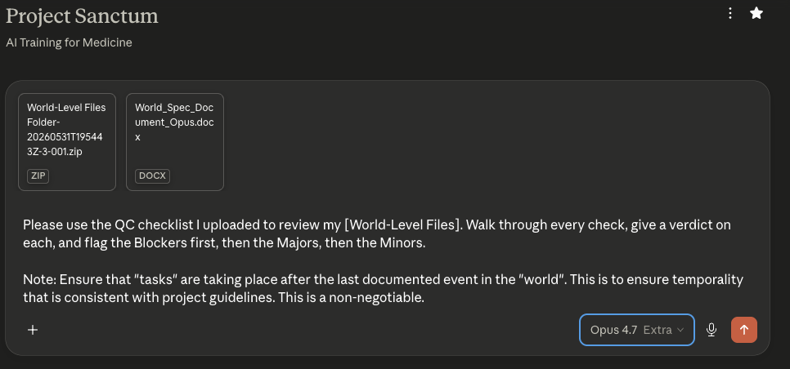

Your Deliverable | Corresponding AutoQC Prompt File/s  +  Supplemental documents
World-level files  (all of them in a zipped folder) | AutoQC_Section_3_World_Files_v6.6_writer.docx  +  Your World Spec document

🛑 ONBOARDING ENDS — NEW WRITERS STOP HERE
🛑 ONBOARDING ENDS —

NEW WRITERS STOP READING HERE

If you're a new writer, stop reading at this point.

Your next steps:
- Submit your Brainstorm and World Spec for review
- Wait for sign-off from your assigned lead / reviewer

Once you're approved, return to this guide and continue reading from Phase 2 onward. That's where you'll learn how to build files, write tasks, run the agent, QA, and complete the evaluation deliverables as a veteran writer.

✍️ Phase 2: Build Your Tasks

Phase 2: Build Your Tasks

Before you start
Phase 2 assumes you have already completed Phase 1. That means you have an approved World: a self-contained file environment built around a realistic clinical scenario, with documents grouped by clinical phase and organized into essential and supplementary files. Your World is now frozen — its files do not change between tasks.
You will build 8+ tasks you designed by adding golden response and grader guidelines. All of this work happens in RL Studio — the platform where you build, test, and submit your tasks.
This phase walks through each step in the order you will encounter it.

Components of a Built Task
Component | What It Is
Task prompt | The written instruction the agent receives. This should read like a real clinical request — the kind of assignment a clinician would actually give or receive in practice. It tells the agent what to do, for whom, and what deliverable to produce. You should have your task prompts created when filling out the World Spec Doc.
Golden response | A complete, correct output that you write yourself. This is the benchmark the Agent Grader uses to evaluate the agent's work, and the reference point reviewers use to assess your task's quality. It should be at the level you would sign and place in a chart.
Grader guidelines | Natural language instructions that tell the AI grader how to evaluate the agent's output. This is not a rubric with binary checkboxes. It is a set of directions that help the grader understand what matters, what is wrong, and what variation is acceptable within clinical practice.

👣 How to Self-QC Your Task Prompts

Ey How to Self-AutoQC Your Task Prompts
Description: This is the OPTIONAL informal QC workflow you can run inside Claude Project BEFORE uploading any deliverable to its corresponding AutoQC gate in RL Studio. The purpose is to spot check the quality of your deliverables in advance and catch issues before they show up as RL Studio audit items. Informal QC in Claude Project is ENCOURAGED but not required; the formal QC of record now lives entirely in RL Studio.

🔑 Summary of Key Steps 👣

Step 1: Start a new chat on your Claude Project

Step 2: Copy/paste the following prompt

“Please use the QC checklist I uploaded to review my [Task Prompts]. Walk through every check, give a verdict on each, and flag the Blockers first, then the Majors, then the Minors. Note: Ensure that "tasks" are taking place after the last documented event in the "world". This is to ensure temporality that is consistent with project guidelines. This is a non-negotiable”

Step 3: Attach your deliverable + the corresponding AutoQC file/s

Your Deliverable | Corresponding AutoQC Prompt File/s  +  Supplemental documents
Task prompts  (compile in 1 document/pdf) | AutoQC_Section_4_Task_Prompts_v6.6_writer.docx  +  Your World Spec document  +  Your world-level files (in a zipped folder)

🏅 Golden Response

Golden Response
💡The golden response is your gold-standard correct answer — what a senior, board-certified physician would produce in response to the task prompt.
It serves two purposes:
- It is the benchmark the Agent Grader uses to evaluate the agent's output
- It is the reference point for reviewers assessing the quality of your task.
Your golden response should be at the level you would feel comfortable signing your name to — clear, complete, accurate, and appropriately scoped for the deliverable the prompt requests. Every element the prompt asks for must appear in the golden response, and everything in the golden response must be responsive to what was asked.

Writing the golden response
Write the golden response yourself, sequentially following the order of requests in your prompt. For a discharge summary, that means writing the discharge summary. For a medication reconciliation, that means producing the medication list with annotations. Match the format, length, and audience the prompt implies — a handoff note to a covering resident reads differently from a formal consult note to a specialist.
⚠ IMPORTANT: The golden response should NOT be AI generated. This should come from you and your clinical expertise. Same goes for the grader guidelines and task prompts, which should only come from you and should NOT be AI generated.

A few practical principles worth keeping in mind

No agent output should be better than your golden response in any respect.
If you review a trajectory and find that the agent's analysis is more thorough or better reasoned than yours on any point, improve your golden response before proceeding. The golden response sets the ceiling. If an agent exceeded it, the ceiling was too low.
Placeholders are preferable to fabrication.
When source documents genuinely do not contain information needed for an element of the response, the correct behavior is to use an explicit placeholder — e.g., "[No documented baseline weight available]" — not to fabricate a plausible value. Your golden response should model this: if the world files do not support a specific finding, acknowledge the gap rather than filling it in.
Calculations must be unambiguous.
If your golden response includes numerical values, the prompt should specify the rounding convention, and the golden response should follow it consistently. Specify units throughout. If there are multiple valid conversion paths (different currencies, different weight units), the prompt must be unambiguous about which to use, or the grader guidelines must accommodate both.
Your golden response must be consistent with your grader guidelines.
You will write the grader guidelines after the golden response. Once they are written, verify that your golden response would receive full marks under your own guidelines. If it would not, either the golden response is incomplete or the guidelines are asking for something the prompt does not require. Resolve any misalignment before submission.
⚠ A bad golden response is worse than no golden response. The Agent Grader uses it as a benchmark. If it contains errors, unusual structure, or omissions, the grader will adopt those as the standard. Review your golden response with the same care you would apply to a trainee's first draft.

See examples of golden response in appendix: example library → golden response example 1, golden response example 2

👣 How to Self-QC Your Golden Responses

How to Self-AutoQC Your Golden Responses

Description: This is the OPTIONAL informal QC workflow you can run inside Claude Project BEFORE uploading any deliverable to its corresponding AutoQC gate in RL Studio. The purpose is to spot check the quality of your deliverables in advance and catch issues before they show up as RL Studio audit items. Informal QC in Claude Project is ENCOURAGED but not required; the formal QC of record now lives entirely in RL Studio.

🔑 Summary of Key Steps 👣

Step 1: Start a new chat on your Claude Project

Step 2: Copy/paste the following prompt

“Please use the QC checklist I uploaded to review my [Golden Responses]. Walk through every check, give a verdict on each, and flag the Blockers first, then the Majors, then the Minors.”

Step 3: Attach your deliverable + the corresponding AutoQC file/s

Your Deliverable | Corresponding AutoQC Prompt File/s  +  Supplemental documents
Golden responses  (compile in 1 document/pdf) | AutoQC_Section_5_Golden_Response_v6.6_writer.docx  +  Your World Spec document  +  Your world-level files (in a zipped folder)  +  Your task prompts  +  Your task-level files

🧑‍🏫 Grader Guideline

Grader Guidelines
💡Grader Guidelines are the natural-language instructions you write that tell the Grader Agent (a separate AI model) how to evaluate the AI Agent's attempt at your task against your Golden Response.

The goal is to produce a score that a domain expert would agree with, consistently, across many runs. The grader should behave the way a senior reviewer would: read the output, form a judgment, identify what matters, and explain why the score is what it is.
Guidelines exist because holistic judgment alone produces inconsistent scores. The same errors get weighted differently run to run without structure to anchor the grader. The right structure is not a rigid rubric — it is a framework that tells the grader what is non-negotiable, what is allowed to vary, and what patterns to watch for, then asks the grader to assign a holistic score (%) that represents how well the output did against your golden response and grading guidelines.
⚠ IMPORTANT: Current guidance is to not spend a significant amount of time/effort on Grader Guidelines (e.g. aim for <1 page). Consider the examples listed here as more illustrative and educational rather than prescriptive. Many of the sample Grader Guidelines are 2-3 pages long and have very detailed paragraphs.
Per the 04/26/2026 Office Hours guidance, our client would prefer we spend more time perfecting golden responses vs. perfecting grader guidelines.
This document will always be the most updated guideline, so if there is a discrepancy between previous examples and this document, please refer to this document.

The Recommended Structure
 | Preamble  - 1-2 sentences framing the deliverable: what the task is, who the physician-author is, what inputs they had, and what the output is. Also name the reference golden file name verbatim (e.g. CBC_04012025.pdf). Do not provide a hyperlink.
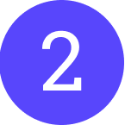 | Register note (optional but recommended)  - 1-2 sentences naming the realistic clinical voice and acknowledging it as a consideration rather than a hard criterion. Prevents the grader from penalising authentic physician shorthand or rewarding over-polished prose.
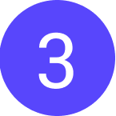 | Section A — Non-negotiables  - Prose describing what is strictly required for the output to count as a competent attempt at the task — the anchor clinical items, cross-source reconciliations, safety elements, scope-of-practice framing, or other content whose absence makes the output wrong regardless of everything else. These are the items a senior reviewer would identify as the central things the task is actually testing. Section A carries the clinical accuracy weight of the guideline.
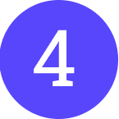 | Section B — Scope, format, and what legitimately varies  - Prose describing the appropriate scope, length, register, and structural options. Names what varies legitimately (format choices, ordering, labeling) and what does not (audience, scope, required content). Includes the fabrication framing and format-penalty guidance.
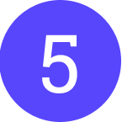 | Section C — Common failure modes (illustrative, not exhaustive)  - Prose describing patterns observed in practice, with explanation of why each pattern matters. Must be explicitly framed as patterns to reason about, not items to tick off. The grader must not treat this list as a rubric or reason away an error because it does not appear here.

Prose over bullets. Inside each section, favor flowing paragraphs over bulleted checklists. Bullets read as "tick these boxes"; prose reads as "reason like a senior reviewer." The grader follows the register you set. If a section reads as a rubric, the grader will behave like a rubric is in use — compressing scores and missing errors the rubric did not anticipate.

Scoring:
After you upload your golden response and grader guideline into RL Studio, you will see a __% score for each trajectory that you end up running on Taiga. This score represents the overall performance of the model’s output against your grading guidelines and golden response.

Generally speaking, a score of <70% means you did a decent job stumping the model while a score of >70% indicates that your task may be too easy for the model.

That being said, you still need to carefully review the actual model output and decide for yourself if the scoring given makes sense. For example, a surgical procedure note task that scores 90% but misses 1 step out of 10 steps that can arguably lead to infection and post-surgical complications should be taken with a grain of salt.

NOTE: As of June 4th, 2026, we are no longer using “scoring bands” in our grader guidelines. Please flag any inadvertent mentioning of it here in our instruction document and onboarding materials.

See examples of grader guidelines in appendix: example library → grader guidelines example 1, grader guidelines example 2

Writing Guardrails (Sections A and B)
A golden answer is always included. It gives the grader a concrete reference for judgment-based dimensions — scope, depth, audience, appropriate length. Its usefulness depends entirely on how the guardrails are written.
- Use the labeled A/B/C structure, not a single instruction. A grader that receives undifferentiated guidance will treat format preferences and clinical errors as equivalent. Section A carries the clinical accuracy weight. Section B carries the scope and register calibration. Section C carries the pattern library.
- Task-specific direction, not generic permissions. Open-ended instructions such as "there are multiple valid ways to complete this task" give the grader permission to be lenient on scope and audience deviations that are task-level failures. Name what to evaluate and at what weight.
- Name what legitimately varies and what does not. State explicitly that structural differences are acceptable, but do not extend that permission to scope, audience, or content that is a non-negotiable requirement of the task.
- A bad golden answer is worse than no golden answer. If it contains errors or unusual structure, the grader will adopt it as a flawed benchmark. Review the golden file before including it.
- Validate required criteria against the prompt, not just the source documents. If a guardrail states that a clinical detail is unsupported or must not be fabricated, confirm the prompt itself does not provide that detail as constrained input. A prompt revision that adds vitals, labs, or exam findings invalidates any check calling those details unsupported. Guardrails must be re-reviewed whenever the prompt changes.

The fabrication framing
Section B should contain an explicit fabrication clause. The construction to use:
Use the golden as your reference for what's supported by the source files.
Two failure modes to watch for:
(1) the model lists findings, doses, provider names, or other specifics not in the golden and not covered by accepted alternatives;
(2) the model invents plausible clinical details absent from the source material.
Section B lists pre-authorized alternatives. Answers outside those alternatives should generally be flagged as fabrication even when defensibly argued, since the grader has no independent way to verify the underlying clinical claim.
This framing forces the grader to treat Section B as the authoritative boundary for acceptable variation. Without it, graders tend to justify fabricated content on plausibility grounds, which is the single most common grader calibration failure.

Writing Section C (Common failure modes)
Section C is where the task's actual error distribution lives. It should be drawn from observed trajectories and grader runs, not anticipated in advance. The opening line of the section should carry the framing verbatim:
These are patterns to reason about, not items to tick off.

Each pattern should be described in one or two sentences explaining what the pattern looks like and why it matters — not just that it is wrong. The grader should be able to recognize a variant of the pattern that the section did not explicitly enumerate.

The Test for Any Grader Guideline
💡Would a senior domain expert read the grader's reasoning and agree with both the score and the logic? If the grader is ticking boxes rather than reasoning, the guidelines need more natural language and less structure. If the grader is producing different scores for the same errors, the guidelines need more explicit anchors. If the grader is consistently lenient on a known failure mode, check whether the guardrail language is giving it permission to discount that failure rather than directing it to evaluate it.

👣 How to Self-QC Your Grader Guidelines

How to Self-AutoQC Your Grader Guidelines
Description: This is the OPTIONAL informal QC workflow you can run inside Claude Project BEFORE uploading any deliverable to its corresponding AutoQC gate in RL Studio. The purpose is to spot check the quality of your deliverables in advance and catch issues before they show up as RL Studio audit items. Informal QC in Claude Project is ENCOURAGED but not required; the formal QC of record now lives entirely in RL Studio.

🔑 Summary of Key Steps 👣

Step 1: Start a new chat on your Claude Project

Step 2: Copy/paste the following prompt

“Please use the QC checklist I uploaded to review my [Grader Guidelines]. Walk through every check, give a verdict on each, and flag the Blockers first, then the Majors, then the Minors.”

Step 3: Attach your deliverable + the corresponding AutoQC file/s

Your Deliverable | Corresponding AutoQC Prompt File/s  +  Supplemental documents
Grader guidelines  (compile in 1 document/pdf) | AutoQC_Section_6_Grader_Guidelines_v6.6_writer.docx  +  Your World Spec document  +  Your world-level files (in a zipped folder)  +  Your task prompts  +  Your task-level files  +  Your golden responses

👣 How to Set up Your Task in RLS

How to Setup Your Tasks in RL Studio
Video Tutorial 👉Task Writing - Recording
Video Tutorial 👉 004 Task Prompts + Task-level Files + AutoQC- Recording

Before you start writing, watch this 3-minute walkthrough to see the full process from creating a task in RL Studio to running the agent. You will see where each deliverable goes: task input files, the task prompt, grader guidelines, and the golden response.

🔑 Summary of Key Steps 👣

Set Up Tasks in RLS
Before you go into RLS, confirm three things are done and reviewed: the golden response, the grader guidelines, and the world spec. Also confirm that your pod lead or team lead has uploaded all the world files to RLS.
Setting up a task:
1. Log into RLS at studio.mercor.com using your Okta account.
2. Find your world in the list and click into it.
3. Click Create Task and set up one task at a time.
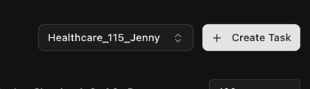
For each task:
Type the task name in the problem statement field.
Click Add Files and upload any task-specific files for that task.
Go back to your Google Drive folder, open the prompt file, and copy it into the prompt field in RLS.
Open the grader guidelines file and copy it into the grader guidelines field.
For the golden response, upload the file directly rather than pasting it.

⚠️ Save changes after every single step. If you navigate away without saving, you lose everything. After all tasks are set up, save again and verify the content is all there before you run anything.

Run the Agent
Once all tasks are set up and saved in RLS, you are ready to run the agent.

To start a run:
1. Select the correct version.
2. Pick the latest model.
3. Click Run.

The run takes roughly an hour for all tasks, so while the first task is running, go back and finish setting up any remaining tasks.
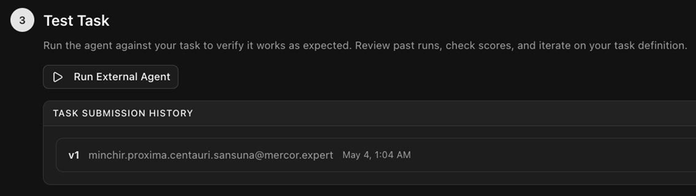
Once a run finishes:
1. Click on the latest version under the Task Submission History in #3 Test Task.
2. Click Run All QA. This triggers the automated quality check.
3. Wait 10 to 20 minutes.
4. Come back and click Fetch QC Report to pull up the results.

When the QC report comes back, you are ready to move into Phase 3: QA your Tasks, where you will review the findings and fix what you can.

✔️ Phase 3: QC Your Tasks

Phase 3: QC your Tasks
→ Pipeline Steps 11, 13, 14 (Task AutoQC post-setup, Task AutoQC post-run, Taiga QC)
You've built your tasks — prompts, golden responses, grader guidelines. Before any of that enters the evaluation pipeline, it needs to pass a quality gate. The purpose of QC (Quality Check) is to catch inconsistencies and clinical errors that would undermine the evaluation:
- Missing files
- Temporal contradictions
- Grader guidelines that penalize what the golden response itself does
- Clinical details that can't be traced to any source document
A task that clears QC is one where you can be confident any failure the agent produces is a genuine reasoning error, not a consequence of your task design.
💡 The QC mental model. QC evaluates your task package as a whole — prompt, files, golden response, and grader guideline — as a single unit. It asks: does this task package hold together as a self-consistent, realistic clinical simulation?

Video walkthroughs
Task AutoQC on RLS | 👉 002 Task AutoQC.mp4 | Steps 11 & 13 — Task AutoQC pre-run + post-run
Trajectory Runs and QC | 👉 003 Trajectory Runs & QC.mp4 | Step 12 & 14 — Run the Agent + Taiga QC

Default number of trajectories per run: 10. QC jobs take time to process — no need to wait on the screen.

What QA flags vs what QA doesn't
✅ QA flags (you address) | ❌ QA does NOT flag (engineering handles)
Task prompt references a doc that's not in the attached file set | Script failure
Prompt states 50 files but 52 are attached | Grader model not reading all attached files
Prompt says "two weeks after Feb 1" but golden response dates Feb 28 (4 weeks later) | Formatting errors in the automated pipeline
Golden response includes a clinical detail not traceable to any source file | Other backend / engineering issues
Grader guideline penalizes an error the golden response itself commits
Medication dose in golden response contradicts source files

⚠ QA is not a technical debugging exercise. Technical issues route to engineering automatically. Your responsibility is the clinical and task-design findings.

QC gates in Phase 3
Step from Production Pipeline | Gate | What runs
11 | Task AutoQC (post-run) | Same checks rerun after the agent's run. Catches issues that only surface in actual agent behavior
12 | Run the agent
13 | Taiga QC | Trajectory + grading audit in Taiga. Address every audit item before moving to Phase 4

How findings work — severity + categories
Three severity levels
Severity | What it means | Action
Error | Blocks submission | Must resolve before next gate
Warning | Should be reviewed | Fix, or dispute with documented justification
Info | Informational only | No action required

Four finding categories
Category | What it is | Your action
Grader issues | Problems with the grader guidelines themselves | Edit grader guidelines in RL Studio; save new version
Clinical issues | Clinical inaccuracies in task setup, golden response, or grader guidelines | Fix and document
Input file errors | Problems with the World files themselves | You cannot fix — flag and note this is an input file issue
Engineering / technical errors | Outside clinical scope | Note for engineering POC; leave as-is

How to interpret QA feedback — clinical judgment is the source of truth
Sanctum's QA incorporates machine models as part of the workflow. Because of this, your clinical judgment is the source of truth.
Feedback type | When to push back | When to defer
Clinical feedback | Not commonly practiced; not well justified clinically → state your reasoning, move forward | Aligned with standard practice → fix
Administrative feedback | Spec doc detail level / grader prescriptiveness — use expert judgment | Clear inconsistency → fix

💡 QA feedback is to be evaluated critically — not treated as absolute truth. Sanctum is a physician-led effort. QA supports your judgment; it doesn't replace it. When unclear, reach out to your reviewer or Pod Lead.

How to respond to a finding
- Click the finding to expand it
- Read description + evidence
- If valid: thumbs up → fix the issue → save new version
- If invalid / false positive: thumbs down → add brief justification

Strong vs. weak Disagree responses
Disagree responses are where most QC Findings work happens. Be specific.
❌ Weak
“Disagree — this finding is wrong.”
Why: No reasoning, no evidence. The reviewer has no way to verify your judgment, and will likely overturn your vote.

✅ Strong
“Disagree — the finding says the prompt asks for inconsistent output formats. The prompt explicitly says 'save as Excel' (line 4 of the prompt); the AI's variability is in section structure, not output format. Section structure variability is acceptable per Section 3A.4 (acceptable ambiguity).”
Why: Cites the source of the disagreement, points to the specific evidence, and references the relevant standard. A reviewer can verify in 30 seconds.
⚠️ Do not accumulate unaddressed findings across runs. Resolve or dispute each one before moving on. The next step (running the agent at Step 12, or moving to Taiga QC at Step 14) is gated on this.

The Triage Decision: Fix Now or Fix Later

Not every audit item requires you to re-open and revise the task immediately.
Fix now means updating the current task package, revising the prompt, golden response, grader guideline, or file set and resubmitting. This applies when the issue is major: a factual inconsistency that would make the golden response incorrect, a missing file that breaks the task's self-containment, a temporal error that changes the clinical scenario, or a grader guideline that would systematically misdirect scoring.
Fix later means documenting the issue and moving forward. This applies when the finding is minor or cosmetic: a formatting preference, a supplementary file that could be improved but does not affect any correct answer, or a grader phrasing that could be tightened but does not produce incorrect scores. These issues are logged and queued for the next revision cycle.
The default posture is to keep tasks moving unless the issue materially affects the validity of the evaluation. When in doubt, ask your pod lead or Team Lead.

Check list before moving to Phase 4:
- All Error-level findings from Task AutoQC (Step 11 AND Step 13) resolved
- All Warning-level findings either fixed or disputed with justification
- Taiga QC (Step 14) completed and all findings addressed
- Golden response is accurate and consistent with all source files
- Grader guideline does not penalize anything the golden response itself does

👣 How to address Taiga QA items

How to Properly Address QA Items on RLS: Taiga/EnvLinter/Data Quality Workflow

→ Pipeline Steps 13–14: after your agent run completes

Video Tutorial 👉 007 Taiga/EnvLinter vs. Traj. AutoQC vs. Runs - Recording | Notes

After you've run the external agent (Step 12) and 10 trajectories are produced, your task goes through two parallel QC layers:
- Taiga QC — runs on the Taiga platform with two audit types: EnvLinter (Ambulancer) + Data Quality
- AutoQC — runs in RL Studio

🔑 Summary of Key Steps 👣

Step 1: Verify the run completed successfully
Click into the task. You should see your agent run with 10 trajectories listed, each with a score.

[screenshot placeholder]

Step 2: Fetch the QC report
Click the "Fetch QC Report" button (NOT the arrow next to it — that goes somewhere else).
You'll see "QC report triggered successfully." The report takes a few minutes to populate — you don't need to wait on the screen.

[screenshot placeholder]

Step 3: Review the QC Report Summary
Once the report is ready, you'll see categories:
Category | What it means | Action
Reward Hacking | Technical check | Ignore — not your responsibility
Difficulty Pass Rate | Whether task was hard enough | Informational; review out of curiosity
Ambulancer (EnvLinter) | Taiga's QA agent — clinical + structural | MUST address every flag
Data Quality | Taiga's clinical data check | MUST address every flag
Human Review | (Not used) | Skip

[screenshot placeholder]

Step 4: Address each EnvLinter (Ambulancer) audit item
Open the Ambulancer section. Each audit item has:
- Severity (Critical / Warning)
- Description of the issue
- Recommendation for how to fix

For each audit item, decide:
Your decision | Click | Then
Agree — I'll fix it | 👍 Thumbs up | Write a brief note on what you'll do
Disagree — I won't change | 👎 Thumbs down | Write a clear justification
It's a technical issue (not clinical) | 👎 Thumbs down | Write "Defer to tech team" + flag in #sanctum-help

[screenshot placeholder]
Examples of good responses
For a trap (intentional design choice):
- "This is an intentional design choice for the task — the agent should be able to maneuver around this. I would not want to explicitly specify the name in the chart as this would ruin the point of the test."
For a technical issue:
- "Deferring to tech team. This relates to web search function needing to be enabled. Flagged to Rahul + team."
For an issue you'll fix:
- "Agree. Will delete the synthetic training document banners from the PDFs and re-upload."
Click "Send" to submit each response

Step 5: Address each Data Quality audit item
Same workflow as Step 5 — open each item, decide thumbs up or down, justify, submit.

[screenshot placeholder]

Step 6: Address AutoQC audit items (after Taiga is done)
After all Taiga items are addressed, scroll to the AutoQC section. Same workflow:
- Thumbs up + brief note (you'll fix)
- Thumbs down + justification (you disagree OR it's technical)

Four categories of AutoQC findings
Category | What you can do
Grader issues | Fix grader guidelines in RL Studio; save new version
Clinical issues | Fix the underlying clinical content + document
Input file errors | Can't fix yourself — flag + note "input file related"
Engineering / technical errors | Defer to tech team

Step 7: Document everything in your Google Doc backup
It is a way to organize your thoughts and back up your responses. It also makes it easy for your reviewer to see what you addressed and how.

[screenshot placeholder]

Step 8: Re-run agent if you made changes
If your responses include fixes (thumbs up + "I'll fix X"), you need to:
- Make the actual changes to your task / files / golden response / grader guidelines
- Save the new version in RL Studio
- Re-run the agent (Step 12 again) — same settings as before
After re-running:
- New trajectories will appear
- New QC report will be generated
- Repeat Steps 4–8 until all audit items are resolved

Step 9: Submit and move to Failure Analysis
Once every audit item is addressed (either fixed or disputed with justification):
- Confirm in RL Studio that all items show "Feedback submitted"

[screenshot placeholder]

2. Click "Send for task writing fixes" (or equivalent submit button)

[screenshot placeholder]

3. Your task moves to the reviewer queue. Reviewer will either approve or send back with feedback
4. After reviewer approval, you'll proceed to Failure Analysis (Step 15)

[screenshot placeholder]

Note: While we finalize the creation of the written guidance and instructions for this part of the production pipeline, please refer to the video tutorial series tab in the meantime.

If you have any questions, please post in #taiga-envlinter-qa-items-clarifications channel AND #autoqc-feedback-issues channel

🔍 Phase 4: Evaluate the agent

Phase 4: Evaluate the Agent
→ Pipeline Steps 15–18 (Failure Analysis + Grader Analysis + Preference Labeling + AutoQC + Final Reviewer Review)
After your task package clears QC (Phase 3), the AI agent has run against it and produced multiple trajectories. Phase 4 is where you evaluate what the agent actually did and how the grader scored it — producing the data that drives both model improvement and grader calibration.
⚠ Please note: Phase 4 is a manual and human driven section. You will be writing the analyses yourself. However, we have prepared templates for you to organize your thoughts before putting them into RL Studio.

Each task gets three evaluation deliverables, completed together in a single ~1-hour pass:
- Failure Analysis (FA) — what the agent got wrong + why
- Grader Analysis (GA) — how well the grader scored the agent's work
- Preference Labeling (PL) — head-to-head comparison of two attempts
After you write FA + GA + PL, all three pass through AutoQC (Step 17) and final human review (Step 18) before delivery.

The 4 steps in Phase 4
Steps in the Production Pipeline | What runs | Your deliverable | Video Tutorial
14 | FA + GA writeup | Failure Analysis (6–8 sentences) + Grader Analysis (4–6 sentences) | 📹 004 FA & Grader Feedback
15 | Preference Labeling | 7-section PL writeup comparing two trajectories | 📹 006 Preference Labels
16 | AutoQC on FA + PL | Address findings on your FA + PL writeups | 📹 005 FA AutoQC + 📹 007 PL AutoQC
17 | Final Reviewer Review | TL / pod lead / EPM signs off for delivery | —

💭 What is Failure Analysis?
Failure Analysis

A structured write-up of what the AI agent got wrong, where the reasoning broke down, and what the real-world legal consequence would be.

Writing Structure
- Clinical errors (primary focus): Wrong diagnoses, missed findings, incorrect medications or doses, unsupported clinical claims, failure to cross-reference documents, falling for designed traps
- Administrative / procedural errors: Policy violations not identified, billing or coding errors missed, documentation gaps, incorrect follow-up plans — flag these when they are important to the task's clinical workflow
- Style and formatting errors: Wrong audience (physician language in a patient-facing document), missing structure (flat medication list instead of categorized), scope failures (too much or too little content for the task type)
- Patterns Across Runs (if applicable) Note patterns across the trajectories — systematic failures vs. one-off mistakes, and which run scored differently and why.

Use the standard template (feel free to modify) when writing up your failure analysis. It includes the structure for both paragraphs (failure analysis and grader analysis) along with prompts to make sure each one covers what it should.

👉Template: FA/GA Template [05/14/26]
See example of failure analysis in appendix: example library → Failure analysis example

Writing Standards for Trajectory Failure Analysis
Your failure analysis will be read by people who range from clinical peers to non-medical engineers. The following standards ensure your explanations are useful to all audiences:

- Be specific, not generic. "The model got the medication list wrong" is not a failure explanation. "The model listed metformin as active on the discharge medication list despite Endocrinology recommending it be held until creatinine returns to baseline, creating a risk of lactic acidosis in a patient with Cr 1.8" is a failure explanation.

- Name the document. Specify which file(s) the reviewer should check to verify your analysis: "See the Day 9 attending progress note and the Endocrinology consult note from Day 8."

- Separate clinical error from formatting preference. A discharge summary that organizes information by system instead of chronologically is a structural choice, not a clinical failure. A discharge summary that omits the GI bleed entirely is a clinical failure. Do not conflate the two.

- Quantify the consequence when possible. Instead of "this could harm the patient," write: "Resuming metformin with Cr 1.8 exceeds the FDA-recommended threshold (Cr > 1.5 in males) and carries a risk of metformin-associated lactic acidosis, a condition with 30–50% mortality."

- Write for a non-specialist. Your failure analysis must be understandable to a reviewer outside your subspecialty. Avoid unexplained jargon. If you reference a clinical concept, provide enough context that a general internist — or a technically informed non-physician — can follow your reasoning.

- Distinguish severity tiers. Not all failures are equal. A fabricated vital sign is a different tier of severity than a mildly suboptimal medication dose. Your explanation should make the clinical gravity self-evident: a patient safety failure that could cause harm vs. a documentation preference that affects quality but not safety.

👣 How to do Failure Analysis

Step by step guide on Failure Analysis in RL Studio

All trajectory failure analysis work is performed in RLS / Taiga. Follow these steps in order
Video Tutorial 👉Failure Analysis + Grader Feedback Run- Recording

Video Tutorial 👉Failure Analysis AutoQC Review Process- Recording

🔑 Summary of Key Steps 👣

Step 1: Select the Trajectory Run
From the available trajectory runs for your task, select the lowest-scoring run. For this QC project you are analyzing one run only — not multiple runs.
In RL Studio, click on the latest version under the Task Submission History, identify the lowest-percentage run, and click Download Output.
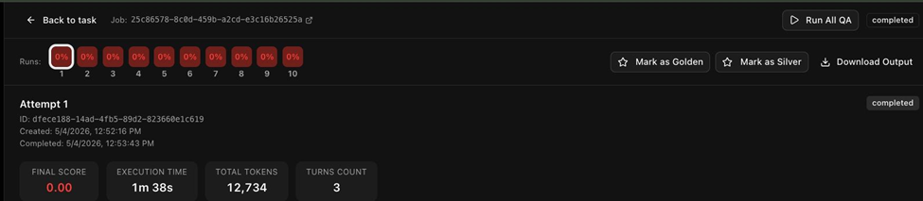

Step 2: Review Grader Scores
Review the automated grader scores for the run. The grader output can point you toward high-level errors, omissions, and strengths. However, treat this as a starting point only — grader scores require your independent verification. Do not anchor on the grader's assessment. The grader may miss errors, over-penalize formatting issues, or misattribute partial credit. Your clinical judgment is the authority, not the grader.

Step 3: Download and Read the Output
Download the full output of the trajectory run. You are expected to read it yourself, end to end, alongside your golden response. Do not rely solely on the grader summary or skim for flagged sections. Errors the grader missed will only surface from your own careful reading.

1. Download the Files
Go to the Actions menu in the upper-left corner of your screen.
Select Download Output Directory from the list.
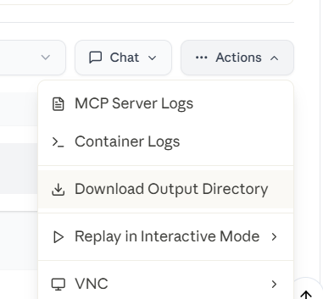

2: Locate the Download
A compressed folder ending in .tar.gz (a "tarball") will download to your computer.
Open your Downloads folder to find it.

3: Extract the Files
To use the files, you must "unzip" or extract them from the compressed folder:
Windows 11: Right-click the folder and select Extract All.
Other Windows versions: Right-click the folder and use a program like 7-Zip or WinRAR to extract the contents.
Mac: Simply double-click the folder, and it will automatically unzip for you.

4: Conduct the Trajectory Failure Analysis
Read the agent output and identify the errors. Prioritize in this order:
Clinical errors (primary focus): Wrong diagnoses, missed findings, incorrect medications or doses, unsupported clinical claims, failure to cross-reference documents, falling for designed traps
Administrative / procedural errors: Policy violations not identified, billing or coding errors missed, documentation gaps, incorrect follow-up plans — flag these when they are important to the task's clinical workflow
Style and formatting errors: Wrong audience (physician language in a patient-facing document), missing structure (flat medication list instead of categorized), scope failures (too much or too little content for the task type)

Step 5: Draft the Trajectory Failure Analysis
Your findings get turned into two written paragraphs. Both go into the evaluation document:
Trajectory Failure analysis paragraph: Covers the model failures themselves — what the agent got wrong, what the correct answer is, and what documents support the correct answer. Organize by severity: lead with clinical errors, then administrative, then style.
Grader analysis paragraph: Covers what the grader got right and wrong in evaluating those failures — errors the grader missed, false positives the grader flagged, or scoring decisions that don't match the clinical reality of the output.
See FA Template and GA Template section for instructions on writing them

➗ What is Grader Analysis?

Drafting the Grader Analysis
Write a single paragraph of 4 to 6 sentences in natural language. Stay focused on grader behavior — not on the agent.

The paragraph should cover:
What Section A, Section B, and Section C handled correctly. Name the sections explicitly in your analysis.
Where the grader under-penalized or over-penalized
Concrete recommended edits to the A, B, or C sections of the grader guidelines, including any failure modes that should be added to the Section C list

👉Template: FA/GA Template [05/14/26]
See example of grader analysis in appendix: example library → Grader analysis example

Writing Standards for Grader Analysis

Focus on the grader, not the agent. The agent's errors belong in the Trajectory Failure Analysis. The Grader Analysis is about whether the grader correctly evaluated those errors.

Be specific about which section of the grader you are critiquing. Name Section A, B, or C. Quote the specific rubric language when it matters.

Recommend concrete edits, not vague concerns. "The grader missed the H&P-over-pharmacy anchoring failure" is a finding. "Add 'anchoring on the H&P over pharmacy fill history' to the Section C failure mode list" is a recommended edit.

Distinguish grader misses from grader mis-scores. A miss is when the grader did not identify a failure at all. A mis-score is when it identifies the failure but assigned a seemingly inappropriate score.

Grader Analysis Checklist
Before submitting your Grader Analysis, verify the following:
- Is my paragraph 4 to 6 sentences?
- Did I focus on grader behavior, not on agent behavior?
- Did I name Section A, B, and/or C explicitly?
- Did I identify both what the grader caught and what it missed?
- Did I comment on whether or not the score appeared fair and appropriate?
- Did I recommend at least one concrete edit to the grader guidelines?

Did I flag any failure modes that should be added to the Section C list?

👣 How to do Grader Analysis

Step by step guide on Grader Analysis in RL Studio
Video Tutorial 👉Failure Analysis + Grader Analysis - 004 Failure Analysis and Grader Feedback.mp4

All grader analysis work is performed in RLS / Taiga. Follow these steps in order.

🔑 Summary of Key Steps 👣

Locating the Grading Transcript
All Grader Analysis work is performed in RLS / Taiga, on the same trajectory you used for the Trajectory Failure Analysis (the lowest-scoring run for the version under review).
Inside the trajectory view, switch from the Agent Trajectory tab to the Grading Transcript tab. This shows the grader's full reasoning, the rubric sections it stepped through, and the total score it assigned.

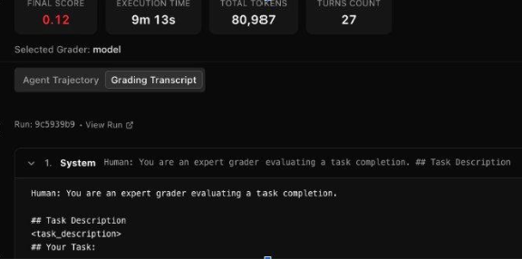
The Grading Transcript tab in RL Studio. Switch from Agent Trajectory to Grading Transcript to see the grader's reasoning.

How to Conduct the Grader Analysis
Open two things side by side:
Grader transcript — from the Grading Transcript tab in RL Studio
Grader guidelines — your own grader guidelines document for this task

Read the transcript section by section and compare each step against the corresponding rubric section in your grader guidelines. The goal is to figure out what the AI grader did wrong, where it diverged from the rubric, and where the rubric itself could be tightened.

Look for the following:
- What the grader handled correctly in Section A, Section B, and Section C
- Where the grader under-penalized — failures it should have caught but missed or scored too generously
- Where the grader over-penalized — things it docked points for that the rubric does not actually penalize, or that don't reflect real clinical error
- Gaps in Section C — failure modes that came up in the trajectory but are not listed in the common failure mode section

🏷️ What is Preferential Labeling?

Preference Label Template
Preference labels are how we tell the model which outputs are clinically better and why. Each label is a structured judgment from a physician — that judgment is the training signal that shapes how the model improves over time. The grader can score outputs but cannot tell the model that a discharge summary missing the GI bleed is a more serious failure than one that organizes information unconventionally. You can.
Scale Selection: State your preference in one line (e.g., "A2 (better)" or "B3 (much better)").
Justification: A few sentences explaining why one attempt is preferred. Focus on the main drivers — the specific findings, errors, or judgment calls that decided it.
Prompt adherence: Did each attempt deliver what the prompt actually asked for?
Correctness: How accurate is each attempt against the chart? Note any factual errors or clinical judgment wins or losses on either side.
Completeness: Did each attempt cover the required content? Note any gaps, omitted findings, or extraneous additions.
Methodology: How did each attempt approach the task? Note differences in clinical reasoning, organizational choices, or scope decisions.
Quality and clarity: How readable, organized, and useful is each output for its intended audience?
Summary: Summarize your justification and reasoning behind your selection.

NOTE: When writing your preferential labeling, avoid the usage of the word “both” as much as possible. Instead, be very specific about which output you are writing about for each talking point.

⛔ DON’T: “Both outputs failed to recognize hypomania/mania as a FDA warning/precaution for Wellbutrin.”
✅ DO: “Output A failed to mention neither hypomania nor mania as an FDA warning/precaution for Wellbutrin. Similarly, while output B did caution against recommending Wellbutrin to patients with an active diagnosis of bipolar disorder, it failed to provide a nuanced explanation on how mania and hypomania can be activated even amongst individuals with no current diagnosis of bipolar disorder.”

When Scoring, sse the A4–B4 scale. The scale runs from slightly better up to significantly better in either direction. Match the tier to the size of the gap between the two outputs.

Tier | When to Use
A4 / B4 (significantly better) | One output is overwhelmingly better. The other has multiple major errors, gets the core diagnosis wrong, or produces an output that is unsafe or unusable.
A3 / B3 (much better) | One output is clearly and substantially better. The other has a significant clinical error, falls for a central designed trap, or misses a critical finding.
A2 / B2 (better) | One output is meaningfully better. It catches an additional finding, avoids a clinical error the other makes, or handles a key reasoning step correctly.
A1 / B1 (slightly better) | Both outputs are close in quality. One edges ahead on a specific, narrow point.
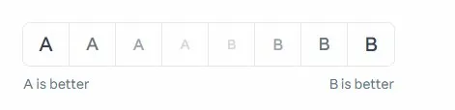
See example of preference labeling in appendix: example library → Preference Labeling example

👣 How to do PLs

Step by step guide on Preference Labeling (PL) in RL Studio

What You're Doing
For each task, you compare two agent runs (Response A and Response B) against your golden response, decide which one is clinically better, select your preference on the A4–B4 scale, and write a justification explaining your decision. RL Studio will choose the trajectories for you as Response A and Response B. To see the responses you will compare, start by pressing “Ready for Analysis.”

🔑 Summary of Key Steps 👣

NOTE: Press “Ready for Analysis” only after your QA stage has been approved by your leads.
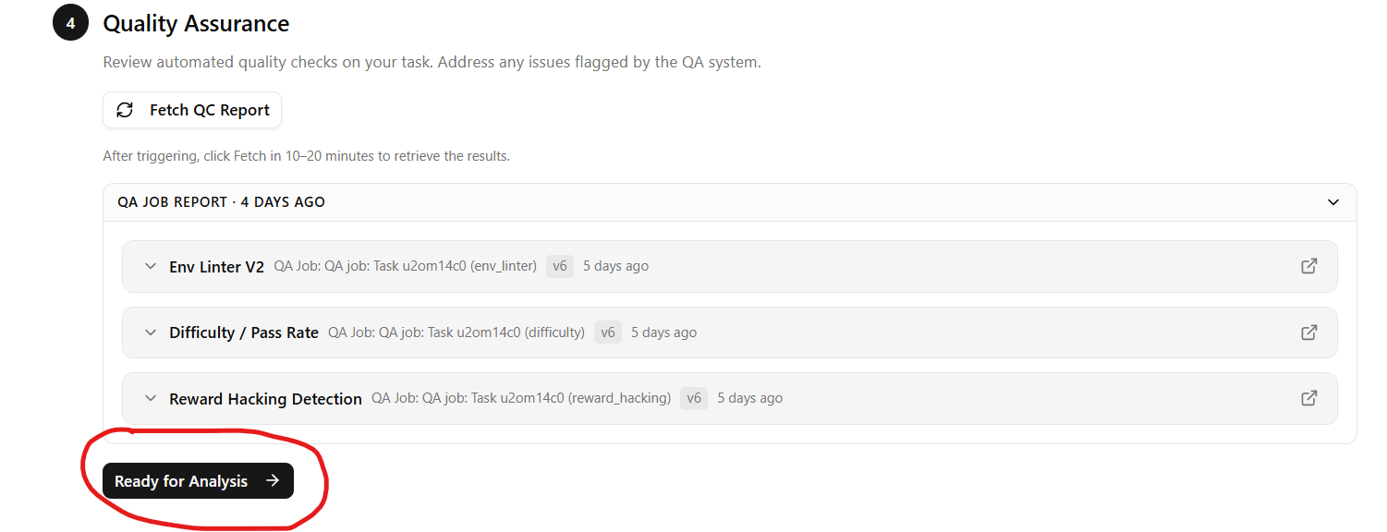

Step 1: Read Both Outputs Fully
After pressing “Ready for Analysis” you will see this: 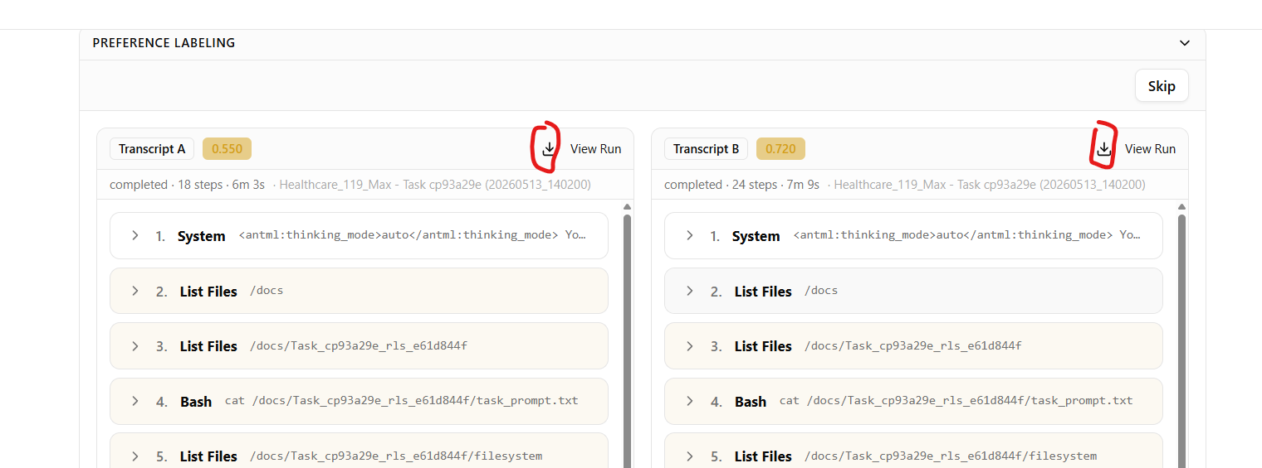

Click the download icons to the left of “view run.” By pressing each of these download icons you will download zip files that contain the deliverable files that were generated during the trajectory runs chosen for this preference labelling step. Open the Word Doc or other files type present in the zip files. Your “preference” will be determined by comparing these files (A against B). You will write the details of your preference by using the directions in Step 2 below. Read Response A and Response B end to end before making any judgment. Do not stop reading one early just because it seems obviously worse. Have your golden response available as the reference throughout.

Step 2: Compare A and B Across Five Dimensions
Compare the two outputs against each other — not separately. Make a genuine effort to identify any meaningful differences between the two outputs across these five dimensions:
Prompt adherence: Did each response address all requirements of the task prompt?
Correctness: Are there factual errors, flawed reasoning, or unsupported clinical claims in either?
Completeness: Did each fully answer the task, or are there missing findings, omitted medications, or gaps?
Methodology: Did each use the appropriate clinical approach and reference the right source documents?
Quality and clarity: Is the output structured, clear, and usable for its intended audience?

Pay particular attention to clinical errors, administrative errors, and style or formatting differences.

Step 3: Select on the A4–B4 Preference Scale
Use the A4–B4 scale. The scale runs from slightly better up to significantly better in either direction. Match the tier to the size of the gap between the two outputs.

Tier | When to Use
A4 / B4 (significantly better) | One output is overwhelmingly better. The other has multiple major errors, gets the core diagnosis wrong, or produces an output that is unsafe or unusable.
A3 / B3 (much better) | One output is clearly and substantially better. The other has a significant clinical error, falls for a central designed trap, or misses a critical finding.
A2 / B2 (better) | One output is meaningfully better. It catches an additional finding, avoids a clinical error the other makes, or handles a key reasoning step correctly.
A1 / B1 (slightly better) | Both outputs are close in quality. One edges ahead on a specific, narrow point.


Step 4: Write Your Justification
Write a justification that explains your decision. Lead with your verdict in one line. Then write a few sentences on each dimension covering what drove the preference. Be specific about the clinical or administrative difference that decided it. If you cannot point to a concrete difference, reconsider your rating. See

Step 5: Submit
Copy the full written justification and paste it into the comments box in RLS.
Click Submit Preference.
Before submitting, confirm your scale selection and your justification tell the same story. If your paragraph describes a major clinical error in one response but you selected A1 or B1 (slightly better), the rating does not match the analysis.
Check the submission history to confirm your entry is showing before you navigate away. If it is not there, submit again. Once the submission history confirms your label is saved, that task is fully complete.

🧵 QC+FA+GA+PL Walkthrough

👉 🎥 QA/FA/GA/PL: Tying it all together
This video shows what resources/templates you can use to organize and finalize your responses to the QA audit items, failure analysis (FA), grader analysis (GA), and preferential labeling (PL)

📎 Appendix

Appendix

⁉️ What is QA/QC?
Project Sanctum QA/QC Workflow: A Learner's Map

Below is a visual outline of each QA/QC layer your work passes through, in the order you actually hit them in RL Studio (RLS).
Blue is the World-Building phase. Orange is the Task-Building phase. By reading this document, you should be able to appreciate how each contributes to the overall quality of our submissions.

🌍 World-Building Phase
I  Self-AutoQC | What is it: Informal AutoQCs done asynchronously.  What does it check for: Whatever you want to check in the world-building phase (brainstorm doc, world spec doc, your world-level files).  What does it produce: Feedback on how to improve your brainstorm doc, world spec doc, and / or world-level files.  Why does it matter: A layer of quality check before you share your final world-level materials (brainstorm, world spec, world-level files) with colleagues or upload to RL Studio.  Where is this located: Claude Project.  Who takes ownership: Writer.
│  │  II  RLS AutoQCs  Part I: Brainstorming  Part II: World Spec  Part IV: Applying to World | What is it: AutoQC embedded within RL Studio (i.e. RLS).  What does it check for: Depends on the phase the writer is in on RL Studio. Part 1: Brainstorming Doc. Part 2: World Spec Doc and Templates. Part 4: Applying to World —contains World Spec document + Finalized post-engineering pipeline world-level files.  What does it produce: More robust feedback on your world-level deliverables compared to the self-AutoQC.  Why does it matter: A formal layer of quality check in RL Studio that writers and reviewers are held accountable for.  Where is this located: RL Studio (RLS).  Who takes ownership: Writer and Reviewer.
🔨 Task-Building Phase
III  Self-AutoQC | What is it: Informal AutoQCs done asynchronously.  What does it check for: Depends on what the writer wants to self-check at the time (task prompts, golden responses, grader guidelines).  What does it produce: Feedback on how to improve your task prompt, golden responses, and grader guidelines.  Why does it matter: A layer of quality check to ensure alignment between your task-level files (task prompts, golden response, grader guidelines) AND world-level materials (world spec, world-level files) before sharing with your reviewer and uploading to RLS.  Where is this located: Claude Project.  Who takes ownership: Writer.
│  │  IV  RL Studio Task  AutoQC | What is it: Formal AutoQC embedded within RL Studio.  What does it check for: Mainly task-level materials, just like the self-AutoQC equivalent.  What does it produce: More robust feedback on how to improve your task prompt, golden responses, and grader guidelines to ensure alignment with the rest of your world.  Why does it matter: A formal layer of quality check in RL Studio that writers and reviewers are held accountable for. This time, however, task-level materials are AutoQC'd in tandem with world-level materials to ensure alignment (i.e. Does the task prompt, grader guideline, and golden response all align with the information in the world spec and world-level files?).  Where is this located: RL Studio (RLS).  Who takes ownership: Writer and Reviewer.
│  │  V  Taiga QA | What is it: Formal QA outside of RLS in a platform called Taiga. Taiga runs separate trajectories and analyses of your world, including scoring the model's performance against your grading guidelines and golden response. Two types of Taiga QA audit items exist: EnvLinter and Data Quality.  What does it check for: Everything you have uploaded thus far (all of your world-level and file-level materials).  What does it produce: Robust feedback and audit items, clinical or technical in nature, that the writer MUST address individually (non-negotiable).  Why does it matter: These are robust additional layers of QA requested by our client to ensure that tasks marked for delivery are genuinely high-quality, and that changes to task-level (and if needed, world-level) materials are made before delivery.  Where is this located: RLS and the Taiga platform (separate website / platform).  Who takes ownership: Writer, Reviewer, Pod Leads, and Team Leads.
│  │  VI  Taiga QA Feedback Review | What is it: Formalized feedback on whether you sufficiently addressed the Taiga QA audit items from the EnvLinter and Data Quality reports.  What does it check for: Your thumbs-down responses for specificity, justification, and whether each one explains why you disagreed with the flag.  What does it produce: Feedback on your specific responses and justification to each EnvLinter and Data Quality audit item.  Why does it matter: Many writers submit tasks that don't sufficiently address the non-negotiable, client-requested Taiga QA audit items, driving a high defect rate. This blocks us from making the necessary changes on our worlds and tasks and from delivering high-quality batches to the client.  Where is this located: Primarily RL Studio (+/- Google Docs as a backup working document, using our team-approved templates/organizers).  Who takes ownership: Writer, Reviewer, Pod Leads, EPMs, and Team Leads.
│  │  VII  Failure & Grader Analysis AutoQC | What is it: Formalized feedback on whether you sufficiently drafted your failure-analysis (FA) and grader-analysis (GA) write-ups, as outlined in our instruction and onboarding documents.  What does it check for: Your FA and GA write-ups.  What does it produce: Individualized feedback on whether you answered the main questions sufficiently in 2 to 4 paragraphs total. FA: (1) reasons for genuine model failure, (2) what the model output did well. GA: (3) what the grader got wrong, (4) what the grader got right.  Why does it matter: Similar to Taiga QA Feedback Review: we have been approving tasks with insufficient or inaccurate descriptions of how the model failed (how the model got stumped, i.e. FA) and what went wrong versus right with the AI grader in relation to our grading guidelines and golden responses (i.e. GA).  Where is this located: Primarily RL Studio (Google Docs as a backup working document, using our team-approved template).  Who takes ownership: Writer and Reviewer.

🪞 Self-AutoQC Cheat Sheet
How to Self-AutoQC in Claude Project (Optional)
Description: This is the OPTIONAL informal QC workflow you can run inside Claude Project BEFORE uploading any deliverable to its corresponding AutoQC gate in RL Studio. The purpose is to spot check the quality of your deliverables in advance and catch issues before they show up as RL Studio audit items. Informal QC in Claude Project is encouraged but not required; the formal QC of record now lives entirely in RL Studio.

Step 1: Start a new chat on your Claude Project



Step 2: Copy/paste the following prompt

“Please use the QC checklist I uploaded to review my [insert deliverable here]. Walk through every check, give a verdict on each, and flag the Blockers first, then the Majors, then the Minors.”



The deliverables that you may QC throughout the production pipeline include the following:
- Brainstorm document
- World Spec document
- World Spec Files (all of them should be QC’d in tandem)
- Task Prompts*
- Golden Response*
- Grader Guidelines*

⚠️NOTE: Remember that the *task prompts, *golden responses, and *grader guidelines have to be written by YOU and not the LLM. You may run a QC after you have written them but you may not ask Claude to write them for you from scratch.

Step 3: Attach your deliverable + the corresponding AutoQC file/s



Your Deliverable | Corresponding AutoQC Prompt File/s  +  Supplemental documents
Brainstorm document | AutoQC_Section_1_Brainstorm_v6.6_writer.docx
World Spec document | AutoQC_Section_2_World_Spec_v6.6_writer.docx  +  Your Brainstorm document  +  Your templates/reference files
World-level files  (all of them in a zipped folder) | AutoQC_Section_3_World_Files_v6.6_writer.docx  +  Your World Spec document
Task prompts  (compile in 1 document/pdf) | AutoQC_Section_4_Task_Prompts_v6.6_writer.docx  +  Your World Spec document  +  Your world-level files (in a zipped folder)
Golden responses  (compile in 1 document/pdf) | AutoQC_Section_5_Golden_Response_v6.6_writer.docx  +  Your World Spec document  +  Your world-level files (in a zipped folder)  +  Your task prompts  +  Your task-level files
Grader guidelines  (compile in 1 document/pdf) | AutoQC_Section_6_Grader_Guidelines_v6.6_writer.docx  +  Your World Spec document  +  Your world-level files (in a zipped folder)  +  Your task prompts  +  Your task-level files  +  Your golden responses

💭 Concept Deepdive

💭 Glossary

Glossary — every term you'll encounter
Read this section all the way through before you start designing. Almost every "what does X actually mean?" question new writers ask is answered here. Every term follows the same pattern: What (one-sentence definition), Why (why it exists in the workflow), How (how you interact with it).

Components of the Project
Term | What, Why, How
Scenario | What — The realistic patient case. It is the starting point of your World and Tasks are built around it. It describes who the patient is, their medical history, the admission event, and the clinical course that makes all tasks simultaneously active.  Why — The Scenario is the foundation your World and Tasks are built around. Every document in the World exists because the Scenario justifies it, and every task draws meaning from it. Without a coherent Scenario, the World becomes a random collection of files.  How — You capture your scenario in the Brainstorm by answering three structured questions: clinical context (care setting, reason for admission, stage of hospital course), key players (patient, family, attending, consulting specialists, care team), and precipitating event (the development that makes all tasks simultaneously live).
Task | What — A realistic clinical assignment an AI agent attempts to complete using only the files in your World. You design 8+ tasks per World, each producing a concrete deliverable.  Why — Tasks are the unit of testing. The agent attempts each task you designed; the Grader Agent grades it. Tasks must be sophisticated enough that a junior clinician would struggle to complete them reliably — work that requires the judgment, format awareness, and analytical depth of a senior practicing clinician.  How — Task work happens in two parts:  • Task sketching — In your Brainstorm, you sketch 8+ task ideas, capturing the workflow each maps to, what makes it hard, and the expected output.  • Task building — In your World Spec, you draft full task prompts. After the World is built (Phase 2), you finalize each task in RL Studio with three components: Task Prompt, Golden Response, and Grader Guidelines.
World | What — The realistic clinical environment your AI agent navigates to attempt your tasks. Built around one patient case and scoped to support 8+ tasks, a World contains the patient records, care team, timelines, and parallel clinical workstreams of a complete patient case — progress notes, consult notes, lab reports, imaging, medication lists, nursing flowsheets, patient-provided documents, and more. Think of it as the patient chart a clinician would have in their EMR.  Why — The AI Agent operates only within the World. It has no patient-specific knowledge outside the chart, no access to the attending, no ability to page consult teams or request additional records. The World is both the agent's workspace and the entire universe of patient-specific information it can draw on.  How — You design the World through your Brainstorm and World Spec Document. The AI Build Pipeline reads your approved Spec and Reference Templates folder and generates the actual chart files. Your role is to specify what should be built, curate the templates that anchor generation, and review what gets produced before approval.
Workflow | What — A category of end-to-end clinical or administrative work that clinicians perform regularly (medication reconciliation, discharge summary drafting, prior authorization, RCA, peer review, coding determination). Reusable across patients; lives in the maintained Workflow List your team lead provides.  Why — Workflows anchor every task to real clinical work, so the training data reflects what clinicians actually do on the job rather than invented exercises. Designing each World across multiple distinct workflows also forces diversity — the AI agent gets tested across the full range of physician judgment (clinical documentation, medication management, care coordination, quality and safety oversight, administrative-clinical hybrid work) rather than the same skill repeated.  How — Each of your 8+ tasks per World maps to one workflow drawn from the approved Workflow List. Aim to span 3–5 distinct workflows across the World (repetition is allowed as long as you clear that minimum). At least one task must use a P0 workflow. You pick workflows during Brainstorm (in your rough task ideas), then confirm them when filling Field 1 of each Task in World Spec Section 2.  💡 Workflow vs. Task — the source of confusion: A Workflow is the type of work (process category — reusable across Worlds). A Task is a specific instance of one Workflow applied to your patient, written as a prompt the AI agent attempts. One Workflow → many possible Tasks across many Worlds.
Golden Response | What — The expert-quality deliverable for a task — the actual, fully-drafted work product a senior clinician would produce. A real clinical artifact (discharge summary, reconciled medication list, consult note, coding determination, prior authorization letter) at senior-attending quality.  Why — It defines what "correct" looks like. The Grader Agent compares every attempt against it, and it proves your task is solvable from the materials provided. If you can't write the Golden Response cleanly from your World, your task isn't well-specified yet.  How — You draft the Golden Response when building your tasks in Phase 2 (in RL Studio). AI may support drafting, but you own the final work product — every clinical decision, every medication, every rationale must hold up under your professional review.
Grader Guidelines | What — Natural-language instructions that tell the Grader Agent how to evaluate an attempt against your Golden Response. Not a rigid rubric — directions that help the grader understand what matters, what counts as wrong, and what clinical variation is acceptable.  Why — The Grader Agent has general clinical judgment but no context on your specific task. The Grader Guidelines calibrate it on the task-specific points — what to check, what counts as correct, what common errors to flag. Without them, the grader scores too leniently or too strictly.  How — You write the Grader Guidelines after drafting the Golden Response, in Phase 2 in RL Studio.
Brainstorm | What — Your high-level plan for the World you'll build and the tasks that will run inside it. The first deliverable in onboarding. Captures your scenario and 8+ task sketches.  Why — It's the design pitch that anchors everything downstream. Before you write a full Spec, your scenario and task ideas need a human sign-off so you don't invest hours building a World that won't support viable tasks. Without it, writers waste hours on Worlds that don't pass review.  How — You write the Brainstorm in RL Studio, then post it in your pod channel for pod lead or peer review per current channel norms. It must clear Brainstorm AutoQC and Human Review before you move to the World Spec.
World Spec Document + Reference Templates | What — The full specification of your World — scenario context, full 8+ task designs (including task prompts), file inventory, and the Reference Templates folder. The Reference Templates folder contains the document templates the AI Build Pipeline uses to generate your World files.  Why — The Spec + Templates is the blueprint the AI Build Pipeline reads to generate your World's synthetic files. Anything not specified won't appear in your built World — the pipeline can't infer details from context. Reference Templates anchor the format and style of each generated document.  How — You develop the Spec and curate the Reference Templates folder using the Claude Project workflow (see template & reference guide). Both are uploaded together to RL Studio as a single package. The package must clear World Spec AutoQC and Human Review before engineering handoff.
AI Build Pipeline | What — An AI system that reads your approved World Spec and Reference Templates folder and generates the actual chart files that populate your World.  Why — Manually drafting an inpatient chart of 25+ documents per World would take many hours and produce inconsistent output. The AI Build Pipeline scales this while keeping document content internally coherent.  How — You don't operate it directly. After your Spec is approved, the pipeline runs automatically and synthesizes your World files. Your role is to review the generated files (Step 9 in the production pipeline) — minor issues you edit in place, major issues you flag for regeneration.
Trajectory | What — The full record of one agent run on one task — the agent's reasoning trace, the tool calls it made (which files it opened, what searches it ran), and the final output it produced. Think of it as a screen recording of the agent working through the task.  Why — Trajectories are how you see what the agent actually did, not just what it produced. They're the input for everything in Failure Analysis and Preference Labeling.  How — You don't generate trajectories yourself — the agent does, automatically when you run a task in RL Studio. You review them in RL Studio / Taiga during the QA and Evaluate phases.

The AI agents you'll encounter

Term | What, Why, How
AI Agent | What — The AI model that attempts to solve your task using the World files and your prompt.  Why — It's the model under test — the one Sanctum is helping improve.  How — You don't interact with it directly. You design the task, run the agent against it in RL Studio, and review the trajectory afterward.
Grader Agent (or Grader) | What — A separate AI model that evaluates the AI Agent's output for each task. It reads what the agent produced, compares it against your Golden Response, and applies your Grader Guidelines to produce a holistic score plus reasoning.  Why — Hand-grading every agent attempt isn't practical at the volume Sanctum produces. The Grader Agent does it instead — applying your Golden Response and Grader Guidelines to score each consistently. Its scores become part of the training signal.  How — You calibrate the Grader Agent by writing the Grader Guidelines. You audit its performance through Grader Analysis — for each trajectory you fail-analyze, you write a paragraph evaluating what the Grader Agent caught, missed, or scored incorrectly.
AutoQC (Automated Quality Check) | What — Automated AI checks that audit your deliverables at multiple stages of the pipeline — Brainstorm AutoQC, World Spec AutoQC, World AutoQC (on generated files), Task AutoQC (pre- and post-agent run), and AutoQC on Failure Analysis + Preference Labels.  Why — Tasks and Worlds need to be sound before they reach delivery. AutoQC catches problems — ambiguous prompts, missing files, schema errors, contradictions in the World — that would otherwise quietly contaminate training data.  How — You receive AutoQC findings at each gate and resolve them: fix the issue, or override with specific reasoning if the finding is a false positive. AutoQC must clear before you move past each stage.
Taiga QC | What — A second layer of quality check. You will use it for double QCing your deliverables.  Why — When you run a task in RL Studio, the actual agent execution happens on the client’s infrastructure, and the resulting trajectories, outputs, and grading data are stored on Taiga. RL Studio is your authoring environment (Brainstorm, World Spec, task setup, Golden Response, Grader Guidelines); Taiga is where the agent's actual output is captured and audited. Anything trajectory-related goes through Taiga.  How — You address Taiga QC findings as the writer (Phase 3, Step 14 in the production pipeline).

Evaluation Deliverables

Term | What, Why, How
Failure Analysis (FA) | What — Your structured write-up of what the AI Agent got wrong on a given trajectory — the specific reasoning step that broke down and the real-world clinical consequence. Documents clinical, administrative, and style errors.  Why — Engineers use Failure Analyses to understand where the model breaks down. Without specific diagnoses, failures are just noise that can't drive model improvement.  How — You write one FA per task on the lowest-scoring trajectory, comparing it to the Golden Response (Phase 4, Step 15).
Grader Analysis (GA) | What — Your structured write-up of how well the Grader Agent evaluated a given trajectory — what failures it correctly identified, what it missed, what it falsely flagged, and whether its score was calibrated against your independent clinical judgment.  Why — Auditing the Grader Agent produces signals for engineers to improve the grader prompt. Without it, grader errors compound silently — the training data becomes less reliable, and downstream models inherit those errors.  How — You write one Grader Analysis paragraph alongside each FA (Phase 4, Step 15).
Preference Labeling (PL) | What — Your head-to-head comparison of two AI Agent trajectories (A vs B), with a written rationale explaining which is better and why. Justified across a seven-section format.  Why — Comparative preference data trains the grading model to distinguish between acceptable and excellent clinical work — a stronger signal than absolute scoring alone.  How — You produce one Preference Label per task (Phase 4, Step 16), comparing two attempts from your task's trajectories.

💭 Scenario Deepdive

Scenario

What a Scenario Does
The Scenario does three jobs:
Job | What it means
Anchors the World | Everything in your World exists because the scenario justifies it. Without a clearly anchored patient and clinical situation, document content drifts and writers can't extend the chart consistently.
Generates document variety | The clinical situation has to be rich enough that progress notes, consults, labs, imaging, and so on all naturally arise. Single-encounter scenarios can't test the cross-document reasoning the project measures.
Produces friction | Real clinical work is messy. Specialists don't always agree. Families and care teams sometimes pull in different directions. PCPs and inpatient teams arrive at different plans. These disagreements are where real clinical judgment lives — and they're what a strong World captures. Friction is about people and perspectives: two named parties with explicit positions disagree, and the agent has to trace the disagreement to its resolution rather than default to whichever opinion came most recently.

⚠ Use fictional patients. AI agents have access to training data. Real patient cases from published literature or case reports create a risk that the agent will draw on outside knowledge rather than reasoning from your World files. All patient names, dates, and identifying details must be fictional but should sound realistic.

💡An Orientation Example
Below is an example of a scenario featuring the patient Maria Vasquez:
A STRONG SCENARIO + Friction Points

1. Scenario (World Setup)
Typical clinical world. A tertiary academic hospital with high-risk obstetrics and maternal-fetal medicine.
Anchor patient: Maria Vasquez is a 35-year-old Hispanic/Latina woman at 28 2/7 weeks gestation with chronic hypertension managed on labetalol 200 mg twice daily. She presents to the ED with elevated blood pressures, abdominal pain, and lab findings consistent with HELLP syndrome. Imaging confirms placental abruption. She is admitted for emergent management and undergoes preterm cesarean delivery. Multi-system but bounded: her underlying hypertensive disease (the antihypertensive optimization engine), a coagulopathy that emerges in the context of HELLP and abruption (the bleeding-risk engine), and postoperative pulmonary edema requiring cardiology co-management (the postpartum cardiomyopathy workup engine). The patient has limited prenatal care and has not been able to afford her blood pressure medication consistently — a social-work-relevant SDOH thread that runs through discharge planning.
Timeline shape: a multi-day inpatient admission anchored on the ED presentation and cesarean delivery, running through postoperative recovery, multispecialty consults, and discharge. Tasks are independent encounters anchored at various points across the admission and post-discharge follow-up.

2. Major Friction Points
- Central. OB versus Anesthesiology on delivery timing and analgesia. OB advocates for urgent cesarean delivery given progressive abruption and worsening HELLP. Anesthesiology raises concerns about neuraxial anesthesia given thrombocytopenia (platelets in the 60s–70s range) and the bleeding risk profile — pushing for general anesthesia or delayed delivery if maternal status permits. The attending issues a decision under time pressure; the friction is documented in pre-delivery huddle notes.
- Central. Cardiology versus OB/MFM on postpartum antihypertensive management. Cardiology recommends restarting an ACE inhibitor postoperatively for postpartum cardiomyopathy and ongoing pulmonary edema management. OB/MFM advocates against ACE inhibitors during lactation (recommending nifedipine or hydralazine instead) given the patient's stated intent to breastfeed. The attending issues a split decision on Day 4 based on the lactation timeline.
- Secondary. Social work versus medical team on discharge readiness. Social work flags that the patient's housing and financial circumstances will not support adherence to a complex postpartum antihypertensive regimen + lactation support + neonatal follow-up. The primary team is anchored on clinical stability and a planned discharge by Day 6. Social work argues for a longer stay or coordinated outpatient transitional care to address the SDOH gaps.
- Secondary. Neonatology versus family on extreme prematurity counseling. At 28 weeks, neonatology presents survival statistics and likely NICU course; the family pushes back on aggressive intervention given financial constraints and uncertain follow-through capacity. The conversation is documented across multiple counseling notes, with no single resolution captured.

The Four Traits of a Strong Scenario

Trait 1 — Patient clearly defined
A specific patient with enough identifying detail — demographics, comorbidities, presenting condition, care setting — that any writer or reviewer reading the scenario could anchor a chart around them.
❌ Weak
A pregnant woman with high blood pressure presents to the ED.
Why: No demographics, no gestational age, no specifics on hypertension, no setting context. Anyone building this chart would have to invent every load-bearing fact.

✅ Strong
Maria Vasquez is a 35-year-old Hispanic/Latina woman at 28 2/7 weeks gestation with chronic hypertension managed on labetalol 200 mg twice daily, admitted to the ED for superimposed HELLP syndrome with placental abruption.
Why: Named patient, demographics, gestational age, baseline meds, presentation, admission diagnosis — every load-bearing detail is locked in.

Trait 2 — Generates a mix of document types
A scenario should naturally produce the full range of clinical documents — progress notes, consult notes, lab reports, imaging, medication lists, nursing flowsheets, patient-provided documents.
❌ Weak
A patient comes in for a routine annual physical.
Why: Single encounter. The chart realistically holds a SOAP note, maybe one lab — not enough variety to test cross-document reasoning.

✅ Strong
A multi-day inpatient admission for HELLP/abruption with delivery, postoperative pulmonary edema, multidisciplinary management (OB, anesthesiology, cardiology), and recovery — generating ED triage notes, admission H&P, progress notes from multiple specialties, lab trends, imaging, delivery records, MAR, discharge summary.
Why: Multiple document categories from multiple specialties, multi-day timeline, transitions of care.

Trait 3 — Realistically supports 8+ tasks
The scenario should be substantial enough that 8+ distinct clinical tasks could plausibly arise from this case. Too narrow and the World can't support enough tasks; too sprawling and the chart can't stay coherent.
❌ Weak
A patient is being seen for a sprained ankle.
Why: Single-issue, short-duration. Realistically produces 2–3 tasks at most — the case can't support a World.

✅ Strong
The Maria Vasquez admission generates discharge summary, medication reconciliation, OB consult note, anesthesia note, social work assessment, antihypertensive optimization plan, follow-up plan for pending placental pathology, and more.
Why: Multi-day, multi-specialty, multi-encounter cases naturally generate 8+ distinct tasks across different workflow types.

Trait 4 — Contains multi-stakeholder friction
A strong scenario contains stakeholder conflicts — disagreements between people, not just discrepancies between documents. Specialist vs specialist, family vs medical team, primary vs consultant, patient vs provider.
❌ Weak
A patient comes into urgent care complaining of a sprained ankle. The world is just you and the patient — evaluating, imaging, and treating the injury.
Why: A solo encounter between a single physician and a single patient leaves no room for multi-stakeholder friction. No opposing specialties, no family vs. team disagreement, no consult-vs-attending split. A case at this scope can anchor a workflow, but it can't anchor a World — the dimension we're testing isn't present.

✅ Strong
Cardiology recommends restarting both lisinopril and spironolactone on Day 8 for HFrEF mortality benefit. Nephrology recommends holding both until Cr <1.6 and K+ <4.5. The attending issues a split decision on Day 9: lisinopril restarted at 10 mg (sided with cardiology), spironolactone held (sided with nephrology).
Why: Two named specialties with explicit, opposed positions — and an attending decision that resolves the friction through senior judgment. Tests whether the agent reads the most authoritative note rather than defaulting to the most recent specialist recommendation.

Common Mistakes on Scenario

Mistake 1: Patient too generic
Describing the patient at such a high level that any chart could be built around them — no specific demographics, no defined comorbidities, no operative dates.
❌ Weak
A middle-aged man with high blood pressure and some heart issues presents to the hospital with shortness of breath.
Why: No demographics, no specific comorbidities, no medication baseline, no precipitating event with an "as-of" moment. Anyone building this chart would have to invent every load-bearing fact, and downstream writers would extend the chart in different directions. The scenario can't anchor.

Mistake 2: Temporality
You cannot create a scenario in the middle of the World. If you have a patient chart with records dating back five years and you're about to do a task, you cannot just date-stamp the task for 2023 or 2024 — that's fraud. The task has to take place temporally after what has already happened in the World.
Temporality begins at the Scenario and World level. Your Scenario defines the stage of the patient's clinical journey, and your World contains the records available at that point in time. Because every Task takes place after the World already exists, the World timeline must stop before the workflows the agent will perform.
For example, if you have a patient chart with records dating back five years and you're about to do a task, you cannot just date-stamp the task for 2023 or 2024.
A well-designed Scenario therefore establishes a clear temporal cutoff: the world represents everything that has already happened, while the tasks represent the work occurring next.
❌ Weak
The World includes a patient chart with records dating back five years (2020 through March 2025). A task is designed and date-stamped for January 2023.
Why: The January 2023 task date sits in the middle of the World's timeline — there are over 2 years of World records dated after January 2023. The agent attempting this task would see those later records (2024 and 2025), which shouldn't exist yet from the task's perspective. Tasks must take place after what has already happened in the World, not in the middle of it.

Drop the "fictional name" language
Writers don't need to include the words "fictional name." Patient names are understood to be synthetic.

❌ Weak
"Mr. Harold Pemberton (fictional name) presents with…"

Why: No need to mention “fictional name”. Replace it with "Mr. Harold Pemberton presents with…".

Where to use Scenario
Your scenario will appear in two deliverables during onboarding:
- Brainstorm — the conceptual pitch and design of your World you submit before you move forward
- World Spec Doc — the full design document where your scenario anchors every file and every task

Same scenario, two levels of detail. The Brainstorm will capture the concept; the World Spec locks in the specifics that an AI pipeline uses to generate your World files.

Scenario Self-Check
☐ I can explain why I anchor in my role before designing my scenario
☐ I can name the three jobs a scenario does in my World
☐ I can name the four traits of a strong scenario
☐ I can distinguish a friction (people-based) from an information discrepancy
☐ I know where my scenario lives across the onboarding deliverables (Brainstorm + World Spec)

💭 Task Design Deepdive

Designing Tasks

Understanding Tasks
You designed your scenario. Now you'll design 8+ task ideas for it — the realistic clinical workflows your patient case would generate.
A task is a realistic clinical workflow an AI agent attempts to complete using only the files in your World. Each task is one workflow applied to your specific scenario (e.g., a discharge medication reconciliation for your patient, an RCA for a specific safety event). You'll design 8+ tasks per World, each producing a concrete deliverable.
Every task you design must map to a workflow on Sanctum's maintained list of approved workflows — you select from validated clinical and administrative deliverables. The list of workflows will be provided after onboarding. Three rules apply:
- Each of your 8+ tasks must map to one workflow on the approved list.
- Your tasks should collectively span at least 3–5 distinct workflows. Repetition is allowed once you clear that minimum.
- At least one task per World must use a P0 (high priority) workflow.
P0 (high priority):
- Discharge Medication Reconciliation — Reconciling pre-admission vs discharge meds; adjudicating each discrepancy as intentional change or unintentional error. Output: reconciled med list with disposition + rationale.
- Patient Safety Event Investigation and Root Cause Analysis — Determining whether a safety event resulted from individual error, system failure, or communication breakdown. Output: RCA report with timeline, contributing factors, and corrective action plan.
P1 (medium priority):
- Accounts Receivable Follow-up and Collections — Requires coordinating across multiple payer portals, billing systems, patient records, and communication channels to resolve unpaid balances.
- Operative/Procedure Report Documentation — Synthesizing intraoperative observations and procedural steps into a structured narrative. Output: operative report with procedure, findings, technique, complications.

A Task IS | A Task is NOT
Real clinical work a senior would actually perform | A quiz or test question
Producing a concrete deliverable (discharge summary, medication list, consult note) | An open-ended question with no defined artifact (e.g., "what are your thoughts on this patient?")
Challenging/complicated enough to require senior clinical judgment and cross-document reasoning | Performing a formulaic or routine task

Two parts of task work
Part 1 (now) — Task designing. You capture 8+ rough task ideas as part of your Brainstorm. Each task is a short sketch.
Part 2 (later, after building the world) — Task building. After your World is built (Section 4), you turn each rough task into a fully built task that an agent can run against— writing the actual prompt, drafting the Golden Response, and building the Grader Guidelines.

💡An orientation example
Here are some sample rough task ideas anchored to a scenario featuring Mr. Pemberton, a 74 years old male with CHF (EF 30%), CKD stage 3b, T2DM, AFib on apixaban, GERD, COPD.
ROUGH TASK IDEAS — MR. PEMBERTON SCENARIO
Task 1: Discharge medication reconciliation at care transition (P0). Draws on the cardiology/nephrology friction over anticoagulation, vague "resume home meds" orders, and dose adjustments during AKI. Anchored hospital day 11.
Task 2: Hospital discharge summary. Draws on copy-forward errors across progress notes, the GI vs IR friction over bleed management, and the multi-specialty medication changes. Anchored hospital day 11.
Task 3: Wound care consult SOAP note. Draws on the newly identified sacral pressure injury and nutritional risk factors (albumin 2.9, recent steroid course). Anchored hospital day 11.
Task 4: Post-discharge urgent care SOAP note for leg pain and fever. Draws on patient-provided inaccuracy in the home med list and the recent steroid/DM immunocompromise. Anchored 2 weeks post-discharge.
Task 5: Pre-operative medical clearance for a planned procedure. Draws on recent AKI, anticoagulation on board, and stress-dose steroid considerations. Anchored 6 weeks post-discharge.
...and so on for 8+ tasks total, spanning 3–5 distinct clinical workflows.

Three principles of task design
Every task design must satisfy three principles:
- Realistic + map one of the workflows — The task is real clinical work a senior clinician would actually receive in your specialty. If you couldn't imagine this assignment landing on your desk during a normal workday, it's not realistic enough.
- Complex — The task requires senior-level clinical expertise to get right. Remember: today's best AI models perform like someone just starting in your domain — freshly board-certified, or in their first year as a medical director — capable and knowledgeable, but without the seasoning that years in your specialty build. The complexity comes from senior clinical judgment, cross-document reasoning, or domain-specific knowledge that only seasoning produces.
- Deliverable — Every task must produce a concrete output. Not "let me know what you think" or "explore this case" — a specific work product (a discharge summary, a reconciled med list, a consult note, an RCA report) .

Traits of a Strong Task Design
A strong task design hits all four traits. Treat each as a quality bar to clear, not just a checkbox.
Note: the examples below are illustrative rough task ideas meant to demonstrate the underlying concept. They aren't meant to be copied directly into your final task list.

Trait 1 — Maps to an approved workflow
Every task must map to one workflow on Sanctum's approved workflow list. The list is your starting point — each entry has a name, a description, and a defined output. If you can't point to a specific approved workflow your task maps to, it's not a Sanctum task — no matter how realistic the clinical work feels.
❌ Weak
List which of Mr. Pemberton's medications are contraindicated in Stage 3b CKD. Draws on his renal function and home med list. Anchored anytime.
Why: This doesn't map to any approved workflow on the list. "List contraindicated medications" isn't a workflow on its own — it's at best an excerpt of what a Discharge Medication Reconciliation produces. If your task is a slice of a real workflow rather than a complete one on the approved list, it's not Sanctum-ready.

✅ Strong
Discharge medication reconciliation at care transition (P0). Draws on the cardiology/nephrology friction over anticoagulation, vague 'resume home meds' orders, and dose adjustments during AKI. Anchored hospital day 11.
Why: Maps directly to an approved workflow — Discharge Medication Reconciliation (P0) — with a defined description and output on the list.

Trait 2 — Requires reasoning, not just extraction
The task requires the agent to synthesize and reason across multiple files in the World — not just extract facts. Reasoning means connecting findings, weighing decisions, and applying judgment. If the task can be answered by pulling facts (even from multiple documents) without reasoning over them, it's too easy. The agent should have to do reasoning + extraction, not just extraction.
❌ Weak
List every appointment date Mr. Pemberton has had over the past five years. Draws on outpatient clinic notes, ED visits, and procedure records. Anchored hospital day 11.
Why: The task pulls facts from multiple documents — but the work is pure extraction. No synthesis, no reasoning, no judgment. AI handles extraction well on its own; the task produces little training signal.

✅ Strong
Hospital discharge summary. Draws on copy-forward errors across progress notes, the GI vs IR friction over bleed management, and the multi-specialty medication changes during the admission. Anchored hospital day 11.
Why: Requires reading 11 days of progress notes, multiple consult notes, and the medication record — then synthesizing them into a coherent narrative that resolves contradictions, traces the attending's decisions, and applies clinical judgment. Not pure extraction; reasoning is the core of the work.

Trait 3 — Concrete, evaluable deliverable
The task names a specific deliverable in a gradeable format. Not "tell me what you think" or "summarize" — a specific work product a reviewer could grade against a Golden Response.
❌ Weak
Look into Mr. Pemberton's wound care needs. Anchored hospital day 11.
Why: No defined deliverable — could be a memo, a bullet list, an order set, a verbal recommendation. Every clinician would produce something different. Not gradable.

✅ Strong
Wound care consult SOAP note. Draws on the newly identified sacral pressure injury and nutritional risk factors (albumin 2.9, recent steroid course). Anchored hospital day 11.
Why: Specific format (SOAP note), specific deliverable type (consult note), specific clinical anchors. A reviewer can grade against the four sections (S/O/A/P) and the required clinical content (staging, etiology, treatment plan).

Common Task Design Mistake

Task independence
A common mistake is thinking that the output from Task 1 has to be part of the design for Task 2, and that the output from Task 2 has to be part of the design for Task 3. This is not what we are looking for.
Tasks should be independent of each other. Just like you could have multiple deliverables given the data set in front of you, those don't have to be scaffolded on top of each other.
❌ Weak
Task 1: Write the discharge medication reconciliation for Mr. Smith on Day 8.
Task 2: Using the medication list from Task 1, draft the discharge summary.
Task 3: Using the discharge summary from Task 2, write the follow-up coordination plan for the PCP.

Why: Task 2 depends on Task 1's output, and Task 3 depends on Task 2's. But the agent runs each task independently — with only the World files and its own task prompt available — it doesn't carry anything from one task to the next. Each task should stand alone.

Tasks are not from the physician's perspective
Every task should be framed from the perspective of a physician — not an OT, nurse, social worker, or other role.

❌ Weak
"Write the nursing shift assessment…" / "Complete the OT evaluation…"

Why: Tasks should come from a physician's perspective. Reframe toward: the physician-owned equivalent — progress note, discharge summary, consult note, medication reconciliation, etc.

Tips on Designing Realistic Task Ideas
Tip | Explanation
1 — Draw from cases you've actually managed (while fictionalizing the patient) | A specific admission, encounter, or case you've handled will produce richer task ideas than abstract categories. Anonymize aggressively: change the patient name, dates, hospital, identifying details. The clinical architecture stays; the identifiers go.
2 — Your tasks should utilize various aspects of the files in your World | You will be designing a patient chart or any supporting materials to put in your world based on scenario and task ideas. If you want to build a world with 60 files but your 8 tasks only touch 2 of them, your task design isn't leveraging what you've built. Aim for a reasonable ratio across your 8 tasks.

Tips on Designing Complex/Difficult Task Ideas
Today's best AI models have medical knowledge — they can apply guidelines, recognize syndromes, and recite drug interactions. What they lack is clinical context: the pattern recognition and judgment that come from knowing this patient, knowing the team, and knowing what's actually been decided versus what's just been written down.
Your difficulty target is the gap between someone just starting and someone seasoned. Both have the same training. Both work from the same chart. The seasoned one catches more — not because they know more medicine, but because they know the chart can lie. They trace authority before defaulting to the most recent voice, and they cross-reference before acting. That's the judgment your traps should expose.
💡A trap is a deliberate point of friction embedded in your World files
A place where a careful reader would catch a problem but a less attentive one would not. Traps are intentional design choices — a medication that was changed but never updated on the active list, two specialists who gave conflicting recommendations without resolution, a lab value from Day 1 that no longer applies on Day 8 but was never flagged as outdated. Traps live in the documents, never in the task prompt. The agent discovers them — or fails to — by reading the chart.
Crucially, traps must be realistically buried — never spoon-fed to the model. A trap that announces itself isn't a trap; it's a hint. The cue must be embedded the way real clinical information sits in real charts: discoverable through careful navigation, the way a senior clinician working the chart would catch it.

Trap Ideas
Each idea names what a senior clinician catches and where the agent typically slips. These ideas serve as examples, not requirements.
Pattern | What a senior catches | Why an agent could miss it
Copy-forward errors | Cross-checks whether a value or order in the most recent note has actually been updated since the prior note copied it forward. | Trusts whatever appears most recently in the chart without checking whether it has been superseded.
Specialist friction with attending resolution | Traces the disagreement to the attending's final decision and follows that, even when more recent specialist notes recommend something different. | Defaults to the most recent specialist recommendation, missing the attending's authoritative decision.
Temporal contamination | Recognizes which findings apply at the task's anchor point and excludes findings that have since been superseded — labs that have updated, doses that have changed. | Treats all documents as contemporaneous, applying Day-1 values to Day-11 decisions.
Authority ambiguity | Recognizes which source has authority for a given decision — the attending's note over the resident's plan, the consult's recommendation over the floor team's working diagnosis. | Treats all clinician notes as equally authoritative, or defaults to the most recent.
Social Determinants of Health (SODH) | Recognizes that a patient's social context — housing, transportation, language, food security, caregiver support — shapes what's clinically feasible, and adjusts the plan accordingly. | Treats clinical decisions as independent of social context; recommends an "ideal" treatment without checking whether the patient can actually adhere to it.
Patient-provided inaccuracy | Cross-checks family-provided information against the chart and flags discrepancies. Treats a handwritten medication list from a family member as one source among many, not as authoritative. | Treats family-provided documents as factually equivalent to the chart, missing inaccuracies and omissions.
Insurance / payer friction | Recognizes when a coverage denial, prior authorization, or formulary restriction means the clinically-ideal option isn't operationally available; identifies the next-best option that's actually accessible. | Recommends the textbook-best treatment without checking documented insurance or coverage constraints.
Lack of information / missing data | Recognizes when required information isn't in the chart, acknowledges the gap, and recommends next steps to obtain it rather than fabricating an answer. | Fills in missing information with plausible-sounding fabrication, or fails to flag the gap to the user.
… and many more. Make sure to draw from your experiences.

Trap Examples

Example 1 — Miscommunication
Cardiology starts apixaban on Day 3. On Day 5, Nephrology flags worsening renal function and recommends adjusting all renally cleared medications — but doesn't name apixaban specifically. By Day 6, the pharmacy medication list still shows the original apixaban dose.
Why this is a trap: The agent has to recognize apixaban IS renally cleared, that Nephrology's general guidance therefore applies to it, and that the pharmacy list was never updated. A model that just copies the pharmacy list at discharge propagates the wrong dose. A senior catches it.

Example 2 — SODH
The discharge note documents that the physician reviewed Mr. Park's new medication regimen with him in detail, that the patient was given written instructions on paper, and that he verbalized understanding and asked no questions. The patient nodded and smiled throughout. Buried in a social work intake note from earlier in the admission: Mr. Park's primary language is Korean, with limited English proficiency.
Why this is a trap: The AI agent has to recognize that the patient cannot meaningfully understand written English instructions or "verbalize understanding" in a clinical encounter conducted in English. The documented "patient understands" is a clinical fiction — politeness, not comprehension. A senior catches the SDOH cue (the language barrier flagged in the social work intake) and flags that the discharge plan needs an interpreter, a translated medication list, or a follow-up check with a family member who speaks English. An agent that takes the chart at face value treats the patient as informed and prepared, missing a major safety issue.

Where to use Task Ideas
Your tasks live in two deliverables during onboarding:
- Brainstorm — rough task ideas (one sentence each, naming the workflow, the traps/frictions it draws on, and its timeline anchor) for all 8+ tasks
- World Spec — full task design for each task
Same task, two levels of detail. The Brainstorm captures the idea; the World Spec locks in the design that gets reviewed before the World is built.

Task Design Self-Check
☐ I can define a task and explain why each one maps to an approved workflow
☐ I can name the four traits of a strong task design
☐ I can describe what a trap is and why it must be realistically buried
☐ I can write a task prompt that sounds like a real clinician asking for help
☐ I know where my tasks and prompts live across the onboarding deliverables

💭 Task Prompt Deepdive

Task Prompts
You'll also write task prompts when building your World. A task prompt is the 2–3 line clinical request/instructions the AI agent reads when it attempts your task. It should sound like something a real clinician would write to a covering resident, not a detailed test instruction.
Three rules of writing Task Prompts
- It must come from you, not Claude.
- Keep it conversational. Short, like a real clinician's request. Assume the agent has access to the chart — you don't need to restate anything that's already in the files.
- Don't be prescriptive. Don't dictate the exact format or structure of the output. The agent should figure out what a senior clinician's deliverable looks like for that workflow.

Task Prompt Examples
❌ Weak
"You are an AI assistant. The patient is a 74-year-old male with CHF, CKD stage 3b, T2DM, AFib on apixaban, admitted for CHF exacerbation… [recites chart]. Please produce a discharge medication list that includes the following sections: (1) Active medications, (2) medications that’s never been stopped
Why: too prescriptive, restates chart info, reads like a benchmark exercise. We don’t have to outline everything. A senior/seasoned clinician would be look at a 2 sentence description and know what to do.

✅ Strong
"Please reconcile Mr. Pemberton's discharge meds before he leaves this afternoon. He's been here 11 days. Everything's in the chart."
Why: concise, naturalistic, assumes shared chart context

Common Mistakes in Prompt Writing
Mistake | Why it's a problem | Fix
Prompt is too vague ("Review the patient's chart and write up your findings") | No defined deliverable — the agent doesn't know what output format to produce, and you can't grade a response with no clear target | Name the specific document type and scope
Prompt specifies file names ("Open the Day 3 progress note and...") | Removes the searching and finding challenge | Describe the clinical context and let the agent locate the files
Prompt hints at the trap ("Be careful about the medication discrepancies between cardiology and nephrology") | Tells the agent where to look, making the task artificially easier | State the request plainly; let the documents create the difficulty
Prompt can be answered from general knowledge ("What are the standard discharge criteria for CHF?") | Doesn't require the agent to use World files — produces no useful signal about document synthesis or reasoning | Ground the task in patient-specific data that only exists in the files
Prompt is not anchored to a clinical timepoint | Unclear which documents are relevant, creates ambiguity about what "current" information means | Specify the hospital day and date
Prompt requests multiple unrelated deliverables ("Write the discharge summary AND create a billing audit") | Hard to grade, unclear which output matters, agent may do one well and one poorly | One prompt, one deliverable
Prompt is anchored mid-stay or at an intermediate timepoint within the chart ("On hospital day 3, write the progress note for...") | The agent receives every file in the World on every task. If the task is anchored before the chart ends, files dated after the anchor point become anachronistic — they describe events that haven't happened yet from the agent's perspective. This either breaks the simulation or forces the agent to ignore real documents in the chart. | Anchor the task after the most recent document in the World. Tasks should be set at the end of the chart so every file remains relevant and the agent must synthesize the full record to succeed.
Prompt does not have correct grammar | Flag: typos, missing capitalization, or prompts that read as rushed — ask the writer to tidy them up. | Prompts should be written to a professional standard — clean spelling, grammar, and capitalization throughout.

Where to use Task Prompts
Your tasks live in two deliverables during onboarding:
- Brainstorm — rough task ideas (one sentence each, naming the workflow, the traps/frictions it draws on, and its timeline anchor) for all 8+ tasks
- World Spec — full task design for each task
- Task Building — place your task prompts on RL Studio
The Brainstorm captures the idea; the World Spec locks in the design that gets reviewed before the World is built. The task building is where the agent uses it to run your tasks!

💭 World Deepdive

World

Understanding the World
You sketched 8+ rough task ideas. Section 4 covers the World those tasks will run in — the clinical environment that holds the patient case and supports every task. The files in your world are built by an AI from your scenario and task design, so your role is not to create the files from scratch, but to design what your files are like and review what gets produced.
💡 A World is a complete, self-contained clinical environment built around a single patient case.
It's the workspace the AI agent operates in — your role, your setting, the patient case, and every file the agent would need to attempt your tasks.

Why "self-contained" matters
"Self-contained" doesn't mean the AI agent works in isolation. Web search is active — the AI agent can look up drug interactions, clinical guidelines, contraindications, dosing references, and pathophysiology the same way you might. What it cannot do is access anything specific to this patient outside what you provide — it cannot call the attending, page the consult team, request additional records, or pull this patient up on a real EMR.
This shapes everything that follows. Web search gives the agent general medical knowledge. Only your World gives it patient-specific information. Your World has to contain enough material that a real clinician could solve each task from it alone, and enough structure that solving requires actual clinical reasoning grounded in this specific patient — not just textbook recall.

Inside the World: the files
The bulk of what lives inside your World is the chart files — typically at least 20–30 clinical documents (often more) that the agent reads when attempting your tasks: progress notes, labs, consult notes, imaging reports, medication lists, nursing flowsheets, discharge documents, patient-provided materials, and administrative forms.

You don't write or produce most of these files by hand. The breakdown:

Most files (~80%) are generated by the engineering team's AI pipeline — the bulk of text-based clinical documents (progress notes, consult notes, lab reports, imaging reports, etc.) come back to you ready for review.

Some files (~20%) you generate yourself — multimodal files the engineering pipeline can't produce. The project provides apps and generators for EKG tracings, EEG, lab reports, and ventilator waveforms so you can produce these directly.
We have tools prepared for you to generate these specific file types!

Think of the files as the patient's complete medical record. Every note, every lab, every consult that would exist for that patient is in there. Nothing is flagged. Nothing is summarized for the agent. The agent has to figure out what matters, just like a clinician would.

💡An orientation example of files in a World
Here's what a World for a patient Maria Vasquez. These are high level — roughly the file types a real multi-day inpatient chart would generate:
MARIA VASQUEZ WORLD — FILE INVENTORY SNAPSHOT
ED triage and admission documents: ED clinician note, admission H&P (OB primary), nursing intake assessment.
Daily progress notes: OB attending notes, resident notes, overnight coverage notes across the inpatient stay.
Multispecialty consult notes: Anesthesiology pre- and post-delivery notes, cardiology consult for pulmonary edema, social work consult.
Procedural documentation: Delivery records, anesthesia record.
Lab results: CBC trends, LFTs, coagulation studies tracking the HELLP course.
Imaging and tracings: Obstetric ultrasound images, chest X-ray image for pulmonary edema, EKG tracing from cardiology consult.
Audio: AI scribe transcript of the social work consult discussing prenatal care access and medication affordability; auscultated lung sound recording from postoperative cardiology exam.
Medication documentation: Home medication list, inpatient MAR, blood pressure medication adjustments.
Discharge documents: Discharge summary, discharge medication list, postpartum follow-up plan.
Patient-provided materials: Photo of pill bottles, handwritten home medication list, prior outpatient records, advance directive.
…
Approximately 20–30 documents total — enough for the 8+ tasks the scenario supports.

Properties of a Strong World
A World does its job when three properties hold. Each property serves the World's role as the agent's universe — and each tells you something different about whether the World is ready.
A well-designed World has these properties:
Property | What it means
Realism (most important) | The scenario, documents, and tasks reflect how clinical work actually happens — including the messiness, information gaps, and moments where judgment is required.  Document fidelity — your files should look like something a clinician would actually find in a patient chart, not materials arranged to manufacture a specific outcome. A realistic chart contains both essential files and supplementary files that add cognitive noise.
Complexity | The difficulty comes from the documents and from applying domain knowledge to those documents — not from trick wording in the prompt, rare diagnoses, or deliberately confusing file organization. Two things create this difficulty:  (1) Cross-document reasoning — key facts, specialist recommendations, and decision paths are distributed across multiple files. Tasks where the agent can succeed by pulling a single fact from a single document are not useful; the agent should have to find, connect, and synthesize.  (2) Embedded traps — intentional points of friction in the files (copy-forward errors, specialist friction with attending resolution, temporal contamination, authority ambiguity, resume order traps, patient-provided inaccuracy) that a careful reader catches and a less attentive one misses. Traps are deliberate design choices; AI hallucinations introduced during file generation are not, and must be caught during your file review.
Evaluability | Every task in your World must produce a concrete clinical deliverable that can be graded against a defensible correct answer. Two things must hold:  (1) Concrete deliverable — the task names a specific work product (discharge summary, medication list, consult note, coding determination, prior authorization letter), not an open-ended ask like "tell me what you think."  (2) Writable industry-standard response — you can articulate what a correct answer looks like before the task is built. If you find yourself thinking "there's no right answer to this," either rethink the task or adjust the World files until a defensible answer becomes articulable.
Clinical accuracy | Three things must hold:  (1) Baseline clinical correctness — Clinical guidelines, drug names and doses, lab reference ranges, diagnostic criteria, and procedural conventions referenced in the World are real and correctly described. Drug interactions, contraindications, and dose adjustments (renal, hepatic, geriatric) reflect actual clinical practice. Numerical content (dose calculations, drip rates, eGFR, billing codes, ICD-10/CPT codes) is arithmetically and methodologically sound.  (2) Intentional errors only — Real charts often contain inconsistencies — a stale lab value carried forward, a specialist note that contradicts another, a "resume home meds" order that ignores in-hospital changes. That's part of clinical reality, and it's often the point of the trap. Clinical accuracy is not the standard that "everything must be perfect." It's the standard that every clinical error in your World is one you deliberately put there.  (3) Recognize clinical nuance and ongoing debate — Medicine often doesn't have a single right answer. A common LLM mistake is to anchor on one source ("WHO says X — everyone else is wrong") rather than acknowledge that recommendations vary across societies and the field is still debating. Senior clinicians recognize the nuance. Your World content should reflect this — clinical notes can capture the variation ("per WHO guidelines… though the American Academy recommends differently…"), and your Golden-standard response later should comment on the relevant perspectives rather than declaring one source the definitive answer.

Common file types in a World
Examples of common file types you can find in a world:
Document type | What it contains
Progress notes | Daily attending notes, resident notes, overnight coverage notes.
Lab results | CBC, BMP, CMP, coagulation studies, trending values.
Imaging reports | Chest X-rays, CT scans, ultrasounds, MRIs.
Specialist consult notes | Cardiology, nephrology, GI, pulmonology — where recommendations may conflict.
Medication lists and orders | Home meds, active inpatient orders, MAR, verbal orders.
Nursing documentation | Flowsheets, vital signs, I/O records, nursing assessments.
Discharge and transfer documents | Discharge summaries, transfer notes, referral letters.
Patient-provided documents | Handwritten medication lists, outside records, advance directives.
Administrative documents | Insurance authorization forms, coding sheets, quality metric reports.
Tracings | EKG, EEG< ventilator waveforms, fetal monitoring strips.
Audio files | AI generated audio of conversations (patient-clinician, auscultated heart and lung sounds.

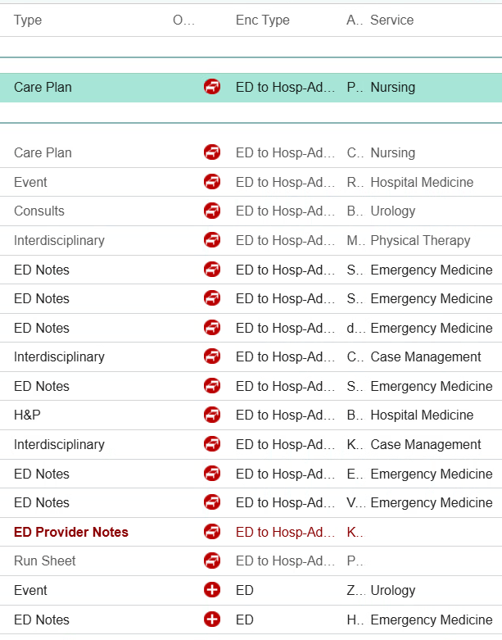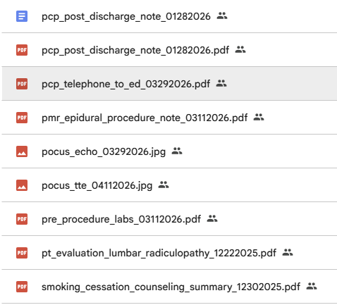

How to review your World files
After your World is designed and approved, there will be an AI Build team that generates your World files. There will also be a summary of AutoQC feedback that may flag problems with the generated files. Your job after receiving the files is to review the AutoQC feedback, address all relevant flags, and fully own the final quality and coherence of your World.
💡 The Review Test: Would a clinician in your specialty accept each document as plausible? If you wouldn't put your name on this chart entry in real clinical practice, it's not ready for the World.
Your review covers two layers:
- Task-level checks — for each of your 8+ tasks: does the designed complexity actually create the intended challenge? Do the documents connect as you designed? Are there any unintended issues that could produce the wrong answer for the wrong reasons? Did your traps survive generation in a form that's discoverable but not spoon-fed?
- World-level checks — across the whole World: do key files read as plausible to a clinician in your specialty? Do supplementary files add realistic context without errors? Are facts, figures, dates, and provider names consistent across all documents — and where they aren't, are the inconsistencies intentional?
💡 AutoQC (AI Quality Check) flags mechanical issues (file completeness, cross-references, defined-term consistency, name/date inconsistencies) automatically as part of the review. Your role is to read its findings, confirm them, and push back if a flag is a false positive.

Where to place World design
You capture your World in two places during onboarding:
- Brainstorm — the World Setup section captures the scenario (patient case + setting + timeline shape)
- World Spec — your main onboarding deliverable. The full design document where your World is fully specified: scenario, tasks, file plan, key facts. This is what your Team Lead reviews and signs off on before engineering generates your World files.
After the World Spec is approved, the World files (chart documents) are generated by AI from your spec, and you review them before the World is locked.

World Self-Check
☐ I can explain what a World is and what "self-contained" means in Sanctum
☐ I can name the four properties of a strong World
☐ I can recognize the common inputs (chart files + multimodal) that live inside a World
☐ I know what I design vs what AI generates — and what I review

💭 Common Mistakes in World Spec

Common Mistakes in World Spec Docs

Mistake | Why It’s a Problem
Letting blueprint content leak into the prompt | Of the six task fields in Section 2, only the Draft Prompt becomes the user message the agent receives. Workflow, Expected Output, Failure Design, and the file ID list are spec metadata for reviewers, graders, and engineering. The prompt should sound like a real user request, not hand the agent context (workflow labels, output structure, trap hints, "note: some documents may be outdated") that it should derive from the files. Spoon-feeding the model lowers the failure rate signal.
Leaving required sections incomplete | Sections 1.1–1.4, Section 2 (overview paragraph), and Section 3 must all be filled. For optional subsections (1.x, Section 4), omit them entirely if they don't apply — do not leave placeholder text.
Designing files before tasks | Files exist to support tasks. Finish all task designs first, then ask: what files does each task require?
Writing prompts that hint at the trap | The prompt should sound like a real clinical request. "Check for errors in the medication list" gives it away. The agent should discover problems by reading the documents carefully.
Leaving the hidden finding vague | "The case is complex" is not a finding. State exactly what the agent must discover, which files contain the evidence, and what synthesis is required.
Putting trap content in supplementary files | Supplementary files add realism and noise only. If a file contains trap content or information critical to a task, it belongs in Essential.
Including over-authorative summaries | If a single document synthesizes everything the agent needs — a complete discharge summary, a prior clinical summary — make it outdated, incomplete, or wrong in a material respect. Otherwise the agent can answer correctly without cross-referencing, and the task loses benchmarking value.
Not specifying reference documents for essential files | Every essential file should include either a reference file link or a description detailed enough for a non-clinician builder to produce a realistic draft.
A single file resolves a task | If one essential file contains everything the agent needs for a task, no cross-document reasoning is required. Every task should require synthesis across at least two files.

📖 Examples Library

🧠 Brainstorm Ex. 1

WORLD BRAINSTORM CHECKPOINT
Conceptual sign-off before world spec drafting begins
World [number per tracker] | Pre-Deployment Travel Medicine: Immunosuppressed Contract Healthcare Worker | Project Sanctum

Concept pitch only. The bar at this stage is conceptual viability, not spec quality. Output is binary: GO or SEND BACK. Specific diagnoses, drug names, doses, ages, dates, and destination are design proposals fixed at spec time against source materials.

1. World Setup
Typical clinical world. An academic travel medicine and preventive medicine clinic that also delivers some primary care. The writer is the acting department medical director while the permanent director is on leave, which seeds one program-level oversight task within this clinical world.
Anchor patient: a woman of childbearing potential, foreign-born and BCG-vaccinated at birth, working as a US-based contract or locums registered nurse. She is being prepared and cleared for a short-term international clinical deployment to a yellow-fever-endemic, high-tuberculosis-burden destination with a highland-plus-lowland itinerary (altitude and a malaria risk gradient). Multi-system but bounded: Crohn disease maintained on an anti-TNF biologic (the immunosuppression engine), latent tuberculosis risk with prior BCG (the screening-confounder engine), and well-controlled type 2 diabetes on metformin (the fitness and medication-logic engine). Pregnancy status is deliberately unresolved at intake.
Timeline shape: a longitudinal pre-departure arc anchored on a fixed deployment departure date, running from screening and referral through pre-departure clearance, with an optional post-deployment return touchpoint. Tasks are independent encounters along this arc; the arc is shared substrate, not a continuous story tasks build on.

2. Major Friction Points
Two central, two secondary. Frictions are people and perspectives.
- Central. Patient versus clinician on vaccines and screening (semi-informed). The patient is a nurse who arrives pre-loaded with conclusions drawn from an AI chatbot and social media. She advocates skipping yellow fever protection and dismissing tuberculosis screening (“my skin test is always positive, it is just the BCG”). The clinician advocates accurate risk mitigation: the chatbot is partially right about the contraindication but wrong about the consequence. Sharp because she half-knows the literature.
- Central. Staffing agency occupational health versus clinician on evidence-based screening. The agency protocol demands a tuberculin skin test plus an annual chest x-ray for every deployed worker regardless of BCG history, and withholds clearance without them. The clinician advocates IGRA given the BCG confounder and argues a repeat chest x-ray is not indicated absent symptoms or a positive IGRA, especially with a recent normal film.
- Secondary. Entry-requirement and agency insistence on yellow fever proof versus clinical contraindication. The destination entry framework and the agency require documented yellow fever vaccination. The clinician holds that the live vaccine is contraindicated by the biologic and must issue a medical exemption with risk counseling and possible itinerary modification.
- Secondary. Treating gastroenterology versus travel and preventive clinic on biologic and latent TB timing. Gastroenterology advocates maintaining remission and continuing the biologic uninterrupted. The travel and preventive clinician advocates that latent tuberculosis must be addressed before or alongside continued anti-TNF given deployment to a high-burden setting, which creates a real sequencing tension against the fixed departure date.

3. Major Traps
Traps are information. Type, one-line description, source location, world-level or task-level.
- Source-of-truth ambiguity. CDC, WHO, and the destination entry requirement disagree on yellow fever for the itinerary, while the biologic independently contraindicates the live vaccine; correct path is exemption plus risk mitigation, not vaccinate. Source: travel guidance reference excerpts in world files. World-level.
- Contradictory records. A historical positive tuberculin skin test (read as “positive, BCG”) sits against the indicated IGRA; anchoring on the skin test or treating BCG as exculpatory both fail, and anti-TNF raises the reactivation stakes. Source: prior occupational health record and outside chart. World-level.
- Buried significant information and temporal. The biologic last-dose date and latent TB treatment plan are buried in a gastroenterology or infusion record, and must be reconciled against the fixed departure date. Source: GI/infusion note in world files. World-level.
- Insufficient information requiring acknowledged uncertainty. Pregnancy status is not clearly documented near the consult; the live vaccine and chemoprophylaxis decisions hinge on it; the correct answer requires resolution before action, not assumption. Source: intake and nursing note ambiguity. World-level.
- Buried significant information. The base site is high-altitude and low malaria risk while a field excursion to a lowland area in the itinerary creates real risk; the detail is buried in agency deployment paperwork and agent selection is constrained by immunosuppression, T2DM, childbearing potential, and cost. Source: agency deployment itinerary document. World-level.
- Source-of-truth ambiguity (low-tier noise). A patient-introduced AI chatbot screenshot asserts a plausible but partially wrong claim in an authoritative voice; it must be subordinated in the source hierarchy and never carries any fact a correct answer needs. Source: patient-provided document, single task only. Task-level.

4. Rough Task Ideas
Five tasks, four clinical and administrative plus one program-level director task. Standard spec is five; the director thread is one of them. Each maps to an approved workflow category and carries task-level traps distinct from world-level traps.
Task 1. Pre-travel consultation note
Deliverable type: Direct clinical documentation.
World elements drawn on: Yellow fever guidance discordance, live-vaccine versus immunosuppression, malaria itinerary and altitude, unresolved pregnancy status, the semi-informed vaccine-hesitancy friction, the GI versus travel friction.
Task-level traps: The single patient-introduced AI artifact lives here; plus a destination entry-requirement detail buried in agency paperwork that the consult must address as exemption rather than rubber-stamp.
Timeline anchor: Roughly six to eight weeks before the fixed departure date, to allow vaccine timing and latent TB lead time.

Task 2. Letter to staffing agency occupational health: TB screening interpretation and latent TB management
Deliverable type: Care transitions and coordination (interagency communication).
World elements drawn on: BCG versus IGRA contradiction, buried biologic timing, the agency versus clinician friction, the GI versus travel friction.
Task-level traps: A recent normal chest x-ray report in the record against the agency demand for another (over-testing); an IGRA result requiring careful interpretation, including the realistic possibility of an indeterminate result under immunosuppression.
Timeline anchor: Roughly five to six weeks before departure, after the consult referral and before clearance.

Task 3. Fitness-for-deployment clearance letter
Deliverable type: Specialty evaluation and legal-medical (fitness-for-duty).
World elements drawn on: The occupational sub-framework, all three comorbidities, the yellow fever medical exemption, the agency versus clinician friction.
Task-level traps: An agency clearance form whose checkbox criteria conflict with clinical reality (for example, “fully immunized per schedule” cannot be truthfully attested given the contraindication), forcing a documented medically accurate exception rather than a rubber stamp.
Timeline anchor: Roughly two to three weeks before departure.

Task 4. Medication reconciliation and travel medication plan
Deliverable type: Medication, coding, and billing (medication reconciliation).
World elements drawn on: Multi-source reconciliation, buried biologic last-dose timing, chemoprophylaxis constraints, T2DM medication logic.
Task-level traps: Infusion-center record, patient-reported list, and primary care list disagree on the biologic agent, dose, or interval, or on the metformin dose; a drug or condition interaction buried in the chemoprophylaxis selection (including childbearing-potential constraints).
Timeline anchor: Roughly three to four weeks before departure.

Task 5. Medical director program-level review
Deliverable type: Quality, safety, and oversight (focused utilization and safety review memo).
World elements drawn on: This patient as the sentinel case for a department-level review of pre-deployment TB screening practice and live-vaccine screening in immunosuppressed travelers, including unnecessary chest x-rays driven by agency protocol. Program-level analysis, not re-adjudication of the individual.
Task-level traps: Aggregate data with a confounded denominator or a misattributed near-miss; a scope-discipline trap tempting the writer to re-litigate the individual case rather than produce program-level findings; a self-containment firewall preventing import of Tasks 1 through 4 conclusions as given.
Timeline anchor: Roughly four to six weeks after the patient deploys (retrospective review window).

What the Lead Evaluates
Walk the checklist. Send back if any item is a clear no.
Area | Checks
World setup | Patient and clinical situation are coherent; specialty, environment, encounter type, and timeline are clear and internally consistent. Patient profile fits the encounter and is one a domain expert has seen several times.
Major friction points | Frictions represent real-world clinical dilemmas; stakeholders and what each advocates are named.
Major traps | Variety of traps that together create enough complexity to stump a physician under normal circumstances.
Rough task ideas | Each task maps to an approved workflow deliverable type; each has its own traps distinct from world-level traps.
Cross-cutting | Self-containment is achievable and the writer has answers; a seasoned clinician could solve every task from intended files alone; the world is representative of daily activities in the domain.

GO  Foundation is viable. Writer proceeds to full spec drafting. | SEND BACK  At least one viability check is a clear no. Lead notes which items need revisiting. Writer revises and re-presents.
Sign-off is verbal or in a brief comment. No formal write-up required at this stage.

🧠 Brainstorm Ex. 2
Edmund World Chen
World Brainstorm Checkpoint

Purpose. Conceptual sign off before world spec drafting begins. Bullet or short narrative form covering the four elements below. No file inventories, no document drafts, no full timeline. This is a concept pitch.
*You may use Claude Project to get you started as mentioned during our 05.03.26 Office Hours.*

Element | What to bring | Examples
1. World setup | This is an inpatient hospital medicine world: a 14 day admission for ESBL urosepsis in a 62 year old Mandarin speaking male (~70 kg) with hypertension, type 2 diabetes mellitus (diet controlled), CKD Stage 2 (baseline Cr 1.2), and hyperlipidemia, plus a 3 day post discharge ED return visit. Course is complicated by AKI, new atrial fibrillation with embolic infarcts, and a hidden cefepime associated neurotoxicity that no clinician in the chart names. Wife is HCPOA. Three consultant services (ID, neurology, cardiology) plus nephrology. Comorbidity profile is intentionally modest because the world tests diagnostic synthesis, not polypharmacy reconciliation. | "This is an inpatient hospital medicine world: a [N] day admission for [presenting problem] in a [age] [sex] with [comorbidities]."  "This is an outpatient primary care world: a single clinic visit for [chief complaint] in a [age] [sex] with [relevant chronic conditions]."  "This is a medical director world: an RCA review of [event type] involving a [age] [sex] who [outcome]; reviewer has access to chart and incident materials."
2. Major friction points | ID hospital day 3 preliminary recommends continue cefepime; ID hospital day 10 final reverses to meropenem after ESBL is confirmed. Same author. Both notes remain in the chart.  Neurology, cardiology, and the medicine team each offer a partial AMS framing (multifactorial metabolic, post stroke, improving on appropriate antibiotic therapy). None reviews the MAR.  Nephrology defers cefepime dosing review to ID; ID does not act on the deferral. The dose error falls into the gap between services. | "Cardiology and nephrology disagree on whether to hold the ACE inhibitor."  "Family wants comfort care; the primary team is still pursuing aggressive workup."  "PCP recommends one regimen at clinic; the inpatient team has a different plan at admission."
3. Major traps | Admission Cr 1.4 contradicts 2019 baseline Cr 1.2. Source of truth ambiguity. World level.  Five day verbatim copy forward of improving on appropriate antibiotic therapy across attending notes despite rising Cr and worsening AMS. Copy forward trap. World level.  Bilateral myoclonus documented only in nursing notes hospital day 7 to hospital day 10, never in any physician note; resolves the shift after cefepime stops. Buried significant information. World level.  Six cefepime doses on a paper MAR during EMR downtime, never reconciled into the electronic MAR within 24 hours per policy. Documentation gap and policy violation. World level.  Three consultant services each provide partially correct, internally consistent AMS framings without reviewing the MAR. Specialist authority trap. World level.  Heparin starts hospital day 7 (same day as myoclonus onset); cefepime stops hospital day 10. AMS improves with cefepime stop, not heparin start. Temporal sequencing. World level.  EEG report hospital day 12 lists drug induced encephalopathy in differential alongside metabolic and uremic causes; neurology reads it as metabolic uremic and the differential is not pursued. Buried significant information. World level.  Auto generated discharge list retains cefepime as Active without attending review or pharmacist co signature; home infusion dispenses both meropenem and cefepime. Source of truth ambiguity plus policy violation. Connects inpatient course to re admission. World level.  Mandarin only patient and HCPOA, language access threaded through discharge teaching, home infusion, and the ED return. SDOH trap. World level. | "Stale EMR med list contradicts a recently filled pill bottle photo. Source of truth ambiguity. Lives in the med rec task only."  "Aspiration event documented mid paragraph in a routine nursing note, never escalated. Buried significant information. World level trap."  "Caregiver burnout limits adherence and follow up capacity. SDOH trap. World level, affects every task that touches the discharge plan."
4. Rough task ideas | Task 1 is a daily progress note. Draws on copy forward, buried myoclonus, specialist authority, and temporal sequencing. Anchored hospital day 14, which the final day of the clinical timeline.  Task 2 is discharge medication reconciliation at care transition (P0). Draws on the auto generated list, paper MAR gap, and policy violations. Anchored hospital day 14.  Task 3 is the patient safety event RCA. Draws on every friction and trap. Anchored HD+3 with ED return data in prompt.  Task 4 is the formal discharge summary. Draws on copy forward, auto generated list, and policy violations. Anchored hospital day 14, which is the last day of the hospitalization.  Task 5 is the ED return visit provider note. Draws on auto generated discharge list and home infusion record. Anchored HD+3 with ED workup data in prompt.  Task 6 is a Neurology follow up note Anchored 2 weeks post discharge. Draws on all of the Neurology evaluation files and EEG report.  Task 7 is the insurance prior authorization for Meropenem. This is anchored on the day of discharge (HD 14) and is drawing from the note from ID. This is written from Case Management and will require Case management and ID notes to be synthesized. Pulls form T7 files and world files. | "Task 1 is a discharge medication reconciliation. Draws on the three way med discrepancy and the buried dose change. Set at hospital day 7."  "Task 2 is a pre operative clearance note. Draws on the cardiology / nephrology friction and the chronic disease profile. Set 2 weeks post discharge."  "Task 3 is the RCA write up itself (medical director world). Draws on every friction and trap. Set 4 weeks after the index event."  “Task 4 is the hospital discharge summary set on the day of discharge”  “Task 5 is set 1 week after hospital discharge when the patient returns back to the hospital with a repeat fever. Create an ED visit note from that visit. This is to be anchored on hospital discharge note”  “Task 6 is set 2 weeks post hospital discharge at the outpatient Neurology visit. Can pull from all of the Neurology evaluation notes in the inpatient setting and from outpatient infusion center notes”  “Task 7 is set on the day of discharge and is the insurance prior authorization letter to get approval for infusion center administration of Meropenem.

Requesting Approval from Pod Leads to move onto the World Specification creation at this checkpoint.

🌍 World 001

King World Harold 001

King World Harold 001

🌎 World 002

Edmund World Chen 002

Edmund World Chen 002

🌏 World 003

Joseph World Marcus 003

Joseph World Marcus 003

🌐 World 004

King World Opus 004
King World Opus - 004

🏅 GR Example 1

Golden Response Example 1 (From World 004, Task 6)

MEDICATION RECONCILIATION
Pt: Caduceus, Opus J. | DOB 14 Mar 1957 | MRN 004-7703 | Allergies: Sulfa (rash)
Date: 15 Dec 2024 | A. Medicina, MD, MPH
Sources: husband's handwritten list 12/14/24, pill bottles (CVS #4782), chart records.

ACTIVE MEDICATIONS:
1. Lisinopril 20 mg PO daily — HTN
2. Amlodipine 5 mg PO daily — HTN
3. Metoprolol succ ER 25 mg PO daily — A-fib rate control
4. Rivaroxaban 20 mg PO daily w/ dinner — A-fib anticoag
5. Atorvastatin 40 mg PO QHS — HLD
6. ASA 81 mg PO daily (OTC) — CV prevention
7. Isosorbide MN 30 mg PO daily — stable angina
8. Omeprazole 20 mg PO daily (store-brand OTC) — GERD
9. Tamsulosin 0.4 mg PO QHS — BPH (dose per bottle; list omitted)
10. Topiramate 25 mg PO daily — migraine prophylaxis
11. Sertraline 100 mg PO daily — PTSD (captured from CVS pill bottle photograph; not on husband’s handwritten list — likely omission. PCP chart 2020, 2023 documents PTSD managed by VA Mental Health, VA Medical Center Norfolk, without naming specific pharmacotherapy. Confirm current dose and adherence with VA Mental Health before finalizing reconciliation)
12. Flunisolide nasal spray, 2 sprays each nostril BID — chronic rhinosinusitis
13. Naproxen 500 mg PO BID PRN — knees, minimal use per pt
14. Diclofenac 1% gel PRN — knees
15. Lidocaine 5% patch PRN — knees
Supplements: Vitamin D, fish oil (doses not specified).
Device: CPAP, d/c'd Jan 2023, non-adherent.
Notes: Polypharmacy, husband manages weekly pill organizer. Orthostatic risk (3 antihypertensives + nitrate + alpha-blocker); pt self-reports lightheadedness — counsel precautions. Bleeding risk w/ rivaroxaban + ASA + PRN NSAID; minimize naproxen, review ASA necessity at next cards f/u. CPAP reengagement separately.
A. Medicina, MD, MPH | 15 Dec 2024

🏅 GR Example 2

Golden Response Example 2 (From World 004, Task 8)

TELEHEALTH MENTAL HEALTH CHECK-IN NOTE
Pt: Caduceus, Opus J. | DOB 14 Mar 1957 | MRN 004-7703
25 Feb 2025 | A. Medicina, MD, MPH — Concierge PCP / OEM
Telehealth Documentation
Mode: Video telehealth via VA-affiliated telehealth platform. Patient/provider locations and identity verification per standard telehealth protocol at visit outset. Ambient AI scribe (VA Ambient AI Scribe v3.2 per scribe header) disclosed per standard workflow.

Reason for Visit
Husband Marcus called requesting MH check-in. Concerns re: pt's low mood, withdrawal from previously enjoyed activities, anticipatory anxiety re: 18 Mar shoulder surgery, and online health-related catastrophizing. Pt agreed to visit. Note also responsive to husband's separate letter re: home observations (reviewed; addressed in fall risk work separately).

Interval HPI (per pt report during visit)
Pt reports feeling "flat," "tired," "not myself." Progressive withdrawal over past 2-3 yr from motorcycle restoration, fishing w/ squadron buddies, reunions. Frames as cumulative identity loss — "every time I get a new diagnosis I lose another piece of myself." Extensive rumination and online catastrophizing re: shoulder surgery (Moyamoya + anesthesia + stroke concerns); husband flagged this pattern. Interval stressors: Moyamoya dx Apr 2022, cardiac burden since 2020, CPAP d/c Jan 2023, 14 Aug 2024 VA rating decision (pt reports disappointment), shoulder injury 27 Jan 2025.
PTSD sx per pt self-report: Content of recurring nightmares unchanged (long-standing dream content). No new intrusions or flashbacks reported. New Year's fireworks managed w/ pre-planned avoidance. Detailed PTSD clinical assessment is within VA MH scope (Dr. Diatriba Morbis).

Today’s Screening (administered at VA MH visit with Dr. Morbis; reviewed by PCP)
PHQ-9 = 14 (moderate depression). Notable items: sleep = 3, fatigue = 3, anhedonia = 2, depressed mood = 2, concentration = 2, item 9 (suicidality) = 0.
GAD-7 = 10 (moderate anxiety). Worry-focused profile.
PCL-5 = 34 (above clinical threshold). Notable: item 12 "loss of interest" = 3, highest single item.

Trajectory Context (per E1-T8 VA MH screening trajectory, Dr. Diatriba Morbis)
PCL-5 has held in 30-34 range since 2018 post-sertraline optimization — PTSD sx stable/well-controlled on established VA MH care.
PHQ-9 has climbed progressively over ~3 yr: 5 (Apr 2022, concurrent w/ Moyamoya dx) → 7 (May 2023) → 10 (Feb 2024, post-CPAP d/c) → 12 (Aug 2024) → 13 (Nov 2024) → 14 today. Clear upward depression trend concurrent w/ accumulated somatic illness, sleep deprivation, and anticipatory surgical anxiety.
GAD-7 w/ modest parallel rise. Current picture: stable PTSD baseline, progressive depression, mild-moderate health-related anxiety.

Mental Status (telehealth-adapted)
A&Ox3. Pt engaged via video, intermittent eye contact (looked away during difficult content). Well-groomed within limits of video assessment. Mood pt-reported "flat, tired." Affect constricted, mood-congruent.
Thought process: Notable for tangentiality during PCP telehealth check-in — pt was at times tangential and there were several interruptions per Dr. Medicina’s observation, a departure from his baseline. TP otherwise linear when on topic.
Concentration: Difficulty sustaining focus during check-in. Consistent w/ PHQ-9 item 7 endorsement and pt’s self-report of “memory shot.” These MSE findings (tangentiality, interruptions) extend the clinical picture beyond the screening scores and corroborate the depression + cognitive trajectory observed.
Insight: Preserved. Pt distinguishes "struggling w/ the shape of my life" from wishing not to be alive. Judgment: Intact. No AH/VH, no delusional content, no HI.

Safety / Suicide Risk Assessment
PHQ-9 item 9 addressed separately: scored 0 on written screen today; verbally re-assessed during visit — pt denies thoughts of self-harm, denies passive wishes of being better off dead, and volunteered explicit commitment to husband and 17yo son. Columbia Protocol Brief Screen administered verbally: NEGATIVE.
Protective factors: intact primary relationship, engaged in care (both PCP and VA MH), preserved insight, no substance use, structured day-to-day life. Chronic risk factors noted: age, male gender, multiple medical comorbidities, firearm in home. Means restriction in place per pt: firearm secured in locked safe, key held by husband. Existing VA MH safety plan remains active. No intent, no plan, no preparatory behavior. Low current acute suicide risk.

Assessment
Service-connected PTSD — stable on established VA MH care. PCL-5 trajectory in same range for several years; PTSD sx adequately managed by long-term MH team.
Progressive depressive symptoms, moderate severity (PHQ-9 14) — onset ~Apr 2022, worsening over past 12-18 mo per screening trajectory. Phenomenology features anhedonia (corroborated by elevated PCL-5 item 12 and pt narrative re: abandoned hobbies), fatigue, sleep disturbance (confounded by untreated OSA), and cognitive impairment (corroborated today by MSE tangentiality and interruptions during PCP check-in). Multifactorial drivers: accumulated somatic illness burden, identity loss from activity disengagement, chronic sleep deprivation, anticipatory surgical anxiety. Clinically distinct trajectory from stable PTSD baseline. Dr. Morbis (VA MH) has increased sertraline from 100 mg to 150 mg daily and scheduled two pre-op trauma-focused therapy sessions prior to 18 Mar surgery; I concur and will support the plan from the concierge PCP side.
Generalized anxiety, mild-moderate — predominantly health-focused and anticipatory re: 18 Mar surgery.
OSA, CPAP non-adherent since Jan 2023 — material contributor to fatigue, cognitive burden, and depression trajectory. Within PCP scope to re-refer to Sleep Medicine for alternative management.

Plan
1. VA MH coordination (Dr. Morbis, PsyD, VA Medical Center Norfolk) — Dr. Morbis has increased sertraline from 100 mg to 150 mg daily and scheduled two pre-op trauma-focused therapy sessions prior to 18 Mar surgery; I concur and will support from the concierge PCP side. Forwarded PCP telehealth check-in observations (tangentiality, interruptions as departure from baseline) + trajectory review for VA MH record. PCP follow-up coordinated with VA MH timeline.
2. Sleep Medicine re-referral (Dr. Adeyemi) — pt remains CPAP-refusing; request evaluation for mandibular advancement device or alternative interface. Rationale documented: OSA is contributing to mood, cognition, fatigue.
3. Counseled pt + husband on online health-searching pattern — structured limits, defer specific surgical-outcome questions to surgeon/anesthesia team, limit reading to surgeon-provided materials. Husband's observations on this pattern reviewed at visit.
4. Safety plan reinforced — reviewed existing VA MH safety plan; confirmed firearm means restriction in place (locked safe, key w/ husband). Pt verbalized commitment to contact me or VA MH before crisis.
5. PCP f/u telehealth within 1-2 wk (sooner if acute concern). Post-op MH check-in f/u within 1-2 wk of 18 Mar surgery, coordinated w/ VA MH.
6. Husband informed of visit outcome at pt's request; provided direct-line number for any acute concerns before VA MH interval appt is scheduled.
Pt acknowledged recommendations, consented to VA MH urgent forward, Sleep Med referral, and pre-op surgical-information boundary plan. Ambivalent re: OSA alternative but willing to consider. Engaged and cooperative throughout.
A. Medicina, MD, MPH | Concierge PCP / OEM | NPI: 1234567890
Electronically signed: 25 Feb 2025

🧑‍🏫 GG Example 1
Reference: Golden_Task6_Med_Rec

Medication Reconciliation Grader Guideline
World 004, Task 6

Below is what will be copied into RLS
You are reviewing a medication reconciliation prepared by a concierge PCP at an OEM initial consultation for a 68 year old Navy veteran. Inputs: a handwritten medication list from the patient's husband (dated one day before the visit), a photograph of CVS pill bottles, and prior medical records including VA mental health notes. The deliverable is a physician facing chart med rec: active medications with dose, route, frequency, and indication, plus optional brief notes (3 to 4 sentences). Read it the way a senior PCP would; this is one defensible med rec, not the only one.
Reference: Golden Response Task 6.docx

Section A: Non-negotiables
The reconciled list is the primary output. Every active medication should appear with dose, route, frequency, and indication, traceable to a specific source (bottle, list, or chart). Errors within the list (wrong doses, wrong frequencies, omitted meds, invented meds) outweigh stylistic choices in the notes section.
Cross source reconciliation is required. No single source is complete. The handwritten list omits some doses and at least one medication in the chart. The pill photo shows 6 Rx bottles plus one OTC box; topicals, patches, nasal sprays, PRN meds rarely used, and VA pharmacy meds typically will not appear.
Two anchor items. (1) Sertraline 100 mg appears on the CVS pill bottle but not on the husband's list; the PCP chart documents PTSD as managed by VA Mental Health, Norfolk, without naming pharmacotherapy. A solid med rec captures sertraline from the bottle, notes the list omission, and recommends confirming dose and adherence with VA Mental Health. (2) The handwritten list omits the tamsulosin dose; the pill bottle confirms 0.4 mg QHS. A solid med rec fills the dose from the bottle rather than leaving it blank or inventing one. CPAP non adherence is worth a brief mention given moderate to severe OSA.

Section B: Scope, format, and what legitimately varies
The deliverable is a chart med rec, primarily a list, roughly one page. Numbered or tabular format is most common; continuous prose is acceptable. Organization by system, indication, or alphabetically is all defensible. The document is physician facing, not patient facing. A brief notes section (3 to 4 sentences) is typical; multi paragraph clinical analyses (polypharmacy physiology, orthostatic review, topiramate pharmacology) drift toward an H&P and are penalized when they crowd out the list.
Use the golden as your reference for what's supported by the source files. Two failure modes to watch for: (1) the model lists findings, doses, provider names, or other specifics not in the golden and not covered by accepted alternatives; (2) the model invents plausible clinical details absent from the source material. Section B lists pre-authorized alternatives. Answers outside those alternatives should generally be flagged as fabrication even when defensibly argued, since the grader has no independent way to verify the underlying clinical claim. Format: .docx preferred; PDF acceptable with a small penalty; plain text penalized more; spreadsheet or slide formats are inappropriate.

Section C: Common failure modes (illustrative, not exhaustive)
These are patterns to reason about, not items to tick off.
Single source reconciliation: taking the husband's list at face value, missing sertraline (visible on the bottle), leaving the tamsulosin dose blank, or assuming the pill photo is the full list.
Fabrication: invented doses for medications listed without them, or whole medications added that appear on no source. When a source omits a detail, the prudent move is to note the omission and propose clarification.
Over producing: multi paragraph polypharmacy or orthostatic analyses that drift out of chart register. The opposite pattern is a clean list with no clinical awareness at all when obvious concerns warrant a brief mention. Also: misreading doses from the photo, patient facing instructions, treating the task as a full H&P.

NOTE: As of June 4th, 2026, we are no longer using “scoring bands” in our grader guidelines. Please flag any inadvertent mentioning of it here in our instruction document and onboarding materials.

🧑‍🏫 GG Example 2
Reference: https://docs.google.com/document/d/1sagcTrLPhWQEq8GhBb1OypKjHR2de_GbbXVyW4a0iTI/edit?usp=drive_link

Telehealth Mental Health Check-In Note Grader Guideline
World 004, Task 8

Below is what will be copied into RLS
You are reviewing a mental health trajectory review and coordination note by the patient's concierge PCP (Dr. A. Medicina), prompted by a portal message from the patient's husband. Patient is a 68 year old Navy veteran with service connected PTSD and OSA, in established VA MH care with Dr. Morbis (PsyD). Inputs: 9 year VA MH screening trajectory, today's item level scores (from the VA MH visit), the ambient scribe transcript from that visit, the established record, and Medicina's own brief telehealth check in (where she observed tangentiality and interruptions as a departure from baseline). Deliverable: a PCP trajectory review note integrating these inputs, comparing current to baseline, documenting Medicina's telehealth observations, and producing a plan coordinating with VA MH. One defensible note, not the only one.
Reference: Golden Response Task 8.docx

Section A: Non-negotiables
Telehealth documentation conventions. Acknowledge mode, platform, location, identity verification, and scribe consent, but use generic placeholders ("per standard telehealth protocol," "VA affiliated telehealth platform") for specifics not in the source rather than invent them. Only the scribe tool is source anchored (VA Ambient AI Scribe v3.2). A note that reads as in person without telehealth framing has missed the task context.
Trajectory recognition (the core Trap 4 test). Today's scores in isolation read as moderate depression, moderate anxiety, PTSD above threshold. The 9 year trajectory shows PTSD stable in the 30 to 34 range since 2018 and depression progressively worsening from 5 (Apr 2022) to 14 today over roughly 3 years. A competent note distinguishes the stable trajectory from the progressive one and names the timeline with date anchors. Treating all three scores as undifferentiated worsening misses the central observation.
Clinical integration beyond the scores. Tangentiality and interruptions are thought process and concentration findings; document in the MSE and connect to the depression and cognitive trajectory and to PHQ-9 item 7. Anhedonia as bridge symptom is worth capturing (PCL-5 item 12 at 3, PHQ-9 item 1 at 2, abandoned hobbies). Name the scribe specific stressor drivers (Moyamoya dx, CPAP non adherence, VA rating decision, shoulder surgery anticipatory anxiety, identity loss) rather than leave as generic depression worsening.
PHQ-9 item 9 addressed separately. Suicidality is its own element. A dedicated safety section notes the item 9 score, verbal re assessment, Columbia Protocol result, protective factors, chronic risk factors, and means restriction status. "Denies SI" without this framing has under executed.
PCP scope; VA MH coordination as plan element. This is a PCP trajectory review and brief telehealth check in, not a VA MH treatment visit. The scribe documents Dr. Morbis's VA MH visit where sertraline was increased from 100 mg to 150 mg and pre op therapy was scheduled; these are VA MH decisions. Attributing them to Dr. Morbis / VA MH is source anchored; documenting Medicina's concurrence is appropriate coordination. PCP role: review trajectory, document telehealth observations, handle PCP scope items (Sleep Medicine re referral, counseling, safety plan reinforcement, follow up), coordinate with VA MH.

Section B: Scope, format, and what legitimately varies
Length 1 to 1.5 pages. Structure: SOAP adjacent, problem based, or integrated narrative with structured plan. Diagnostic labels descriptive ("progressive depressive symptoms, moderate severity") or DSM-5 style; descriptive is closer to PCP scope. Husband's letter referenced explicitly or incorporated indirectly is fine. Formal Columbia score or verbal re assessment is acceptable. Out of scope: VA C&P exam, disability advocacy, comprehensive MH intake, replacement of VA MH provider, unilateral psychotropic prescribing, full trauma focused psychotherapy.
Use the golden as your reference for what's supported by the source files. Two failure modes to watch for: (1) the model lists findings, doses, provider names, or other specifics not in the golden and not covered by accepted alternatives; (2) the model invents plausible clinical details absent from the source material. Section B lists pre-authorized alternatives. Answers outside those alternatives should generally be flagged as fabrication even when defensibly argued, since the grader has no independent way to verify the underlying clinical claim.

Section C: Common failure modes (illustrative, not exhaustive)
These are patterns to reason about, not items to tick off.
Wrong deliverable type. Writing a VA MH provider visit note rather than a concierge PCP trajectory review with telehealth check in observations, or omitting the coordination role.
Snapshot thinking. Today's PHQ-9 14, GAD-7 10, PCL-5 34 reported as current state without engaging the 3 year trajectory. Misses that PTSD is stable while depression is progressive.
Scope overreach into VA MH prerogatives. PCP presents herself as making VA MH treatment decisions (initiating an SSRI, scheduling therapy) rather than documenting Dr. Morbis's decisions. Also: drifting into VA disability advocacy or formal diagnostic revision ("MDD, severe") from a single PCP telehealth visit.
Missing clinical integrations. Tangentiality and interruptions noted in passing rather than integrated into the MSE. Anhedonia as bridge symptom missed. Driver story left as generic depression worsening without the named stressors.
Safety assessment failures. PHQ-9 item 9 folded into generic safety language. Under assessing: brief "denies SI" without Columbia screen, protective factors, or chronic risk factors. Over alarming: treating secured firearms (locked safe, key with husband, means restriction maintained) as an active crisis. Appropriate posture documents low current acute risk with chronic factors and maintained means restriction.

NOTE: As of June 4th, 2026, we are no longer using “scoring bands” in our grader guidelines. Please flag any inadvertent mentioning of it here in our instruction document and onboarding materials.

🔍 FA Example
Trajectory Failure Analysis Example
World: Chen World
Trajectory: Trajectory 2
Failure rate: 0.67

Trajectory Failure Analysis paragraph
On Trajectory 2, the agent opened the chart with the discharge summary and the most recent progress note, then jumped straight to the medication reconciliation task without reading the pharmacy fill history. This skipped the primary trap, which required cross referencing the home dose listed in the admission H&P against the actual fill history showing a dose reduction two months prior. The agent carried forward the H&P dose into the discharge medication list and produced a plausible but incorrect reconciliation. Search behavior was minimal and the agent did not revisit earlier files once the inconsistency surfaced in the consult note. The reasoning chain showed early anchoring on the H&P as the source of truth and no self correction when contradictory data appeared. Final output was confidently wrong with no flags raised about the dose discrepancy. Root cause is failure to apply pharmacy fill history as the authoritative tiebreaker, which is a known trap pattern in this world. This failure mode is showing up at 0.67 on this task, so it is the highest priority pattern to address.

🔍 GA Example
Grader Analysis Example
The Section A clinical accuracy criteria caught the dose error cleanly but the total score did not sufficiently reflect the egregious nature of this in the real-world (i.e. more points should be deducted since this technically can lead to a malpractice lawsuit). Section B scope language held up, and the fabrication clause triggered correctly without ambiguity. One gap surfaced in Section C, where the common failure mode list did not explicitly call out anchoring on the H&P over pharmacy fill history, even though this is the dominant failure pattern observed across runs. Recommend adding that failure mode to Section C and tightening the verify don’t trust language in the prose intro to direct graders toward pharmacy fill history as the spot check anchor.

🏷️ PL Example

Preference Label Example
Preferred output: B
B is slightly preferred over A. Output A does cover the following: pass every Section A anchor — dual inducer washout framing, both inducers named, bictegravir transporter explanation for the creatinine rise, lisinopril continued, HACEK hold flagged with named owner, TEE and LP intentionally deferred, CD4 recovery to 380 documented, rifampin absent from the active list — but B better matches the prompt's PCP-handoff intent and contains one fewer factual error.
Justification
B opens with a "Note to Dr. Jenkins" framing the document as a direct attending-to-PCP handoff, names the consultant disagreements explicitly, and includes a dedicated "Items Requiring PCP Follow-Up" section that lists nine specific threads — the HACEK final result, pending serologies, the new Cr baseline on Biktarvy, future CD4 reads, the herbal supplement counseling that needs reinforcement, the murmur trajectory, rifampin status, sulfa allergy, and weight recovery. This directly answers the prompt's request for a summary "clean enough that she can know what exactly happened." A is a thorough synthesised narrative with a "Key Clarifications for the PCP" section but does not surface the actionable follow-up threads with the same operational clarity. A also lists patient age as 45 in two places; the spec's Patient Profile lists her as 47, which B uses correctly.
Prompt adherence
Output A and Output B produced a discharge summary in the format Dr. Thorne asked for, with the requested content (course summary, diagnoses, medications, follow-up) and the prompt-implied context that the attending is off-service the next day (with Output B being more adherent to the prompt). Output A and Output B retrieved the herbal supplement details, the Spanish referral letter, the consultant disagreements, and the lab trends—-however, output B more explicitly carries the off-service framing through to the document structure with an attestation paragraph and the explicit "Items Requiring PCP Follow-Up" handoff section.
Correctness
Output A and Output B are clinically correct on the substantive medical content — all Section A anchors are integrated, the bictegravir transporter explanation is carried through to the medication list with lisinopril active in output A more explicitly compared to output B, and rifampin is correctly absent from the active list. A contains a small factual error in patient age (45 instead of 47); the spec's Patient Profile has 47 (DOB 12/05/1978, admission 09/10/2024). Output A and Output B attempt to include similar fabricated lab specifics (CMV PCR, EBV PCR, beta-D-glucan, Histoplasma and Coccidioides serologies, peak ESR/CRP values, an "ED admission lactate 1.6" value) that are not in the world files —but output A appears to have more glaring fabrications.
Completeness
Output A and Output B cover admission context, hospital course synthesis, discharge diagnoses, procedures, pending results with named owners, discharge medication plan with rationale, and follow-up timing. However, A is more discursive in the Hospital Course narrative and includes a Patient Education / Counseling section, a Coverage Note, and a more granular pertinent-studies tabular summary. B is tighter in the course narrative and trades length for the operational PCP-handoff section. For a discharge summary specifically intended to stand on its own at PCP follow-up, B's structure is more directly useful.
Methodology
Output A and Output worked through the chart systematically and integrated the consultant disagreements with the attending reframings — neither imports the ART-failure framing as the author's own conclusion. Output B does a slightly better attempt at treating the cardiology sign-out as the closing disposition for the endocarditis question. Output B also more clearly treats the Day 7 IM intern AKI label as the position the ID attending corrected. The methodological difference is in handoff orientation: A organizes the document around clinical synthesis, B organizes the document around what the PCP needs to do at the follow-up visit.
Quality and clarity
Output B is written clearly at appropriate physician-facing register; Output A and B use compact prose and standard clinical shorthand. But A is more narrative and reads with confident hospital-attending voice. B is more direct and operational, with the "Note to Dr. Jenkins" opening and the numbered PCP follow-up list working as a structural device. Output A and B are appropriately long for an 8-day complicated stay but A is somewhat longer.
Summary
B is preferred because it better matches the prompt's PCP-handoff intent — the explicit "Note to Dr. Jenkins" framing, the dedicated "Items Requiring PCP Follow-Up" section listing nine specific threads, and the attestation paragraph all turn the document into a usable operational handoff rather than a record of what happened. B also avoids A's small patient-age error. A is a more polished narrative summary and is fully senior-reviewer-acceptable on the clinical content; the difference is one of fit-for-purpose, not clinical adequacy.

🔍 QC+FA+GA: Combined Example
QC + FA + GA Example

The document below shows one way to organize your thoughts during the Task AutoQC (Steps 11 and 13), Taiga QC (Step 14), Failure Analysis (Step 15), and Grader Analysis (Step 15) phases of the production pipeline. Document exactly what the audit items were for each task, your rebuttal for each, and the next steps to achieve resolution. Revisions will likely need to be made at the task level, which warrants re-running the trajectory after each QA session.

Once you have addressed all QA items and re-running the trajectories did not result in any more red flags, then you may proceed to do failure analysis.

After failure analysis, the final stage is preferential labeling wherein you decide which generated output is superior and why.

👉 World 004 QA + Failure + Grader Analysis

📺 Office Hours & Onboarding

Office Hours Recordings/Minutes:

Sunday, April 12th | Recording | Meeting Minutes
Topics:
- Project overview
- World/Task design vs. Prompt/Rubric framework
- Clinical workflows
- Multimodal data

Sunday, April 26th | Recording | Meeting Minutes
Topics:
- Self-containment
- Reasonable ambiguity
- Degrees of freedom
- Grading guidelines vs. rubric design

Friday, May 1st | Recording | Meeting Minutes
Topics:
- Brainstorming
- File Management/Communication
- World Traps

Sunday, May 3rd | Recording | Meeting Minutes
Topics:
- How to Use Claude Project
- Prompt Engineering Best Practices
- World Files vs. Task-level Files

Sunday, May 24th | Recording | Meeting Minutes
Topics:
- New RL Studio interface clarifications and recap
- Troubleshooting issues/blockers on new RL Studio
- Instruction Document updates
- Demo of clinical data generators (EEG/EKG/EFM/ventilation tracings, lab report templates, etc.)

Sunday, May 31st | Recording | Meeting Minutes
Topics:
- Claude Opus token usage
- What is AutoQC?
- Non-negotiables
- New RLS interface
- Taiga and EnvLinter

Project Kickoff + Worlds Learning Workshop:
Saturday, May 9th | Recording | Meeting Minutes

Onboarding Calls Recordings/Minutes:

Saturday, April 25th | Recording | Meeting Minutes

⚠️NOTE: It is HIGHLY RECOMMENDED that you watch at least the 04/12, 04/26, 05/03, and 05/09 Office Hours recordings and Onboarding Call.

Your success in this project is dependent on your grasp of the fundamental concepts of prompt engineering, rubric design/evaluation, and AI training in the medicine domain.

If you cannot comfortably explain the concepts of self-containment, degrees of freedom, timelessness, and prompt/rubric mismatch, then you will likely require more calibration and guidance from your pod leaders and peer reviewers throughout the production pipeline.

Lastly, our project, like most Mercor projects, have pivots on a daily basis and Office Hours allow you to operate with the latest project guidance and workflow expectations.

📁 Google Drive Organization
Organizing Your World Folder
(NOTE: Organizing your in-progress drafts in a personal Google Drive folder is best practice but not required. The formal package lives in RL Studio.)
There is no assigned folder. If you want to keep your in-progress drafts organized, you can create a personal working folder in Google Drive. This is nice to have but not required. When a deliverable is ready, upload it to RL Studio; that is the formal submission of record.

The folder name is up to you. Whatever helps you keep track works (e.g., "World Harry," "Pemberton_Working," etc.). The folder itself is not tracked on RL Studio, so you don't need to follow any naming convention.
Recommended Folder Structure
Use the following structure inside your working folder. It mirrors how you will have to compartmentalize each deliverable as you upload them individually to RL Studio. Organizing this way makes piecemeal uploads to RL Studio clean and quick.
- Brainstorm Document: your approved brainstorm checkpoint for this world.
- World Spec Document: the main spec for the world. Use the current World Spec template.
- Reference Templates Subfolder: holds all reference templates (custom made, from the internal DataBank, or public domain). Build this folder using the Claude Project workflow in the template & reference guide. At Step 4 of the pipeline, you upload this folder to RL Studio alongside your World Spec as a single package. Files should sit directly inside this subfolder. Do not nest additional subfolders here.
- Task-Level Materials Subfolder: holds everything tied to individual tasks, including:
- Task prompts (e.g., Prompt_Task 1_SME consultation)
- Task-level files (e.g., Pill_Bottles.jpg, MRI_Referral.pdf)
- Grader guidelines (e.g., Grader_Task 1_SME consultation)
- Golden responses (e.g., Golden_Task 1_SME consultation)
- World-Level Files Subfolder: holds copies of the essential and supplementary world files planned in your World Spec. This is where you save the synthetic files once they're released after the World AutoQC gate (Step 8) for your writer review.
- QA Subfolder (Optional): holds filled-out templates and organizers for QA audit items, failure analysis, grader analysis, and preferential labeling.

🎥 File Organization Walkthrough

NOTE: You also have to include “Templates File Folder” which we did not include in the original video.

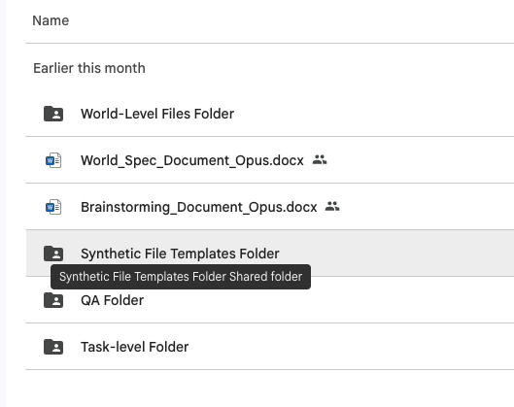

Uploading to RL Studio
All major deliverables (brainstorm, world spec, template files, world-level files, task prompts, task-level files, golden responses, grader guidelines) are uploaded through RL Studio. The engineering team will also automatically extract your world spec and template files directly from RL Studio in order to produce the world-level (i.e. synthetic) files.

After uploading each major deliverable, there will also be an AutoQC checker that will flag items as you go through the production pipeline. In order for you to move on to the next step in RL Studio, you must address each AutoQC audit item.
Close the Loop on Slack
As a general best practice, update your pod leads/reviewer accordingly in Slack after each meaningful upload or milestone (brainstorm submission, world spec submission, task packaging, QA work, etc.) to confirm and flag anything that needs reviewer attention.

💻 Claude Best Practices

Claude Best Practices
Treat Claude the way you would treat a resident who has broad medical knowledge but has never worked in your specific practice setting. You would not hand them a blank page and ask them to design a patient case. You would share your thinking, ask them to challenge it, and use their questions to sharpen your own reasoning.
The template was designed to be Claude-friendly. Using Claude to draft your world spec is not just permitted — it is how most experienced writers on this project work efficiently.

Where to Use It vs. Where Not To
Use Claude for:

Use Case | How | Why It Works
Testing your traps | Feed Claude your documents and prompt to see if it falls for them. | If Claude doesn’t fall for the trap, it may be too obvious. If it does, you know the trap is functioning.
Consistency auditing | Paste all essential documents and ask Claude to identify every contradiction. Compare against your intentional contradiction log. | Catches unintentional inconsistencies across your file set that you might miss on manual review.
Drafting from precedents | Give Claude a real clinical document to adapt rather than asking it to draft from scratch. | Claude-generated clinical documents from blank pages consistently contain generic content that lack the specificity of real drafting.
Drafting the world spec | Fill in the Writer Input Template yourself, then use Claude to turn your inputs into structured spec format. (See the World Spec section for the full 5-step process.) | Claude handles the mechanical assembly; you provide the clinical judgment.
Pressure-testing your ideas | Explicitly ask: "Is this task too easy?" "Does this file earn its place?" "What is the plausible wrong answer, and why would a careful clinician reach it?" | Claude won’t push back unless you ask it to. Use it as a sparring partner, not a yes-man.

Do NOT use Claude for:
These are hard limits — not judgment calls.
- Task prompts
- Golden responses
- Grader guidelines
- QA responses, failure analyses, or preference labels
Check clinical values for consistency, cross-references between documents for accuracy, and that clinical decisions reflect actual practice in your specialty and clinical setting. You remain responsible for everything in your world regardless of how it was produced.

Sanctum Walkthroughs
Two companion guides walk through how to use Claude on a real Sanctum world build. They were written from pearls and pitfalls encountered during the Chen world (process002), with Chen as the worked example.
Long Guide — Full Walkthrough. End-to-end coverage of the world-building workflow: spine work, brainstorm, spec drafting, and the critique pass. Use this when you want the reasoning behind each step. Open the long guide.
Short Guide — Six-Page Quick Reference. The condensed version for new writers who want the workflow without the deep walkthroughs. Best as a checklist once you’ve read the long guide. Open the short guide.

Reference Links
Supplementary material for deepening your prompting fluency beyond the Sanctum-specific workflow.
Video Walkthroughs
- How to get the most out of Claude — general walkthrough from the Anthropic team.
- Prompting techniques in practice — applied examples of clear instructions and role assignment.
Anthropic Documentation
- Prompt Engineering Overview — entry point to all prompting documentation.
- Prompting Best Practices — living reference covering clarity, examples, XML structuring, role prompting, and chain-of-thought.
- Interactive Prompt Engineering Tutorial — nine-chapter hands-on course with example playgrounds.
Sanctum-internal guidance takes precedence when it conflicts with general Anthropic documentation, because it encodes project-specific rules around traps, anchor documents, and grader design that the public docs do not address.

❓ FAQs

FAQs

Q: I am new. Should I start by writing a world spec from scratch?

No. Follow the onboarding path: Step 1 — read 2–3 completed example world specs to understand different approaches and the quality bar. Step 2 — start working on your brainstorm. Step 3 — work on your world spec.

Q: Can I use Claude to write my world spec?
Yes — and it is encouraged. You must use Claude. You can use Claude to brainstorm patient scenarios, expand bullet-point outlines into full world specs and check for consistency across files. You cannot use Claude to write task prompts, golden responses, grader guidelines, QA responses, or preference labels. The world spec template was specifically designed to be Claude-friendly.

Q: I cannot access files that were shared with me. What should I do?

Contact the EPMs to request access.

Q: Who is the world spec written for — engineering's pipeline or other clinicians?
Both. Engineering's synthetic generation pipeline auto-extracts your spec and your Reference Templates folder to generate the actual world files. Other clinicians may later read your spec to understand the scenario well enough to add tasks to your world. Write it to be precise enough for an automated pipeline to build from and clear enough for a clinician who has never seen your case to design tasks against it.

Q: Do tasks need to be sequential? Can I create multi-step tasks?
No, tasks do not need to be sequential. Each task is standalone — the agent tackles it independently with access to the world files and does not carry over context from a previous task. Multi-step tasks are not in scope for now.
Q; What if a later task needs information that is not in the world files? Can I update the world files?

No. World files are static after creation. If a new task requires additional clinical information — a new wound assessment, an urgent care intake form, a family member's handwritten medication list — add it as a task-level input file attached to that specific task. Do not modify or expand the shared world file set, as this would break earlier tasks that were designed against the original files.

Q: How realistic should the prompts be?
Very. Imagine you are a human expert who received this prompt plus these files. Would you have enough context to do the work, or would you have unanswered questions? If the former, it's fair. If you would need to make assumptions to proceed, the prompt needs work.

Q: How do we think about difficulty?
One useful proxy is time: how long would a human expert take to complete this task? In most cases, the answer should be several hours.
Another approach is to review a sample of trajectories and assess whether they contain meaningful deficiencies—errors that a domain expert would consider significant in a real professional context.
Ultimately, difficulty is secondary to realism. The goal is to create tasks that reflect the complexity and nuance of real-world work.
Q: Why are we moving away from rubric-based grading?
Overly prescriptive grading requires prompts to be unrealistically specific to be gradeable. A real attending would simply say "write the discharge summary for this patient" and expect competent judgment on what that requires. Rigid rubrics force us to add instructions no supervising physician would actually give, producing artificial prompts. The agentic approach lets you write realistic tasks without worrying about whether a rubric can capture the quality of the output.
Q: What does "high confidence" mean for preference labels?
The goal is that a large group of human experts, given the task-specific guidelines, would agree on which output is better. It does not mean 100% inter-rater agreement — that is not feasible. It means your label should be defensible to a senior physician reading your justification. If you cannot articulate a specific clinical or administrative difference that drove your decision, reconsider the label.

Claude FAQ
This section covers the most common issues writers encounter during the template and reference file workflow. If your question is not answered here, ask your pod lead or reviewer in Slack.

Claude Project and setup

I cannot find "Projects" in Claude.
Make sure you are signed in at claude.ai (not a different Claude interface). Projects is in the left sidebar. If you do not see it, your account may not have access. Ask your pod lead to confirm your account is set up correctly.

I do not know which email to use for Claude.
Use your Mercor expert email. This is the same email you use for RL Studio and Google Drive. If you are unsure which email that is, check with your pod lead.

Claude says it cannot read one of my files.
Confirm the file is a .docx (not .doc, .pdf, or .pages). If the file is very large, try re-saving it as a fresh .docx. If the problem persists, ask your pod lead.

Working with Claude

Claude is producing everything at once instead of working in installments.
The system prompt instructs Claude to work in installments. If Claude ignores this, paste the following reminder: "Please work in installments of 3 to 5 rows. Pause and check in with me after each batch before continuing."

Claude is going faster than I can keep up with.
Tell Claude to pause. Example: "Pause. Let me review EW1 to EW3 before you continue. I will tell you when to proceed."

Claude asks a question I do not understand.
Ask Claude to rephrase: "I do not understand your question. Can you rephrase it in simpler terms?" If it is still unclear, copy the question and paste it to your pod lead in Slack for help.

Claude produced a template that does not match what I had in mind.
Tell Claude exactly which row and what to fix. Example: "For EW3, the template you produced is an inpatient progress note but my spec describes an outpatient clinic visit. Please redo EW3 using DB_Progress_Note_Outpatient.docx instead." You do not have to start over; Claude can redo individual rows.

Claude seems to be making up content that is not in the DataBank.
The system prompt tells Claude never to fabricate. If you suspect Claude is inventing a template rather than extracting from the DataBank, ask: "Is this template from the DataBank, or did you draft it from scratch? If you drafted it, which row in my spec required a custom-made template?" If the issue persists, flag it to your pod lead.

My Claude session timed out or got cut off in the middle of a batch.
Start a new chat in the same Claude Project. Re-attach all three files and paste the prompt starter again. Then tell Claude where you left off: "We were working on my world-level files. You already completed EW1 through EW5. Please continue from WS1."

Claude is using em dashes, en dashes, or AI-sounding phrasing.
Remind it: "Please do not use em dashes, en dashes, or AI-sounding phrasing in any template you produce. Use plain hyphens or restructure the sentence."

Claude produced a file I cannot open.
Make sure you have Microsoft Word or Google Docs available. Claude produces .docx files. If the file appears corrupted, ask Claude to regenerate it: "The file for EW3 appears corrupted. Please regenerate it."

DataBank and templates

The DataBank template I named does not exist.
Open the DataBank and search for the template by keyword (not exact filename). You may have misspelled the filename in your spec. If no match exists, decide whether to use a different DataBank template, mark the row as custom-made, or ask your pod lead for guidance.

Two DataBank templates seem similar. Which one do I use?
Open both templates and read through them. Pick the one that more closely matches the clinical document described in your spec row. If you are still unsure, ask your pod lead or reviewer.

The DataBank does not have a template for my specialty.
Mark the row as custom-made in the Reference File Origin column. Claude can help you draft the template from scratch, or you can use the custom template generator as a starting point. If your specialty is frequently underrepresented, flag it to your pod lead so the DataBank can be updated for future writers.

A DataBank template looks outdated or has errors.
Do not fix it yourself. Flag the specific template and the issue to your pod lead in Slack. Use the template as-is for now unless your pod lead tells you otherwise.

File naming

The template filename does not match the Filename.type in my spec.
That is correct and expected. The Filename.type column is the final synthetic filename engineering will produce (with a datestamp). The template filename is generic (no datestamp). Do not rename your templates. See Appendix B for the full explanation.

I do not know what to name my custom-made template.
Use a descriptive name that makes it obvious what the document is. Follow the pattern: what it is + where it is from. Examples: HogwartsHospital_Pre-OP_Template.docx, CardiacRehab_ProgressNote_Template.docx. No datestamps on templates.

I do not know what to name my writer-produced file.
Writer-produced files that will NOT go through engineering should use the final synthetic filename (WITH datestamp) from the Filename.type column in your spec. Example: HandwrittenMedList.05.15.2019.png.

I accidentally renamed a template to match the Filename.type column.
Rename it back to the generic template name (no datestamp). If you are unsure what the original name was, check the Reference File Origin column in your spec or ask Claude to remind you.

Writer-produced files

I am not sure if a file should be writer-produced or a template.
Ask yourself: can an engineer who is not a physician produce a realistic version of this file from a template? If yes, it is a template for engineering. If it requires your clinical domain expertise, specialty knowledge, or a tool like Nano Banana Pro or ElevenLabs to create, it is writer-produced. If still unsure, ask your pod lead.

I do not know how to use Nano Banana Pro / ElevenLabs / the clinical data generators.
Refer to the clinical data generators guide linked in Step 3. If you need additional help with a specific tool, ask your pod lead or reviewer. They can walk you through it or point you to a tutorial.

I produced a file but I am not sure if it is good enough to submit.
Open the file and ask: does this look like a realistic version of what it is supposed to represent? If it is a pill bottle photo, does it look like an actual pill bottle? If it is an EKG tracing, would a clinician recognize it as plausible? If you are unsure, share it with your pod lead or reviewer for a quick gut check before uploading.

Claude reminded me about writer-produced files I have not created yet.
This is the system prompt working as intended. Claude tracks which rows are writer-produced and reminds you before you finish. Produce those files using the appropriate tools, add them to your folder, and include them when you upload to RL Studio.

World Spec and Reference File Origin

I am confused about the Reference File Origin column.
The Reference File Origin column tells Claude (and engineering) where each template comes from. For each row, you write one of: the DataBank template filename, Custom made (brief description), Public Domain (form name: source agency), or Writer-produced (brief description, tool). See Step 3 for examples of each.

I am not sure which origin to pick for a particular row.
Start with the DataBank. Open it and search for a template that fits. If nothing fits, decide whether the document is a standard government form (public domain) or something you need to outline yourself (custom-made). If the file requires clinical expertise or specialty tools (photos, audio, tracings), mark it as writer-produced. When in doubt, ask your pod lead.

I am not sure if a row is world-level or task-level.
World-level files are shared across all tasks in the world. Task-level files are specific to a single task. If the file would appear in every clinical encounter for this patient, it is likely world-level. If it is specific to one encounter, it is likely task-level. This guide covers world-level files only. If unsure, ask your pod lead.

I accidentally changed the World Spec template structure.
Revert to the original template and re-enter your content. Engineering's pipeline reads the spec programmatically, so structural changes (renamed columns, rearranged sections, deleted headings) will break file generation. Compare your version to a clean copy of the template or ask your pod lead.

Self-QC

I found a mismatch between my spec and my folder.
Fix it before uploading. If a row in your spec has no matching file, produce or obtain the file. If a file in your folder has no matching row, either add the row to your spec or remove the file. Mismatches are the most common reason a package is returned for rework.

My file count does not match my row count.
Walk through your spec row by row and check off each file as you find it in your folder. Identify which rows are missing files and which files are orphans. Fix each one. If a single row maps to two paired templates (e.g., discharge instructions plus medication list), both files count.

I am not sure if my package is complete.
Run the self-QC checklist in Appendix C. If everything checks out, your package is complete. If you are still uncertain, share your folder and spec with your pod lead for a quick review before uploading.

RL Studio upload

I cannot access RL Studio.
Confirm you are using your Mercor expert email. If you still cannot log in, ask your pod lead to verify your access.

I do not know how to upload individual files.
Refer to the RL Studio upload guide linked in Step 6. If you are still stuck, ask your pod lead to walk you through it. Each file is a separate upload; do not package into a zip.

I uploaded the wrong files and need to fix my submission.
Contact your pod lead immediately. They can advise whether you need to re-upload or whether the submission can be corrected in place.

I finished uploading. What do I do next?
Post in your pod channel confirming the package is complete and tag your pod lead or reviewer. Engineering picks up the package from RL Studio and produces the synthetic files. You do not need to do anything further unless engineering or your reviewer comes back with questions.

General

I am stuck and do not know who to ask.
Your pod lead is your first point of contact for any question about the workflow. If your pod lead is unavailable, tag your reviewer. If neither responds within a reasonable time, escalate in the team-wide Slack channel.

I am confused about the overall workflow.
Re-read Steps 1 through 6 at the top of this guide. The workflow is: brainstorm approved, draft spec, fill in file plan tables, use Claude to assemble templates, self-QC, upload to RL Studio. If a specific step is unclear, ask your pod lead to walk you through it.

This is my first world. Is there someone who can review my work before I submit?
Yes. Your pod lead and reviewer are there to help, especially on your first world. Share your folder and spec with them before uploading to RL Studio. They can catch issues early and save you rework.

